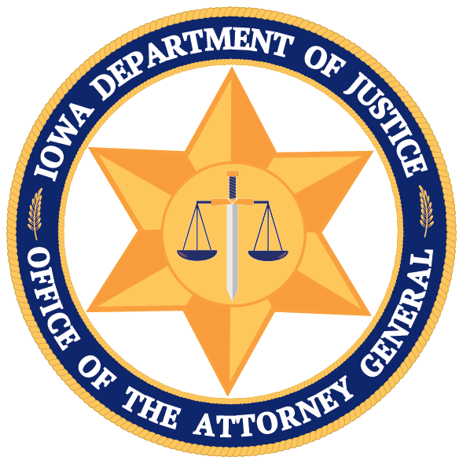
1305 E. WALNUT ST.
DES MOINES, IA 50319
Main: 515-281-5164 Direct: 515-823-9109
Email: Dan.Breitbarth@ag.iowa.gov
www.iowaattorneygeneral.gov
BRENNA BIRD
ATTORNEY GENERAL
DANIEL P. BREITBARTH
ASSISTANT ATTORNEY GENERAL

IOWA DEPARTMENT OF JUSTICE
OFFICE OF THE ATTORNEY GENERAL

SUMMARY: LEGISLATIVE PROPOSAL ON ASSAULTS ON LAW ENFORCEMENT AND FIRST RESPONDERS

Law enforcement don’t get the respect they deserve, certainly not from convicted criminals or those they place under arrest. Derogatory remarks, inappropriate gestures, yelling voices, and all types of assaults are directed their way on a daily basis.

This bill would remind criminals who is in charge, and make the punishment for assaults on law enforcement and our first responders more effective. If passed, it would accomplish the following:
- Increase the level from a “D” to a “C” felony for individuals who commit an assault while using or displaying a dangerous weapon to a first responder or member of law enforcement.
- Increase the level from a “D” to a “C” felony for individuals who commit an assault with the intent to inflict a serious injury to a first responder or member of law enforcement.
- Increase the level from an aggravated misdemeanor to a “D” felony for individuals who commit an assault and cause bodily injury to a first responder or member of law enforcement.
- Increase the level from a serious to an aggravated misdemeanor for individuals who commit all other assaults, including spitting, to a first responder or member of law enforcement. In addition, adds a mandatory minimum term of 7 days jail.
- Includes “saliva” on the list of bodily fluids like urine & feces that constitute an inmate assault against jail or department of corrections staff.

It is unacceptable for individuals convicted of crimes or those being arrested for crimes to spit, hit, or commit any other assault to members of law enforcement or our first responders. A previously underutilized section of code becomes more widely applicable with the above changes.

