567—102.104(455B) Application site restrictions.
102.104(1) The waste shall not be applied to soils classified as sand, loamy sand, or silt on the United States Department of Agriculture (USDA) textural classification chart, 1951 Soil Survey Manual, USDA Handbook No. 18.
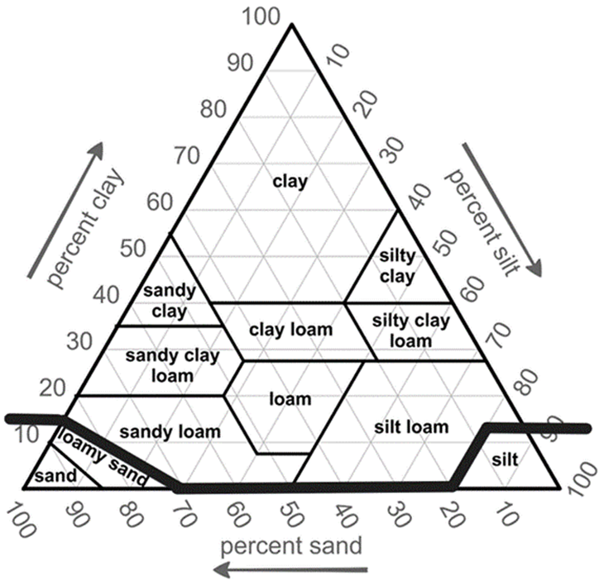
USDA textural classification chart. Sand size particles, 2-0.05 mm;
silt-sized particles, 0.05-.002 mm; and clay sized particles, less than .002 mm.
102.104(2) Land application sites shall have soil pH maintained above 6.0 unless otherwise specified in a permit. If the soil pH is below these levels, it is acceptable to use agricultural lime to increase the pH to an acceptable level prior to land application of sludge.
102.104(3) The waste shall not be applied to ground having greater than 9 percent slope unless specific permit conditions specify otherwise.
102.104(4) If the waste is applied to land subject to flooding more frequently than once in ten years, the waste shall be injected or shall be applied to the surface and mechanically incorporated into the soil within 48 hours.
102.104(5) Application on frozen or snow-covered ground shall be limited to areas of less than 5 percent slope unless specific permit conditions specify otherwise.
102.104(6) Waste shall not be applied within 200 feet of an occupied residence nor within 500 feet of a well that is part of a public water supply, as defined in 567—subrule 40.2(1), or 200 feet of all other wells.
102.104(7) Waste shall not be applied to land used for growing crops that may be consumed by humans without prior heating or processing or those that are commonly available to the public in raw form unless crops grown on the land are not harvested for at least 14 months following land application.
102.104(8) A site shall not be used for land application of waste from more than one generator in the same growing season or for a spring land application after land application the previous fall.
[ARC 0483D, IAB 8/19/26, effective 9/23/26]

