567—101.8(455B) Groundwater monitoring and reporting.
101.8(1) The planning, monitoring, and reporting for groundwater monitoring at a sanitary landfill shall be performed by a qualified groundwater scientist.
101.8(2) Monitoring wells must be constructed and cased by a well contractor certified pursuant to 567—Chapter 82 in a manner that maintains the integrity of the monitoring well borehole. This casing must be screened or perforated and packed with gravel or sand, where necessary, to enable collection of groundwater samples. The annular space (i.e., the space between the borehole and well casing) above the sampling depth must be sealed to prevent contamination of samples and the groundwater. Monitoring wells constructed in accordance with the rules in effect at the time of construction shall not be required to be abandoned and reconstructed as a result of subsequent amendments to these rules unless the department finds that the well is no longer providing representative groundwater samples. Figure 1 contains a general diagram of a properly constructed monitoring well.
a. The owner or operator must notify the department that the design, installation, development, and decommission of any monitoring wells; piezometers; and other measurement, sampling, and analytical devices documentation has been placed in the operating record.
b. The monitoring wells; piezometers; and other measurement, sampling, and analytical devices must be operated and maintained so that they perform to design specifications throughout the life of the monitoring program.
c. Each groundwater monitoring point must have a unique and permanent number, and that number must never change or be used again at the sanitary landfill. The types of groundwater monitoring points shall be identified as follows:
(1) Monitoring wells by “MW# (insert unique and permanent number)”.
(2) Piezometers by “PZ# (insert unique and permanent number)”.
(3) Groundwater underdrain systems by “GU# (insert unique and permanent number)”.
d. Monitoring well construction shall comply with the following requirements:
(1) In all phases of drilling, well installation, and completion, the methods and materials used shall not introduce substances or contaminants that may alter the results of water quality analyses.
(2) Drilling equipment that comes into contact with contaminants in the borehole or aboveground shall be thoroughly cleaned to avoid spreading contamination to other depths or locations. Contaminated materials or leachate from wells must not be discharged onto the ground surface or into waters of the state so as to cause harm in the process of drilling or well development.
(3) The owner or operator must ensure that, at a minimum, the well design and construction log information is maintained in the facility’s permanent record on a form prescribed by the department and that a copy is sent to the department.
e. Monitoring well casings shall comply with the following requirements:
(1) The diameter of the inner well casing (e.g., Figure 1) of a monitoring well shall be at least two inches.
(2) Plastic-cased wells shall be constructed of materials with threaded and non-glued joints that do not allow water infiltration under the local subsurface pressure conditions and when the well is evacuated for sampling.
(3) Well casing shall provide sufficient structural stability so that a borehole or well collapse does not occur. Flush joint casing is required for small diameter wells installed through hollow stem augers.
f. Monitoring well screens shall comply with the following requirements:
(1) Slot size shall be based on sieve analysis of the sand and gravel stratum or filter pack. The slot size must keep out at least 90 percent of the filter pack.
(2) Slot configuration and open area must permit effective development of the well.
(3) The screen shall be no longer than ten feet in length, except for water table wells, in which case the screen shall be of sufficient length to accommodate normal seasonal fluctuations of the water table. The screen shall be placed five feet above and below the observed water table unless local conditions are known to produce greater fluctuations. Screen length for piezometers shall be two feet or less. Multiple-screened, single-cased wells are prohibited.
g. Monitoring well filter packs shall comply with the following requirements:
(1) The filter pack shall extend at least 18 inches above and 12 inches below the well screen.
(2) The size of the filter pack material shall be based on sieve analysis when sand and gravel are screened. The filter pack material must be 2.5 to 3 times larger than the 50 percent grain size of the zone being monitored.
(3) In stratum that is neither sand nor gravel, the size of the filter pack material shall be selected based on the particle size of the zone being monitored.
h. Monitoring well annular space shall comply with the following requirements:
(1) Grouting materials must be installed from the top of the filter pack up in one continuous operation with a tremie tube.
(2) The annular space between the filter pack and the frostline must be backfilled with bentonite grout.
(3) The remaining annular space between the protective casing and the monitoring well casing must be sealed with bentonite grout from the frostline to the ground surface.
i. Monitoring well heads shall be protected as follows:
(1) Monitoring wells shall have a protective metal casing installed around the upper portion of the monitoring well casing as follows:
1. The inside diameter of the protective metal casing shall be at least two inches larger than the outer diameter of the monitoring well casing.
2. The protective metal casing shall extend from a minimum of one foot below the frostline to slightly above the well casing top; however, the protective casing shall be shortened if such a depth would cover a portion of the well screen.
3. The protective casing shall be sealed and immobilized with a concrete plug around the outside. The bottom of the concrete plug must extend at least one foot below the frostline; however, the concrete plug shall be shortened if such a depth would cover a portion of the well screen. The top of the concrete plug shall extend at least three inches above the ground surface and slope away from the well. Soil may be placed above the plug and shall be at least six inches below the cap to improve runoff.
4. The inside of the protective casing shall be sealed with bentonite grout from the frostline to the ground surface.
5. A vented cap shall be placed on the monitoring well casing.
6. A vented, locking cap shall be placed on the protective metal casing. The cap must be kept locked when the well is not being sampled.
(2) All monitoring wells shall have a ring of brightly colored protective posts or other protective barriers to help prevent accidental damage.
(3) All monitoring wells shall have a sign or permanent marking clearly identifying the permanent monitoring well number (MW#).
(4) Run-on shall be directed away from all monitoring wells.
j. Well development is required prior to the use of the monitoring well for water quality monitoring purposes. Well development must loosen and remove fines from the well screen and gravel pack. Any water utilized to stimulate well development must be of sufficient quality that future samples are not contaminated. Any gases utilized in well development must be inert gases that will not contaminate future samples. Following development, the well shall be pumped until the water does not contain significant amounts of suspended solids.
101.8(3) Groundwater monitoring points that are no longer functional must be sealed. Groundwater monitoring points that are to be sealed and are in a future waste disposal area shall be reviewed to determine if the method utilized to seal the monitoring point needs to be more protective than the following requirements. All abandoned groundwater-monitoring points (e.g., boreholes, monitoring wells, and piezometers) shall be sealed by a well contractor certified pursuant to 567—Chapter 82 and in accordance with the following requirements.
a. The following information shall be placed in the operating record on a form prescribed by the department and a copy sent to the department:
(1) The unique, permanent monitoring point number.
(2) The reasons for abandoning the monitoring point.
(3) The date and time the monitoring point was sealed.
(4) The method utilized to remove monitoring point materials.
(5) The method utilized to seal the monitoring point.
b. The monitoring point materials (e.g., protective casing, casing, screen) shall be removed. If drilling is utilized to remove the materials, then the drilling shall be to the maximum depth of the previously drilled monitoring point. All drilling debris shall be cleaned from the interior of the borehole.
c. The cleared borehole shall be sealed with impermeable bentonite grout via a tremie tube. The end of the tremie tube shall be submerged in the grout while filling from the bottom of the borehole to the top of the ground surface. Uncontaminated water shall be added from the surface as needed to aid grout expansion.
d. After 24 hours, the bentonite grout shall be retopped if it has settled below the ground surface.
101.8(4) Groundwater samples shall not be field-filtered prior to laboratory analysis.
Figure 1 – Typical Monitoring Well Cross-Section
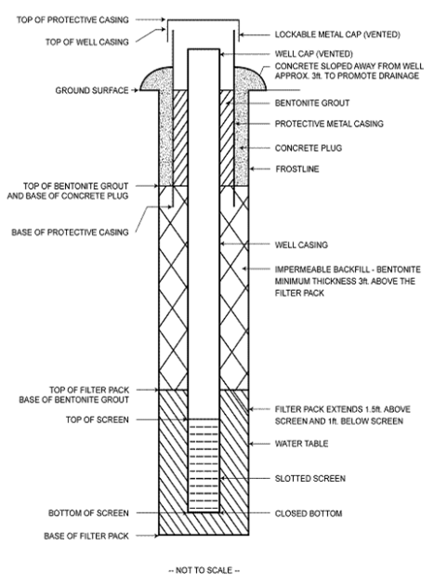
[ARC 0482D, IAB 8/19/26, effective 9/23/26]

