761—450.3(321) Mud and snow tire. A mud and snow tire is a tire that is designed to provide additional starting, stopping and driving traction in mud and snow. The tread design shall have ribs, lugs, blocks or knobs which are discontinuous and have a minimum separation of one-eighth of an inch between the ribs, lugs, blocks or knobs. A substantial portion of the rib, lug, block or knob edge in the design of the tread shall be at an angle greater than 30 degrees to the periphery centerline. A mud and snow tire must comply with the tire restrictions expressed in Iowa Code section 321.440.
A tire labeled “Mud and Snow” or any contraction using the letters “M” and “S,” such as “MS,” “M/S,” “M-S” or “M & S” shall be considered a mud and snow tire.

A representation of the distinguishing features of a mud and snow tire is pictured below.

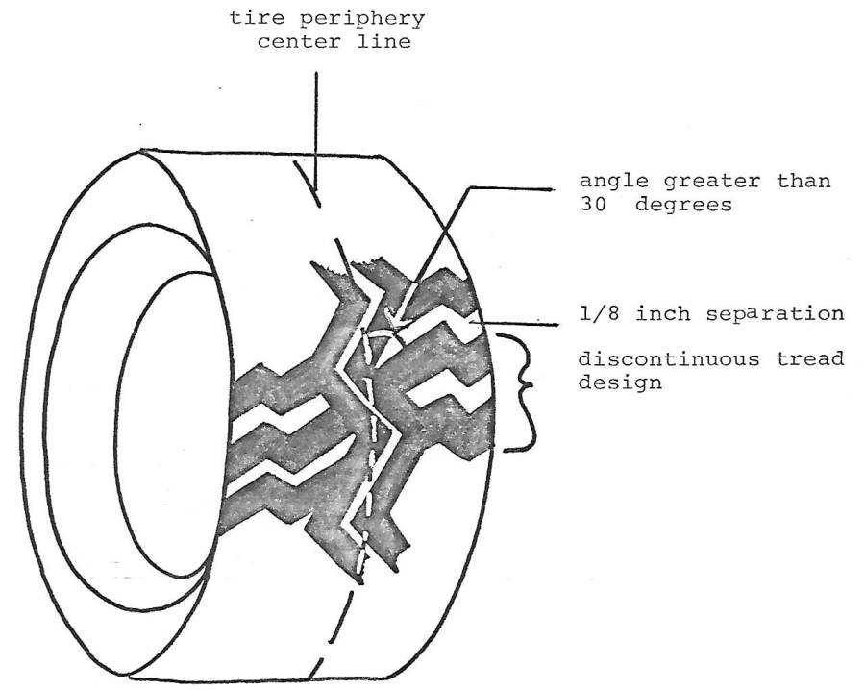
This rule is intended to implement Iowa Code subsection 321.236(12).

