CHAPTER 920
STATE TRANSIT ASSISTANCE
[Prior to 6/3/87, Transportation Department [820]—(09,B)Ch 1]
Chapter rescission date pursuant to Iowa Code section 17A.7: 5/20/31
761—920.1(324A) Statement of policy. State financial assistance to any public transit system is restricted to joint projects with the department that hold substantial promise of accomplishing the following goals:
920.1(1) Development, maintenance and improvement of transit services for the general public and for transportation disadvantaged persons.
920.1(2) Protection of the rights of private enterprise public transit providers, especially those providing intercity scheduled services on fixed routes.
920.1(3) Improvement of transit system effectiveness and efficiency.
[ARC 0221D, IAB 4/15/26, effective 5/20/26]
761—920.2(324A) General information. The department will post annually the required forms and instructions for applying for state transit assistance through an online portal furnished to the transit systems by the department and notify each public transit system in Iowa of the availability. Requests for assistance and questions about application preparation should be directed to: Modal Transportation Bureau, Iowa Department of Transportation, 800 Lincoln Way, Ames, Iowa 50010; telephone 515.233.7870. For more information, visit www.iowadot.gov/modes-travel/transit.
[ARC 0221D, IAB 4/15/26, effective 5/20/26]
761—920.3(324A) Definitions. The definitions in Iowa Code section 324A.1, except for the definition of “urban transit system,” apply to this chapter. In addition:
“Formula assistance” means state transit assistance appropriations minus funds reserved for special projects.
“Operating deficit” means the funding gap remaining after subtracting the passenger revenues from the service’s operating costs.
“Project” means a concerted set of actions that will develop, maintain, or improve one or more elements of the public transit system’s service.
“Urban transit system” means a system designated by the department that meets the requirements of Iowa Code section 324A.1(8). To be designated as an urban transit system for the purposes of this chapter, the system must serve a city or urbanized area with a population of 20,000 or more. The system also must be managed by a board of local officials who have either been elected by the public or appointed by elected officials, and who are responsible for policy and oversight of transit services for one or more incorporated areas within Iowa.
[ARC 0221D, IAB 4/15/26, effective 5/20/26]
761—920.4(324A) Types of projects.
920.4(1) Formula projects. A formula project may involve operations assistance, capital assistance, planning or any combination of the three. These projects are developed with input from the appropriate planning agencies and shall ensure public participation and discussion.
920.4(2) Special projects.
a. Special projects are extraordinary, emergency or innovative in nature and may include but are not limited to the following purposes:
(1) Expanding the scope of planning, managerial, or technical expertise.
(2) Increasing the public’s awareness and understanding of transit.
(3) Enhancing the capacity for administration consolidation and service coordination.
(4) Reducing impediments to intramodal or intermodal transfers.
(5) Increasing the cooperation and coordination between private and public sectors.
(6) Developing, demonstrating, or refining a technical, procedural, or mechanical innovation that may be utilized by other public transit systems in Iowa.
(7) Responding to an emergency situation that places an extraordinary and unforeseen strain on the resources of a public transit system.
b. Applications for training fellowships may be submitted to the department at any time.
c. Applications for special projects are due to the department by October 1 each year. The department may announce to the public transit systems the acceptance of special project applications at other times of the year if unobligated funds are available.
[ARC 0221D, IAB 4/15/26, effective 5/20/26]
761—920.5(324A) Standards for projects.
920.5(1) Requirements for transit system. A public transit system is eligible for project assistance if the system is in compliance with all the following criteria. The transit system:
a. Abides by all applicable state and federal laws and regulations.
b. Maintains primary documentation for all revenues and expenses for a period of at least three years after contract closeout.
c. Maintains the system’s policies, routes, schedules, fare structure and budget in a manner that encourages public review, responsiveness to user concerns, energy conservation and fiscal solvency.
d. Received departmental approval of the system’s plan or schedule for repayment of any loan administered by the department.
e. Accurately reports all services to be supported with project formula assistance and ensures that all services are open to the general public.
920.5(2) Project conditions. The department will obligate state transit assistance for joint projects that meet the following criteria:
a. Each project must be included in the current year of the locally adopted transportation improvement program.
b. Each project shall contain payment criteria, through the contract, which are mutually agreed upon by the department and the contracting officer of the transit system.
c. Each special project shall have a preestablished basis for determining success using a specified means of performance measurement and include a detailed budget of the resources available and the assistance necessary for implementation.
d. State assistance for a special project involving capital expense shall not exceed 85 percent of the project’s total capital expense. State assistance for a special project involving operating support shall not exceed 80 percent of the project’s total operating deficit in the first year and 50 percent of the project’s total operating deficit in the second year.
920.5(3) Items not eligible for assistance.
a. Administrative, operations or capital expenses that are determined by the department to be inconsistent with department policies, public law, officially approved planning and programming documents or inconsistent with the purpose of improving the effectiveness and quality of transit services.
b. Development of managerial, administrative or operational systems that duplicate programs made available at no charge to the transit system by the department.
920.5(4) Determination of system eligibility for formula assistance.
a. Prior to the beginning of each fiscal year, each state-designated public transit system’s formula percentage will be determined through the process shown in the appendix located at the end of this chapter.
(1) Transit system data used in determining formula percentage is based only on services that are open to the general public and is derived from the last fiscal year for which complete information is available.
(2) The process shown in the appendix establishes the percentage of available state transit assistance funds not reserved for special projects for which each transit system is eligible during the fiscal year.
b. The amount of each system’s eligibility for formula assistance from this appropriation will be determined by multiplying the system’s formula percentage by the amount of the appropriation not reserved for special projects.
c. If the dollar amount of state transit assistance is not known until the funds are actually deposited in the state transit assistance account, the amount of each system’s eligibility for formula assistance from these funds will be determined as follows: At the beginning of each month, the system’s formula percentage will be multiplied by the amount of new funds not reserved for special projects that were deposited in the state transit assistance account during the previous month.
d. A transit system’s eligibility for programmed project assistance may be reduced if it is subject to the sanctions outlined in Iowa Code section 324A.5 or 761—Chapter 910.
920.5(5) Determination of amount reserved for special projects. Each fiscal year, at least $300,000 will be reserved from state transit assistance appropriations for special projects. Any special project funds not obligated in the previous fiscal year and any funds made available through closeout of previously approved projects may also be reserved for special projects. Special project funds are distributed by the department on a discretionary basis in accordance with subrule 920.4(2).
[ARC 0221D, IAB 4/15/26, effective 5/20/26]
761—920.6(324A) Processing.
920.6(1) Review and recommendation. The department will review the proposed projects and, based on available funds and the project priorities established by the transit systems, prepare a set of funding recommendations.
920.6(2) Approval and agreement. Upon approval of the projects by the transportation commission, the department will prepare a contract and send it to each public transit system for execution.
920.6(3) Advance payment allowed. Each transit system with a signed contract may be paid formula assistance monthly starting on the execution date of the contract, one-twelfth (or 8.33 percent) of the total contract amount, in advance of project expenditures, if all of the following conditions are met:
a. The transit system included in its application for state transit assistance a request for advance allocations as set forth in Iowa Code section 324A.6.
b. The transit system is current on all reporting required by the department.
c. The transit system is current on all scheduled repayments under loan contracts from the department.
d. The application for advance allocation includes:
(1) The name of the transit system.
(2) A specific statement of the reasons why an advance allocation is required by the transit system.
(3) The signature of the contract officer of the transit system and the date of the signature.
e. The department will give consideration to the following items in determining the approval, disapproval or deferment of advance allocation applications:
(1) The justification submitted with the application pursuant to paragraph 920.6(3)“d.”
(2) The department’s previous experience with the transit system making application, including but not limited to the following:
1. Timeliness of contract and application materials as assessed by the department.
2. Fiscal management capability of the transit system as assessed by the department.
f. If the department defers or disapproves of the transit system’s application for advanced allocation of formula assistance, the department will notify the transit system with reasons for that decision.
g. Any transit system that receives advance allocation payments shall deposit the funds in a separately identified interest-bearing account until such time as the funds are expended on costs incurred by the transit system. All income derived from interest-bearing accounts and investments shall be credited to the transit system and its transit accounts as a nonoperating or nontransportation revenue.
[ARC 0221D, IAB 4/15/26, effective 5/20/26]
761—920.7(324A) Reporting.
920.7(1) Transit systems receiving state transit assistance shall provide quarterly and end-of-the-year financial and statistical reports to the department in the manner and within the time limits described in the state transit assistance contract. These reports shall be made through an online portal furnished to the transit systems by the department.
920.7(2) Failure to file quarterly and end-of-the-year financial and statistical reports by any transit system with the department in the manner and within the time limits described in the state transit assistance contract shall be cause for withholding of state transit assistance payments. The department will notify any transit system of such actions. Withheld state transit assistance payments, both advanced and reimbursement, will resume once the transit system’s required reporting is current.
[ARC 0221D, IAB 4/15/26, effective 5/20/26]
761—920.8(324A) Contract closeout and audits. After the end-of-the-year financial and statistical reports are submitted or after the department has instituted any action(s) for failure to do so, the department will require an audit of the transit system’s books, accounts, records and other material and information necessary to determine contract compliance. The advance allocations paid to the transit system will be taken into consideration and made part of the amount to be audited.
[ARC 0221D, IAB 4/15/26, effective 5/20/26]
These rules are intended to implement Iowa Code chapter 324A.

APPENDIX TO
761—920.5(324A)
LDI | Locally determined income. All transit system revenue dedicated for operations expense during a fiscal year, minus federal operating assistance from the U.S. Department of Transportation and minus all special project operating support and formula assistance funds received from the Iowa Department of Transportation.
OpExp | Operations expense. All eligible transit system expenses related to operating, maintaining, and administering transit operations.
Pass | Passenger. A person boarding a transit vehicle for the purpose of making a trip. A passenger is counted each time that person boards a vehicle for travel to a destination.
RevMi | Revenue miles. Total vehicle miles traveled by revenue vehicles of public transit systems while in revenue service. Excludes miles traveled to and from storage facilities and other deadhead travel.
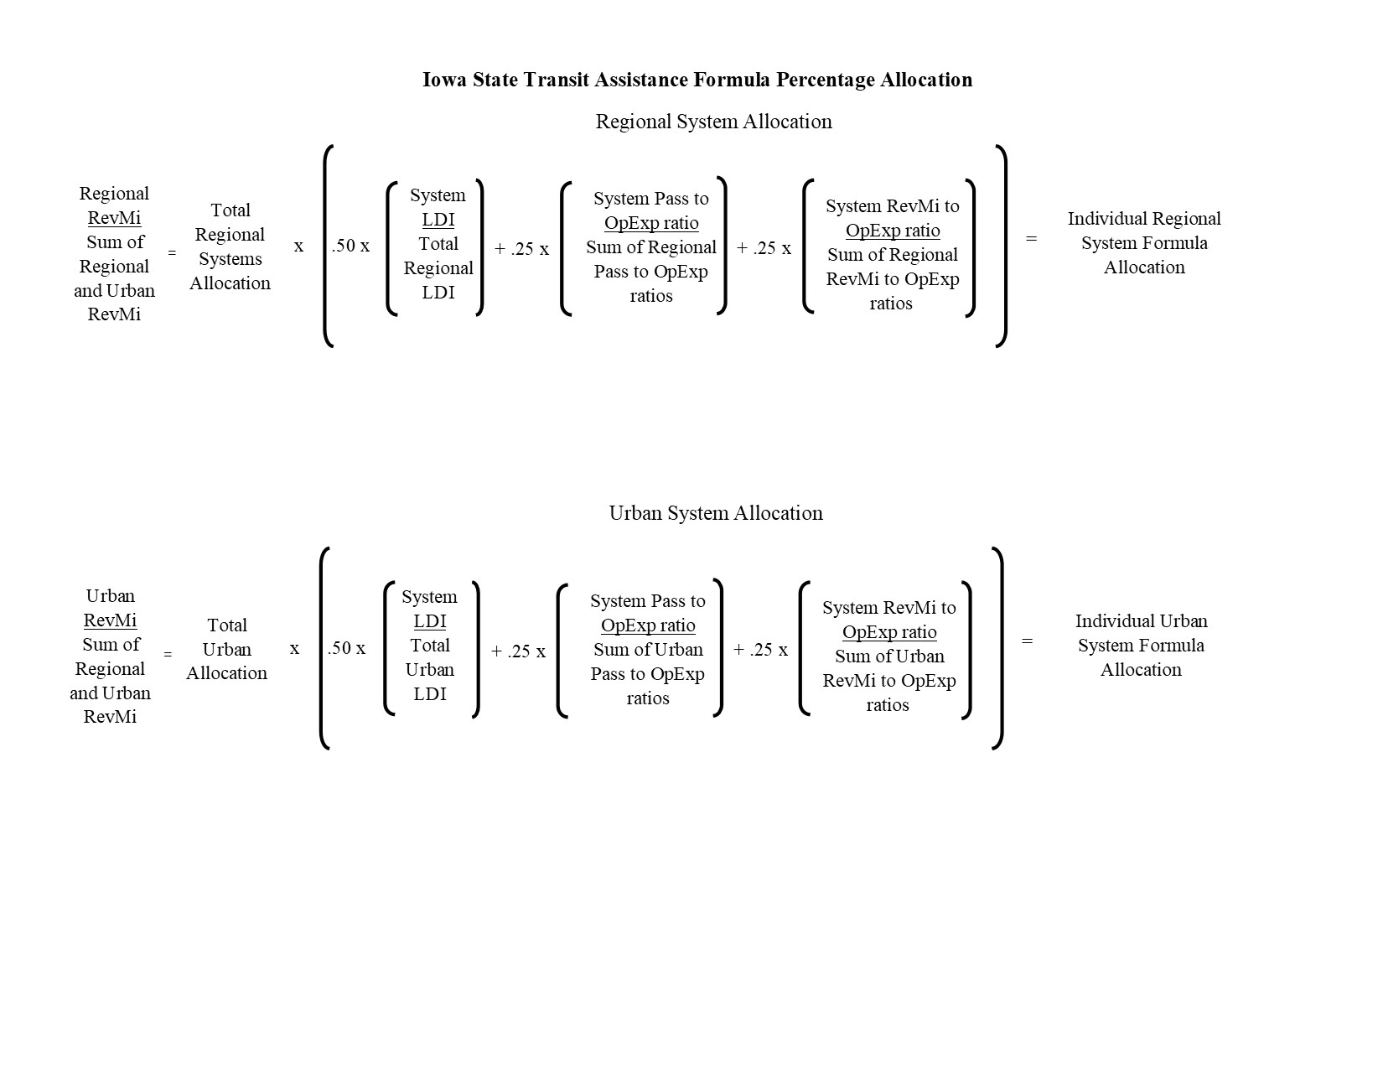
[Filed 9/15/76, Notice 7/26/76—published 10/6/76, effective 11/10/76]
[Filed 2/18/82, Notice 1/6/82—published 3/17/82, effective 4/21/82]
[Filed 4/17/85, Notice 2/27/85—published 5/8/85, effective 6/12/85]
[Filed emergency 12/11/85—published 1/1/86, effective 1/1/86]
[Filed 2/20/86, Notice 1/1/86—published 3/12/86, effective 4/16/86]
[Filed 5/11/87, Notice 3/11/87—published 6/3/87, effective 7/8/87]
[Filed emergency 6/15/89 after Notice 5/3/89—published 7/12/89, effective 7/1/89]
[Filed 9/25/91, Notice 8/21/91—published 10/16/91, effective 11/20/91]
[Filed 1/15/92, Notice 12/11/91—published 2/5/92, effective 3/11/92]
[Filed emergency 7/1/92—published 7/22/92, effective 7/27/92]
[Filed 3/25/94, Notice 2/16/94—published 4/13/94, effective 5/18/94]
[Filed 9/8/94, Notice 7/20/94—published 9/28/94, effective 11/2/94]
[Editorial change: IAC Supplement 2/23/11]
[Filed ARC 3194C (Notice ARC 3034C, IAB 4/26/17), IAB 7/5/17, effective 8/9/17]
[Filed ARC 5497C (Notice ARC 5312C, IAB 12/16/20), IAB 3/10/21, effective 4/14/21]
[Filed ARC 0221D (Notice ARC 9871C, IAB 1/7/26), IAB 4/15/26, effective 5/20/26]

