CHAPTER 26
COUNTING VOTES
Chapter rescission date pursuant to Iowa Code section 17A.7: 1/1/28
PART I—GENERAL PROVISIONS
721—26.1(49) Definitions.
“Blank ballot” means a ballot that contains no votes that can be detected by a tabulating device. See also “unvoted ballot.”
“Hesitation mark” means a small mark made by resting a pen or pencil on the ballot.
“Optical scan voting system” includes a tabulating device that reads ballots by detecting voters’ marks using reflected or absorbed light. An optical scan voting system may be used to count ballots either at the polling place (precinct count) or at a counting center (central count). Optical scan ballots are special paper ballots designed for use with an optical scan voting system.
“Overvote” means to vote for more than the permitted number of choices for any office or question on a ballot.
“Paper ballot” as used in this chapter means a ballot that is intended to be counted only after inspection by precinct election officials. “Paper ballot” in this context means a ballot provided at a precinct that does not have optical scan voting equipment.
“Prescribed mark” means the mark shown in the voting instructions as the appropriate way to mark a vote. “Prescribed mark” includes a close approximation of the mark.
“Question” as used in this chapter includes a public measure as defined by Iowa Code section 39.3(10) and a judicial retention question pursuant to Iowa Code section 46.21.
“Random mark” means a mark on a ballot (other than the prescribed mark) that is used inconsistently, either in or near the voting target or the names of candidates.
“Straight party vote” means a vote cast in the area of the ballot where political parties and nonparty political organizations are listed, pursuant to Iowa Code section 49.37(1).
“Stray mark” means a mark on a ballot that appears to be accidental or appears to be unrelated to the act of filling in the voting target.
“Tabulating device” means the portable apparatus that removes the special paper ballot from the secrecy envelope, examines and counts the votes recorded on the special paper ballot, and produces a paper printout of the results of the voting.
“Undervote” means to vote for fewer than the permitted number of choices for any office or question on a ballot.
“Unvoted ballot” means a ballot that has not been marked in any way. See also “blank ballot.”
“Vote” means the voter’s choice for an office or question on the ballot.
“Voting target” means the place designated on a ballot for the voter to mark the voter’s choice.
“Write-in vote” means a vote cast pursuant to Iowa Code section 49.99 or 52.16.
[ARC 9468B, IAB 4/20/11, effective 5/25/11]
721—26.2(49) Counting votes on election day.
26.2(1) Optical scan—precinct count. Ballots shall be counted at the polling place on election day using the equipment provided. The precinct election officials shall not examine ballots accepted and counted by the tabulating device. After the polls close, the precinct election officials shall:
a. Remove any ballots from the emergency ballot box and insert them into the tabulating device.
b. Examine ballots sorted by the tabulating device because they contain write-in votes and count the write-in votes following the standards in rule 26.20(49).
c. Examine ballots rejected by the tabulating device and abandoned by the voter only if the tabulating device has no override device that permits the officials to reset the tabulating device to accept blank or overvoted ballots. The officials shall follow the standards in rules 26.12(50) through 26.21(49).
26.2(2) Optical scan—absentee and special voters precinct. The ballots shall be counted at a single location on election day as required by Iowa Code section 53.23. When it is necessary to duplicate or enhance a ballot because it is read as blank, the officials shall follow the standards in rules 26.12(50) through 26.21(49).
26.2(3) Paper ballots. Ballots shall be counted at the polling place on election day as provided in Iowa Code chapter 50 or 51, as applicable, according to the standards in Part III.
[ARC 9468B, IAB 4/20/11, effective 5/25/11]
721—26.3(50) Reporting overvotes and undervotes. The reports from computerized voting equipment and canvass summaries for precinct, county and state canvasses of votes shall include the number of overvotes and undervotes for each office and question on the ballot. Undervotes and overvotes shall not be reported on abstracts of votes prepared pursuant to Iowa Code sections 50.24 and 50.39.
EXAMPLE: For a special election, 100 people voted using an optical scan voting system. The printed report from the machine tally of votes should be in substantially the following form:
Number of voters = 100
City Official
Candidate 1 | 24
Candidate 2 | 51
Candidate 3 | 12
Write-in votes | 8
Overvotes | 2
Undervotes | 3
The vote tally portion of the abstract of votes for this office would read as follows:
For the office of city official, there were ninety-five (95) votes cast as follows:
Candidate 1 received twenty-four (24) votes.
Candidate 2 received fifty-one (51) votes.
Candidate 3 received twelve (12) votes.
Scattering received eight (8) votes.
721—26.4(50) Absentee and special voters precinct. The absentee and special voters precinct board shall tabulate ballots in the manner appropriate to the voting equipment, if any has been provided. When an optical scan voting system is used, the board shall follow the procedures in subrule 26.2(2).
[ARC 9468B, IAB 4/20/11, effective 5/25/11]
721—26.5 to 26.9Reserved.
PART II—OPTICAL SCAN VOTING SYSTEMS
721—26.10(50) Systems affected. The following rules apply to all optical scan voting systems in use in Iowa.
721—26.11(50) Examples used. The examples used in this part all show the voting target as an oval on the left-hand side next to each candidate’s name. The same principles demonstrated in the examples apply to other types of voting targets on optical scan ballots.
721—26.12(50) Wrong ballots. Optical scan voting equipment shall be programmed to reject ballots not coded for use in the precinct, as required by 721—subrule 22.201(1). If a recount board appointed pursuant to Iowa Code section 50.48 finds ballots that are coded for a precinct other than the precinct being tabulated, those ballots shall not be counted unless the commissioner or the commissioner’s designee reports that the wrong ballots were delivered to the polling place. The recount board shall immediately report to the commissioner the number of these ballots. The recount board and the commissioner shall securely seal the ballots coded for another precinct and attach to the ballot package a report of the findings. A copy of the report shall be forwarded to the county attorney as a possible violation of Iowa Code section 39A.2(1)“b”(2).
721—26.13(50) Ballot properly marked by the voter. No ballot properly marked by the voter shall be rejected:
1. Because of any discrepancy between the printed ballot and the nomination paper, or certificate of nomination, or certified abstract of the canvassing board.
2. Because of any error in stamping or writing the endorsement thereon by the officials charged with such duties.
3. Because of any error on the part of the officer charged with such duty in delivering the wrong ballots at any polling place.
721—26.14(50) Ballots with identifying marks. The precinct election officials shall reject a ballot if the ballot includes an identifying mark. The following marks shall be considered to be identifying marks:
1. A comment or statement that indicates the identity of the voter either individually or as a member of a group.
2. Initials, a printed name or a signature placed on the ballot in any place other than on the lines intended for write-in votes or intended for the initials of the election official who issued the ballot.
If the ballot has an identifying mark, the precinct election officials shall mark the ballot “Defective due to identifying mark.” The precinct officials in precincts where optical scan voting equipment is used shall tally the votes on all ballots with identifying marks. All of the precinct election officials shall sign the tally. They shall include the tally of ballots with identifying marks in the tally list. The officials shall return the ballots with identifying marks to the commissioner in the envelope or container for disputed ballots as required by Iowa Code section 50.5.
721—26.15(49) Voter’s choice. A vote for any office or question on a ballot shall not be rejected solely because a voter failed to follow instructions for marking the ballot.
26.15(1) If the choice of the voter is clear from the marks for any office or question, the vote shall be counted as the voter has indicated.
26.15(2) If for any reason it is impossible to determine the choice of the voter for any office or question, the vote for that office or question shall not be counted.
721—26.16(49) Determination of voter’s choice.
26.16(1) If a voter uses both the prescribed mark and other marks, only the prescribed marks shall be counted as votes.
EXAMPLE: The voter has used both the prescribed mark and a cross in the voting targets within the same office.
For Board of Supervisors
(Vote for no more than two.)
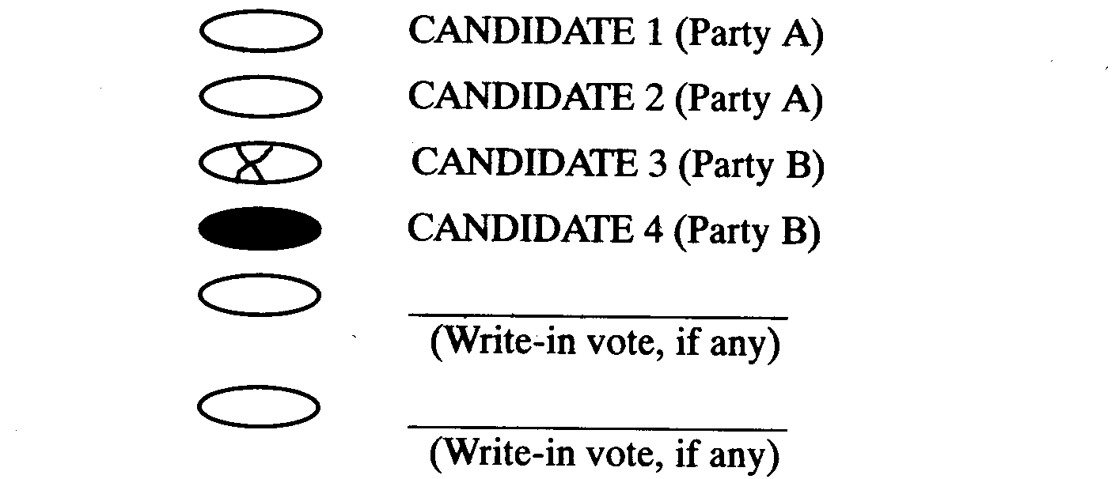
This example shows a vote for CANDIDATE 4. It is not clear from the voter’s mark whether the mark in the oval for CANDIDATE 3 is intended as a vote.
26.16(2) If a voter does not use the mark prescribed in the voting instructions but consistently uses some other mark, the mark shall be counted as a vote if the mark is:
a. In the voting target, or
b. In close proximity to a candidate’s name or to a voting target associated with a candidate’s name or with a “yes” or “no” choice for a ballot question.
721—26.17(49) Marks not counted. The following marks on ballots shall not count as votes:
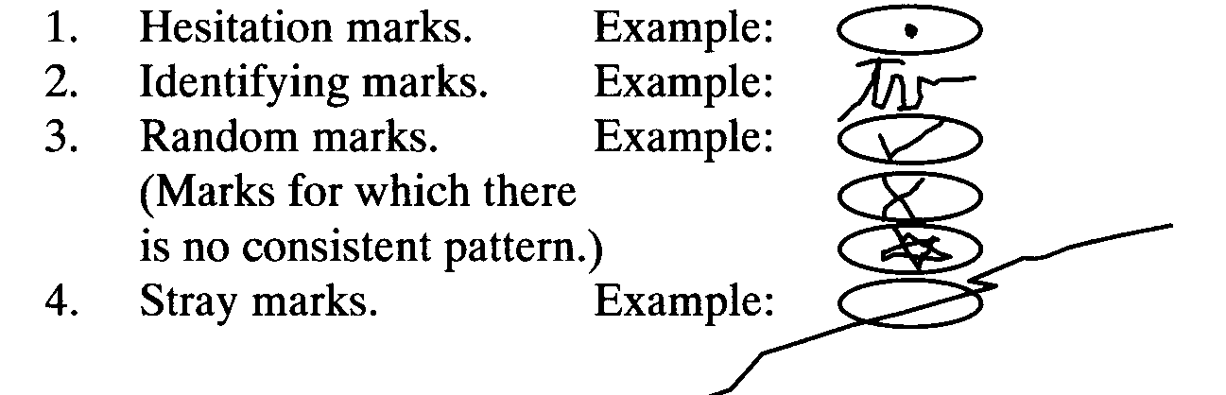
721—26.18(49) Acceptable marks. If the voter uses or places marks on the ballot in a consistent manner as described in subrule 26.16(2), the marks shall be counted as votes. The following marks shall count as votes:
1. The prescribed mark as shown in the voting instructions as the correct manner of marking a vote.
2. A mark that is a close approximation of the prescribed mark but that strays outside the voting target or does not completely fill the voting target. (See Example A of this rule.)
3. Any mark inside the voting target if the mark is consistently used instead of the prescribed mark. This includes a cross, check mark, asterisk, plus sign, diagonal, horizontal, or vertical line or any mark that is substantially contained within the voting target. (See Example B of this rule.)
4. Any mark of the type described in “3” above that is near the name of a candidate or voting target. (See Examples C and D of this rule.)
5. A circle around the voting target for all choices. (See Example E of this rule.)
6. A circle around or a line drawn under the name of the candidate for all choices. (See Example F of this rule.)
7. Names of candidates not crossed out, if the voter has crossed out the names of all candidates except the number (or fewer) to be elected for each office. (See Example G of this rule.)
EXAMPLE A: Close approximations. The voter has consistently marked the ballot by scribbling in the voting targets. The marks do not completely blacken the voting target and one mark strays outside the voting target.
For Board of Supervisors
(Vote for no more than two.)
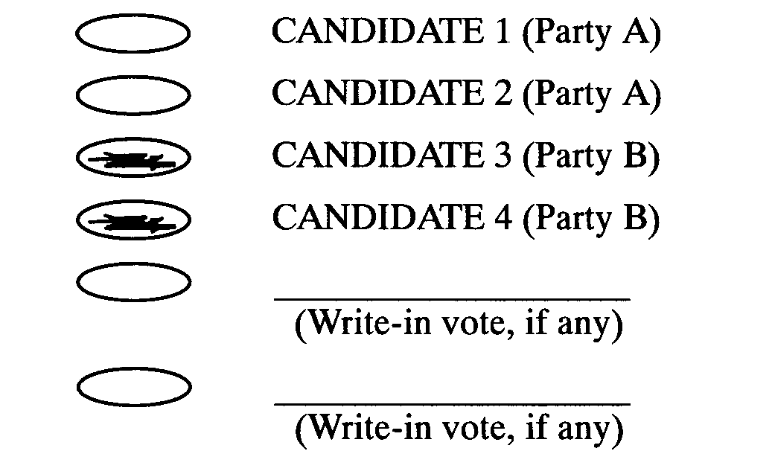
This example shows a vote for CANDIDATE 3 and a vote for CANDIDATE 4. The same principle applies for other voting marks. If the mark used is a close approximation of the prescribed mark, it shall be counted as a vote provided that all other applicable standards are met.

EXAMPLE B: Acceptable mark in the voting target. The voter has consistently marked each choice by putting a check mark in the voting target.
For Board of Supervisors
(Vote for no more than two.)
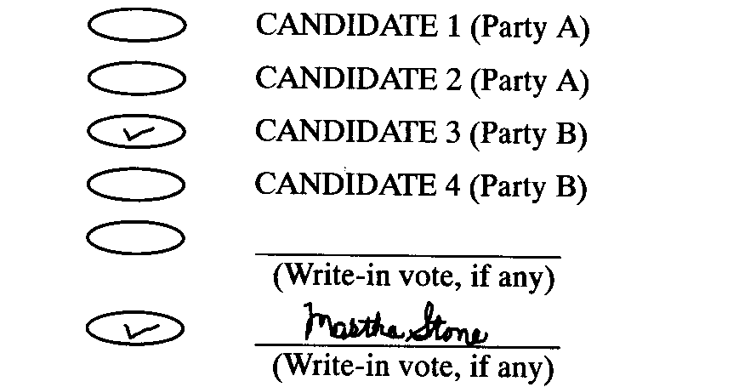
This example shows a vote for CANDIDATE 3 and a vote for the write-in choice, Martha Stone.
EXAMPLE C: Acceptable mark placed near the voting target. The voter has consistently marked each choice by putting a check mark in the space between the voting target and the candidate’s name.
For Board of Supervisors
(Vote for no more than two.)
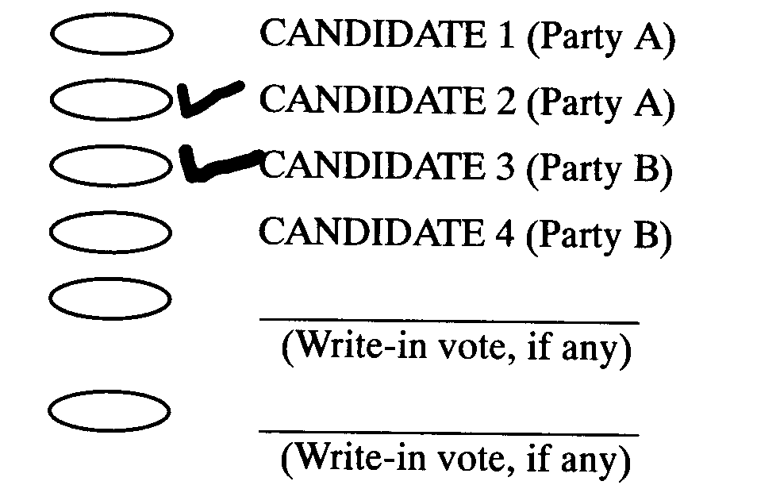
This example shows a vote for CANDIDATE 2 and a vote for CANDIDATE 3.
EXAMPLE D: Acceptable mark placed near a candidate’s name. The voter has consistently marked each choice by putting a check mark behind the candidate’s name.
For Board of Supervisors
(Vote for no more than two.)
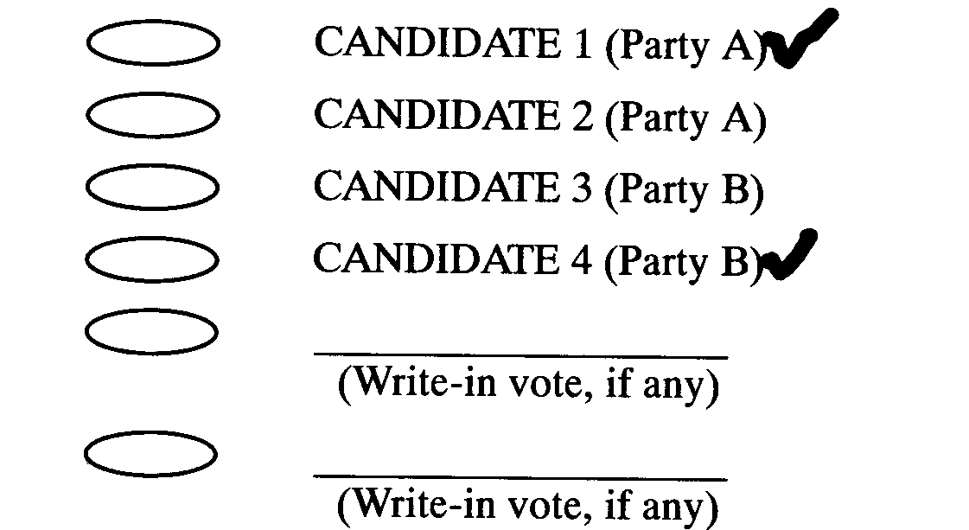
This example shows a vote for CANDIDATE 1 and a vote for CANDIDATE 4.
EXAMPLE E: Choices circled. The voter has consistently marked each choice by circling the voting target.
For Board of Supervisors
(Vote for no more than two.)
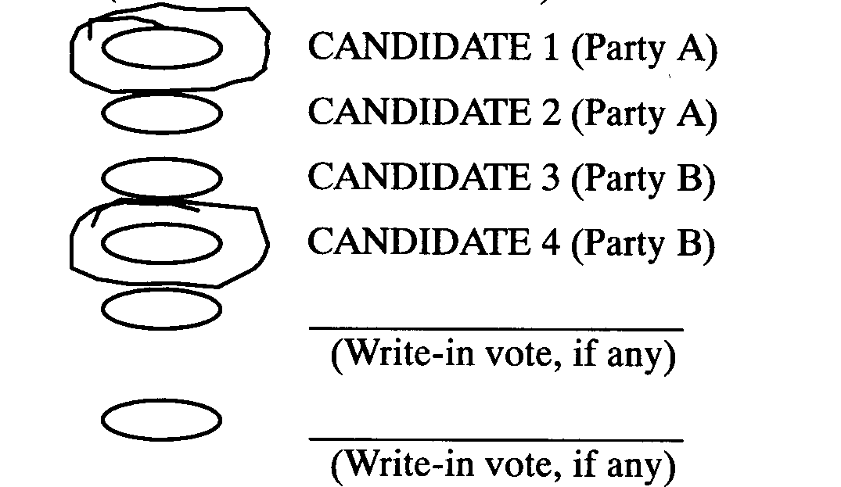
This example shows a vote for CANDIDATE 1 and a vote for CANDIDATE 4.
EXAMPLE F: Choices underlined. The voter has consistently marked each choice by underlining the name of the candidate.
For Board of Supervisors
(Vote for no more than two.)
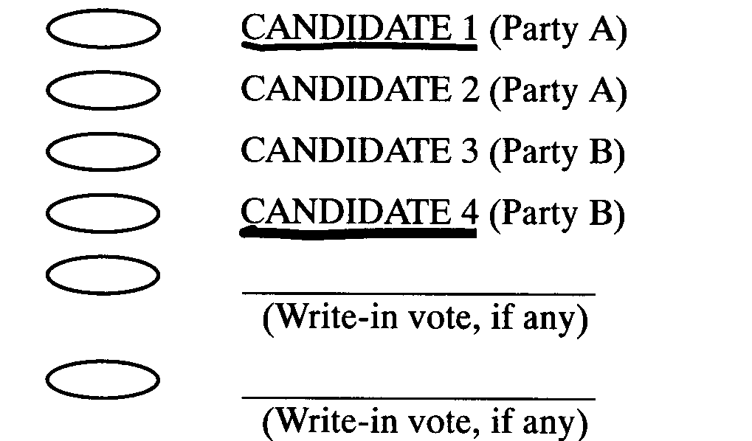
This example shows a vote for CANDIDATE 1 and a vote for CANDIDATE 4.
EXAMPLE G: Choices not crossed out. The voter has consistently marked each choice by crossing out the names of candidates not chosen.
For Board of Supervisors
(Vote for no more than two.)
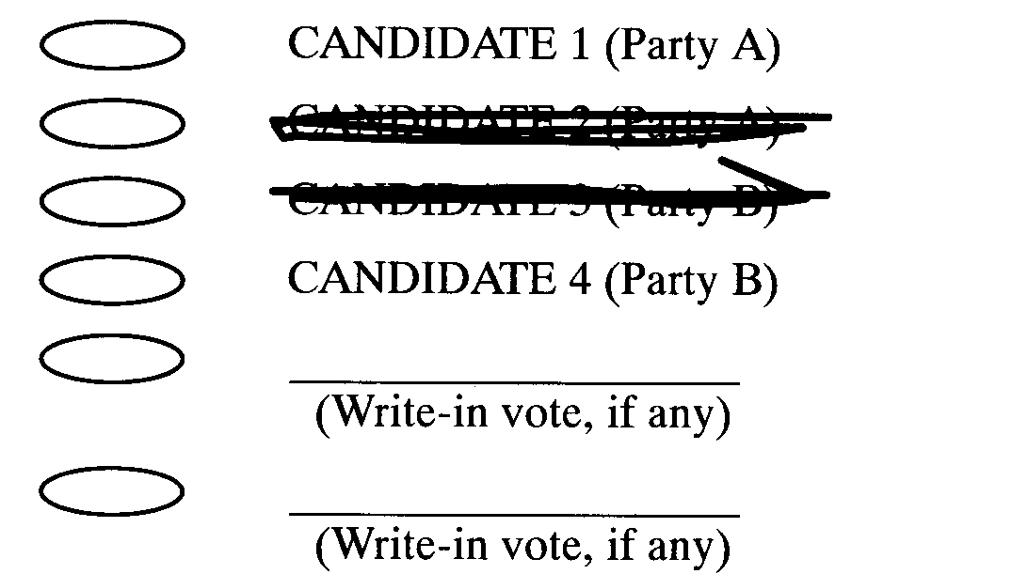
This example shows a vote for CANDIDATE 1 and a vote for CANDIDATE 4.
721—26.19(49) Counting straight party or organization votes. Rescinded ARC 3447C, IAB 11/8/17, effective 12/31/17.
721—26.20(49) Write-in votes.
26.20(1) The precinct election officials and recount board members shall count a write-in vote only if the voting target is marked.
26.20(2) If a voter writes the name of the same person more than once in the proper places on a ballot for an office to which more than one person is to be elected, all but one of those votes for that person for that office are void and shall not be counted.
26.20(3) If a write-in vote duplicates an otherwise correctly cast vote for a candidate whose name appears on the ballot, the write-in vote shall be counted. The ballot has been read as overvoted for this office, and all other votes have been counted by the tabulator.
26.20(4) Write-in votes cast for the office of president and vice president, or for governor and lieutenant governor, shall be tabulated as a single vote for a pair of candidates.
26.20(5) Names. The officials tabulating write-in votes shall disregard misspellings or variations in names or abbreviations for write-in candidates and shall count the variations in the form of the name for a single person if the officials can determine for whom the write-in votes were cast. Write-in votes for fictitious characters shall be tabulated as written.
EXAMPLE A for 26.20(1): Write-in voting target not marked. The voter has not marked the voting target for the write-in votes. Two persons are to be elected to the county board of supervisors.
For Board of Supervisors
(Vote for no more than two.)
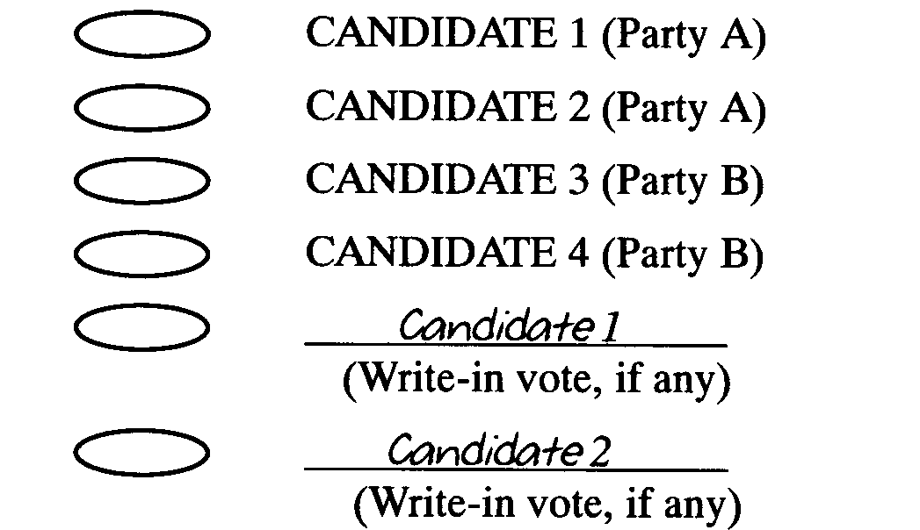
This example does not show a vote. Iowa Code section 49.99 requires voters to mark the voting target for write-in votes on optical scan ballots. If the voting target for a write-in vote is not marked, the vote does not count.
EXAMPLE B for 26.20(1): Write-in voting target not marked. The voter has written in the names on the write-in lines but has not marked the voting targets. Two persons are to be elected to the county board of supervisors.
For Board of Supervisors
(Vote for no more than two.)
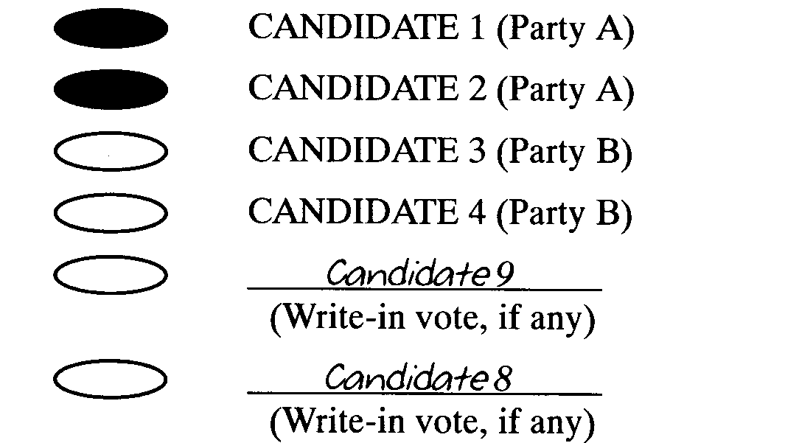
This example shows one vote for CANDIDATE 1 and one vote for CANDIDATE 2. Iowa Code section 49.99 requires voters to mark the voting target for write-in votes on special paper ballots or the votes do not count. These write-in votes have no effect.
EXAMPLE C for 26.20(1): Overvote. The voter has marked the write-in voting target, but has not written a name on the line. Two persons are to be elected to the county board of supervisors.
For Board of Supervisors
(Vote for no more than two.)
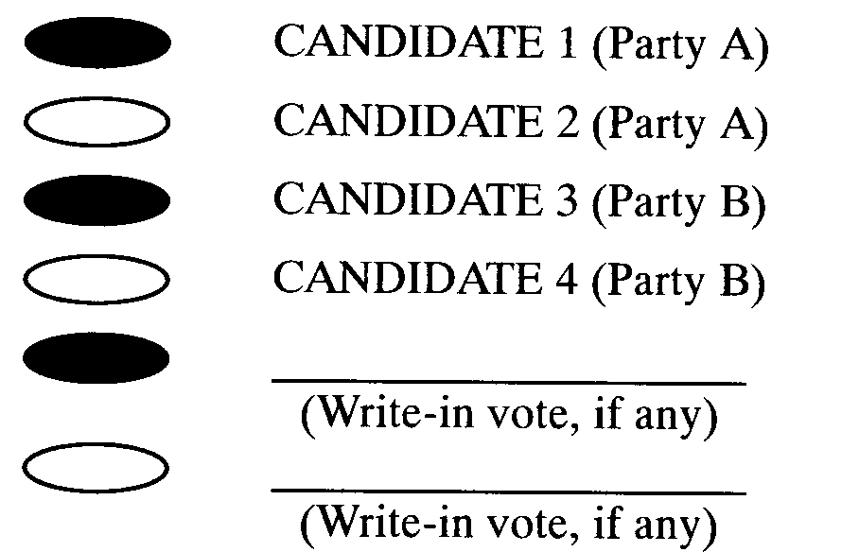
This example shows an overvote. No votes shall be counted for this office. The voter’s choice here can be interpreted in more than one way.
EXAMPLE for 26.20(2): Two write-ins for the same person. The voter has written in the name of the same person on both write-in lines. Two persons are to be elected to the county board of supervisors.
For Board of Supervisors
(Vote for no more than two.)
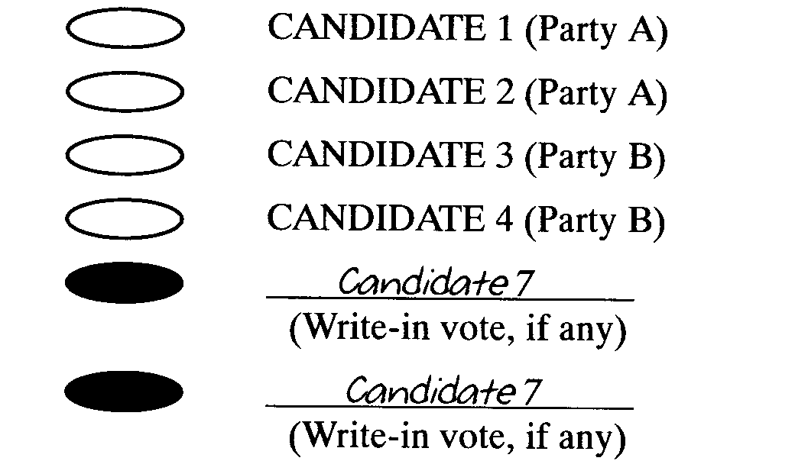
This example shows one vote for Candidate 7. Iowa Code section 49.99 provides that only one vote be counted if a voter writes the name of the same person more than once in the proper places on a ballot for an office to which more than one person is to be elected.
EXAMPLE for 26.20(3): Write-in vote duplicates other votes. The voter has written on the write-in lines the names of the candidates for whom the voter has also marked the voting targets next to the printed names. Two persons are to be elected to the county board of supervisors.
For Board of Supervisors
(Vote for no more than two.)
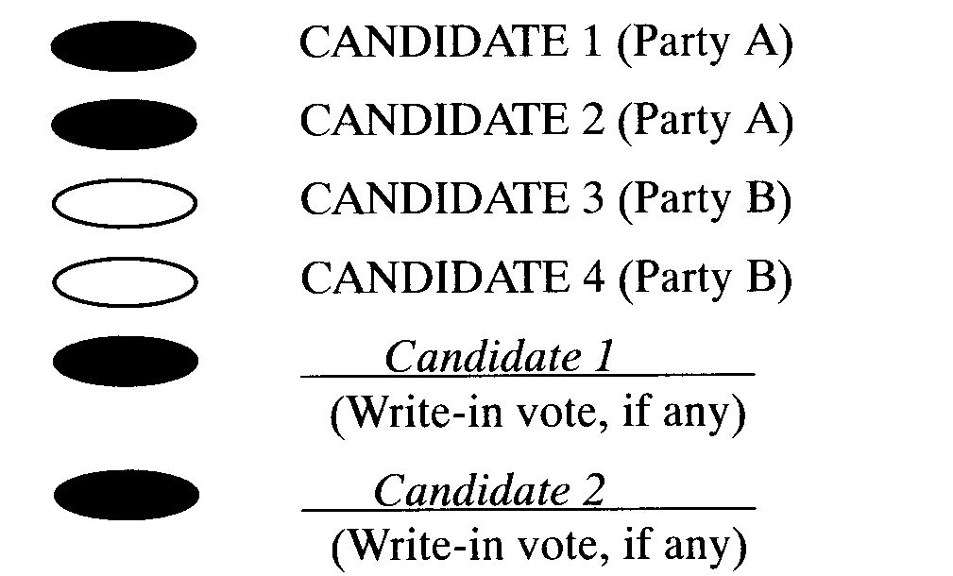
This example shows a vote for CANDIDATE 1 and a vote for CANDIDATE 2. Although the write-in votes duplicate the votes for candidates on the ballot, it is clear that the voter has chosen CANDIDATE 1 and CANDIDATE 2.
EXAMPLE A for 26.20(4): Write-in vote for team on the ballot. The voter has written in the names of the candidates for president and vice president whose names also appear on the ballot.
For President and Vice President
(Vote for no more than one team.)
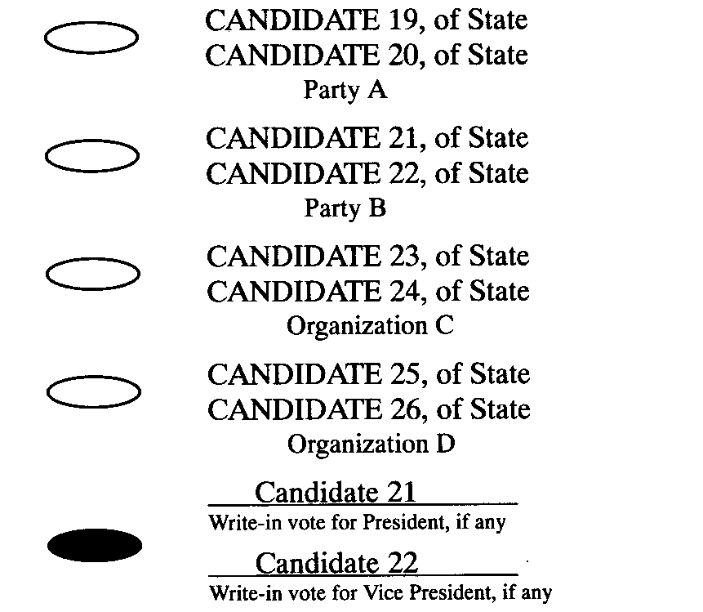
This example shows a vote for the Party B team of Candidate 21 for president and for Candidate 22 for vice president. The voter has clearly chosen this team of candidates.
EXAMPLE B for 26.20(4): Identifying mark with write-in vote for team on the ballot. The voter has written in the names of the candidates for president and vice president whose names also appear on the ballot and has identified the political affiliation of the voter.
For President and Vice President
(Vote for no more than one team.)
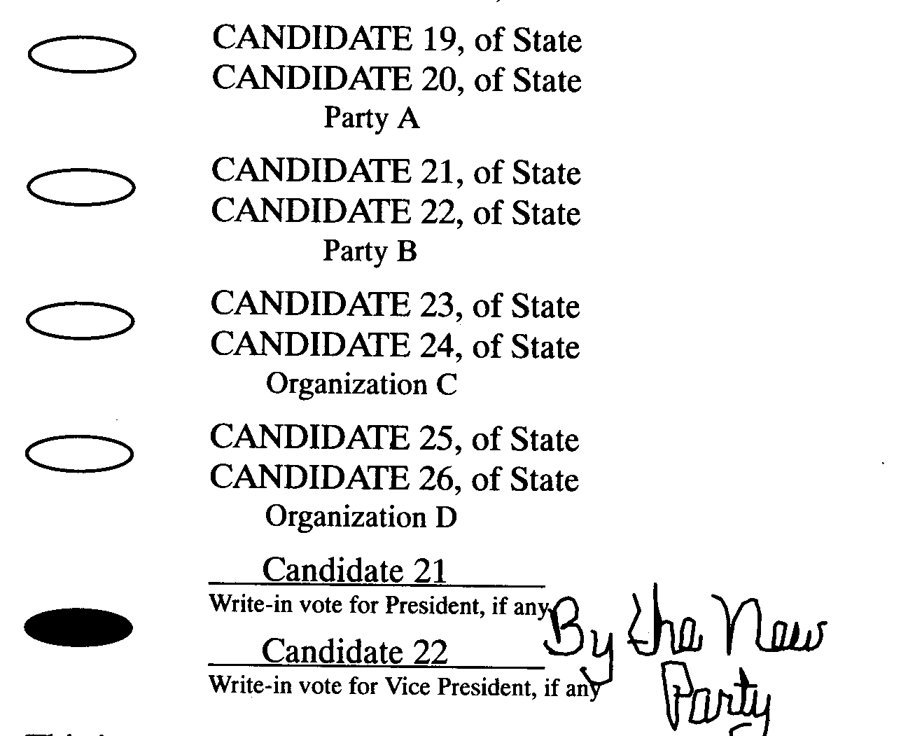
This is not a vote. The political identification next to the write-in lines is an identifying mark, as defined in rule 26.14(50). Do not count any votes on this ballot pursuant to Iowa Code section 39A.4(1)“a”(6) or 49.92. Follow the procedure in rule 26.14(50).
EXAMPLE C for 26.20(4): Write-in vote for part of a team. The voter has written in the name of the presidential candidate of one party and the vice presidential candidate of another.
For President and Vice President
(Vote for no more than one team.)
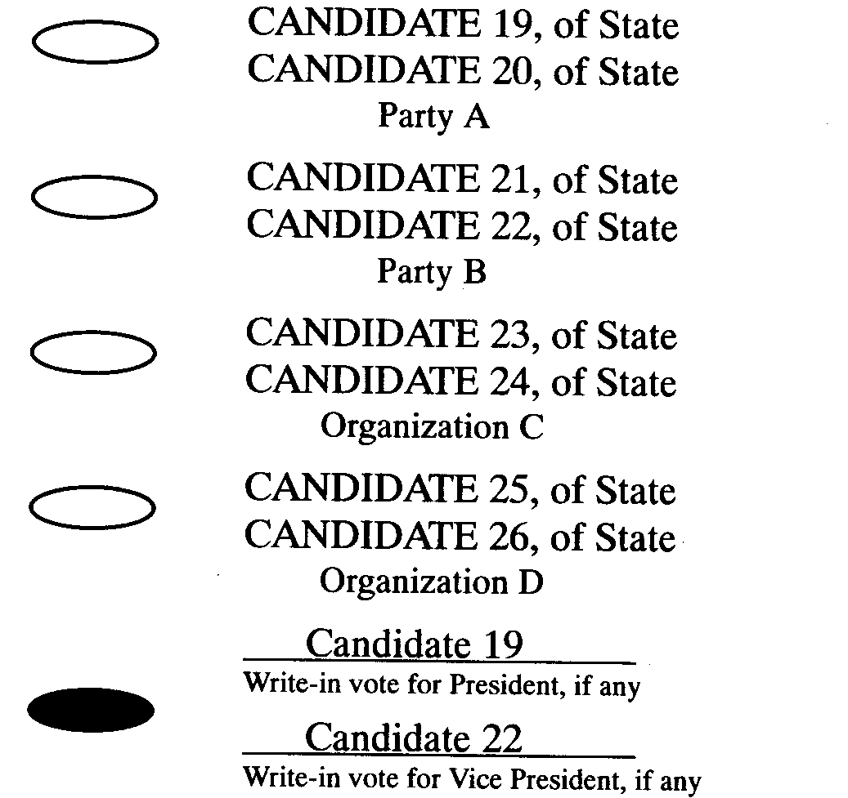
This example shows a vote for the team of Candidate 19 for president and for Candidate 22 for vice president. This does not count as a vote for the president/vice president team of either Party A or Party B.
EXAMPLE D for 26.20(4): Write-in vote for part of a team. The voter has written in the name of the presidential candidate of one party and the name of another person for vice president.
For President and Vice President
(Vote for no more than one team.)
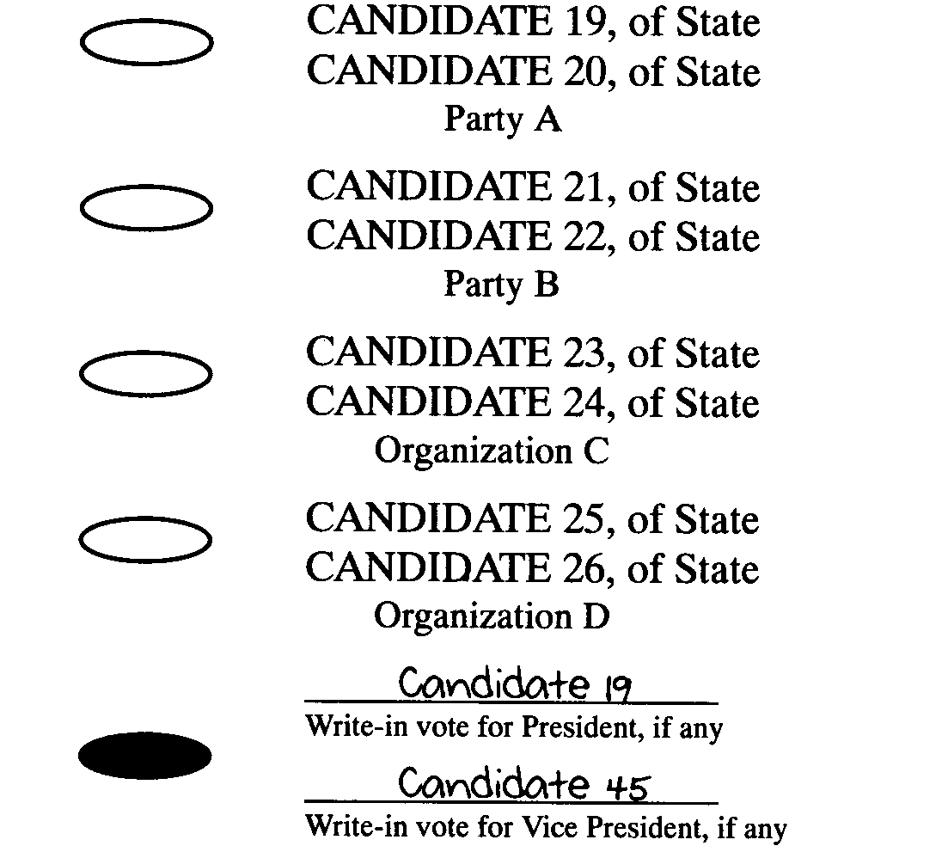
This example shows a vote for the team of Candidate 19 for president (who is also the presidential candidate for Party A) and for Candidate 45 for vice president. This does not count as a vote for the president/vice president team of Party A.
EXAMPLE E for 26.20(4): Write-in vote for president and vice president. The voter has written in votes for president and vice president.
For President and Vice President
(Vote for no more than one team.)
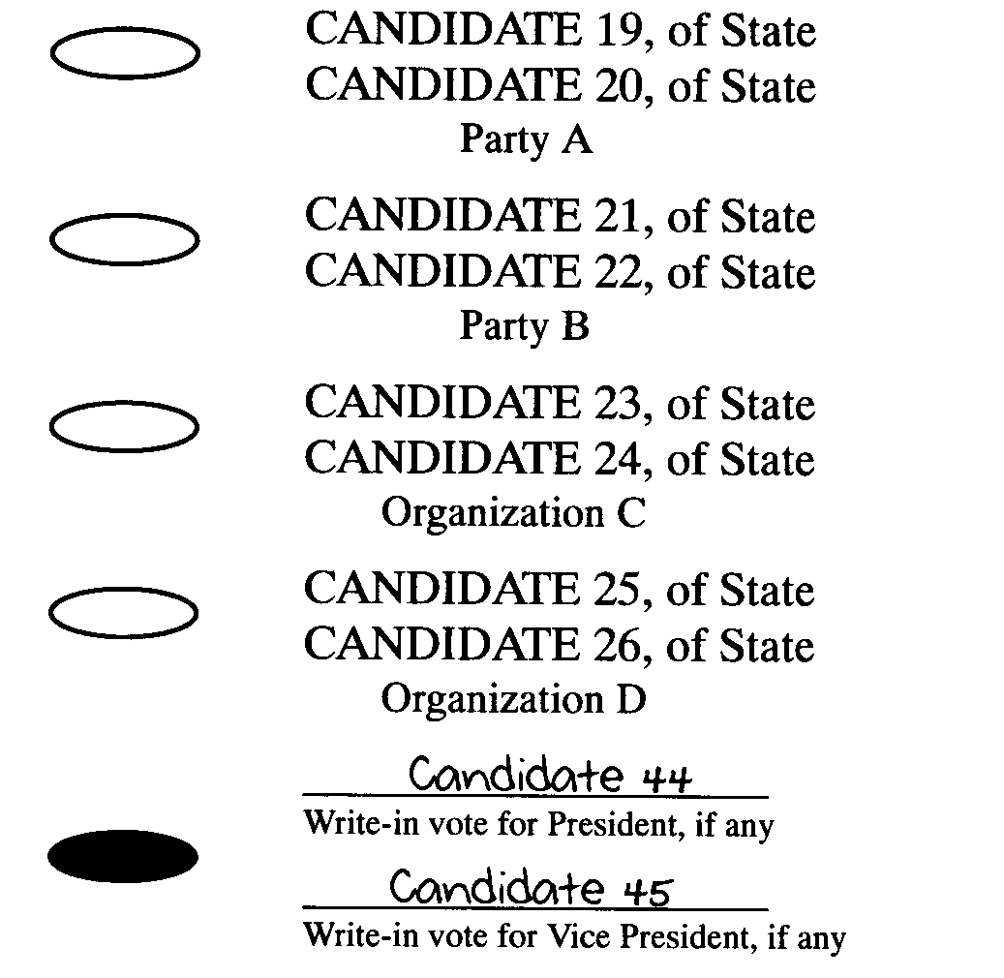
This example shows a vote for the team of Candidate 44 for president and for Candidate 45 for vice president.
EXAMPLE F for 26.20(4): Write-in vote for president and vice president. The voter has written in votes for president and vice president.
For President and Vice President
(Vote for no more than one team.)
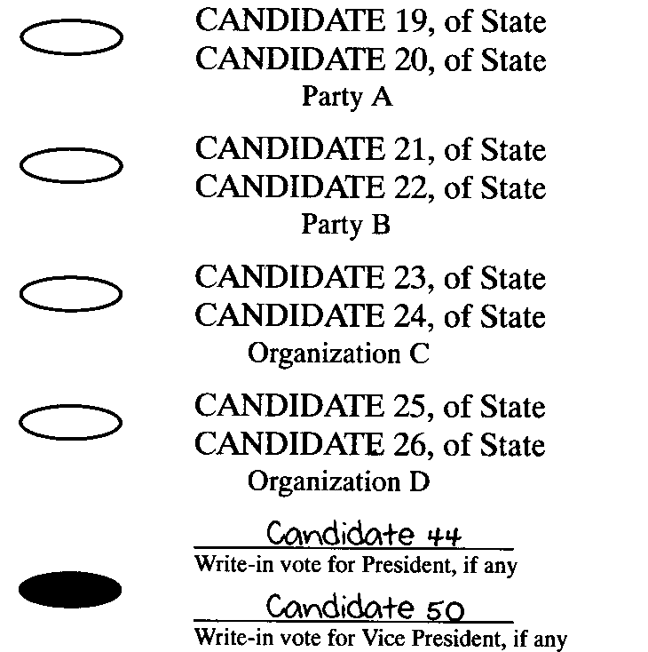
This example shows a vote for the team of Candidate 44 for president and for Candidate 50 for vice president. Even though other write-in votes have been counted for Candidate 44 for president with a different vice presidential teammate, this team is listed and counted separately.
[ARC 9468B, IAB 4/20/11, effective 5/25/11]
721—26.21(49) Corrections by voter. A vote for an office or question shall be counted if the voter has marked the ballot in a manner that will be counted as an overvote by automatic tabulating equipment but the voter has indicated in a clear fashion that the voter has made a mistake. The correction shall be honored if the correction does not include an identifying mark in violation of Iowa Code section 39A.4(1)“a”(6) or 49.92.
EXAMPLE A: Correction. The voter has crossed out the mark for one candidate and has written in the names of two persons on the write-in lines. Two persons are to be elected to the county board of supervisors.
For Board of Supervisors
(Vote for no more than two.)
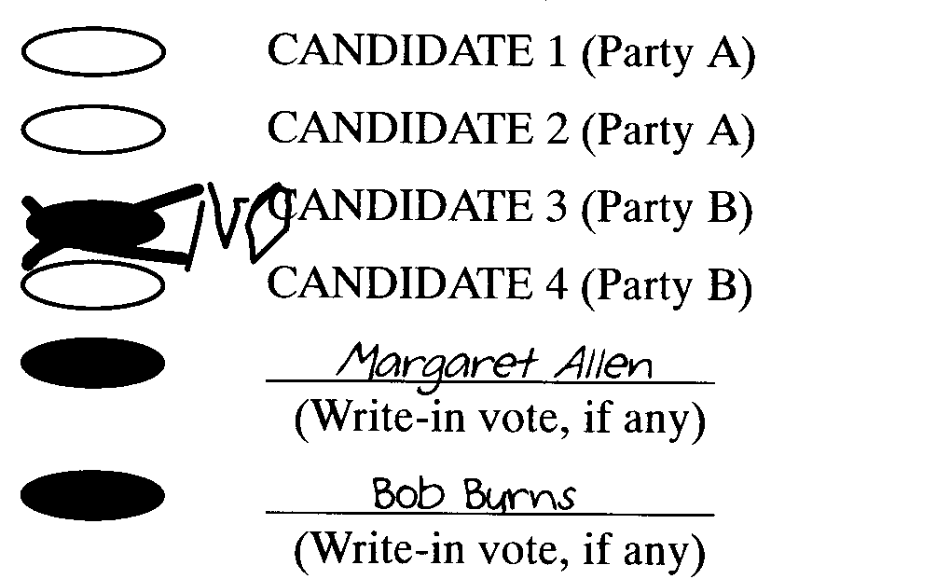
This example shows a vote for Margaret Allen and a vote for Bob Burns. The voter has clearly crossed out the mark for CANDIDATE 3.
EXAMPLE B: Identifying mark. The voter has corrected a mistake by crossing out a marked voting target and has also initialed the correction.
For Board of Supervisors
(Vote for no more than two.)
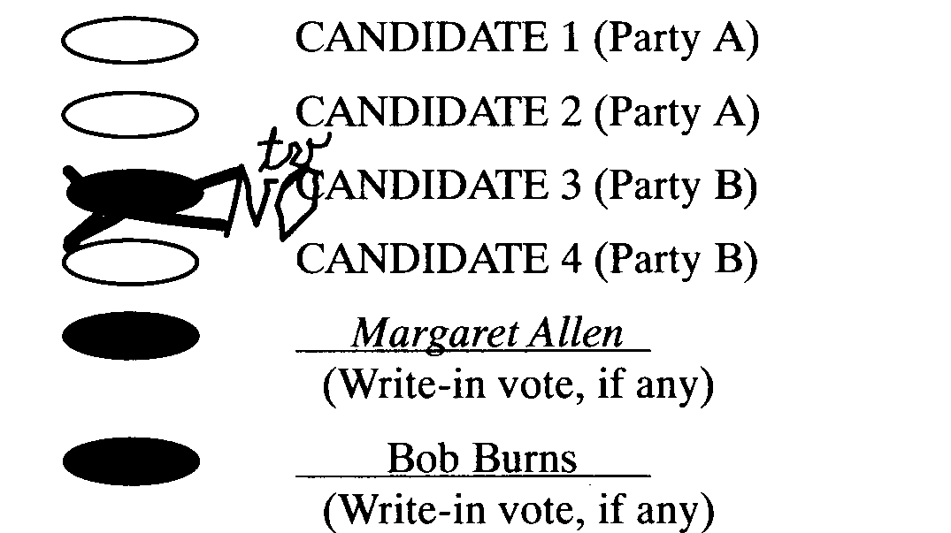
This example does not show a vote. The initials next to the correction identify the voter. Do not count any votes on this ballot pursuant to Iowa Code section 39A.4(1)“a”(6) or 49.92. Follow the procedure in rule 26.14(50).
EXAMPLE C: Erasure. The voter has attempted to erase one marked voting target and has marked another voting target. Two persons are to be elected to the county board of supervisors.
For Board of Supervisors
(Vote for no more than two.)
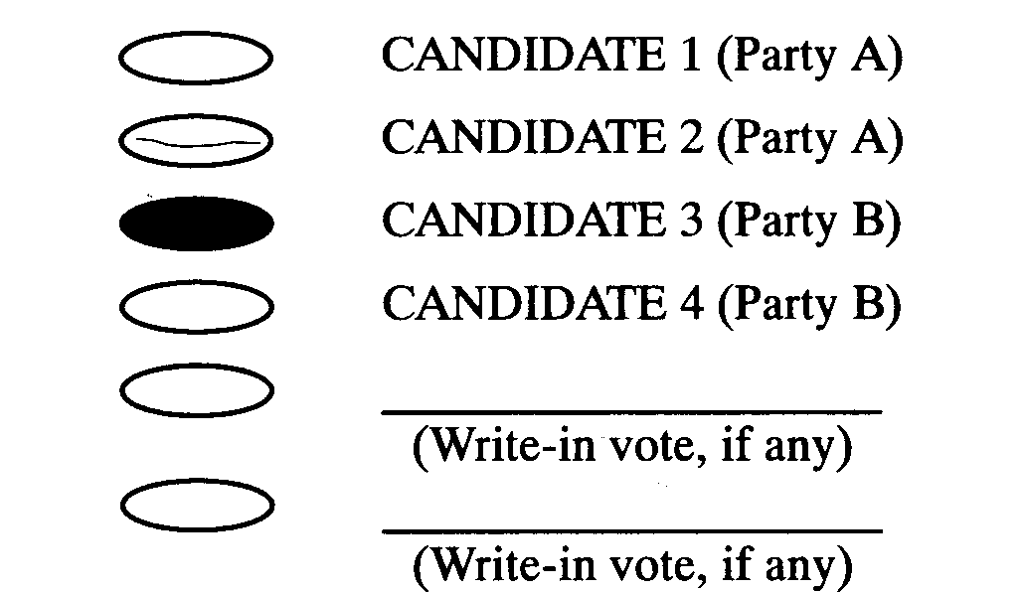
This example shows a vote for CANDIDATE 3. The voter has attempted to erase the mark for CANDIDATE 2. Count this as a vote for CANDIDATE 3.
721—26.22 to 26.49Reserved.
PART III—PAPER BALLOTS
721—26.50(49) Standards. The precinct election officials shall count paper ballots according to the standards for optical scan ballots with the exception that write-in votes shall be counted according to the standards in 26.51(49).
721—26.51(49) Write-in votes. The precinct election officials shall count write-in votes on paper ballots without regard to whether the voter has made a mark opposite the candidate’s name.
721—26.52 to 26.59Reserved.
PART IV—VOTING MACHINES
721—26.60(49) Abandoned ballots. Rescinded IAB 4/20/11, effective 5/25/11.
721—26.61(49) Counting emergency paper ballots. Rescinded IAB 4/20/11, effective 5/25/11.
721—26.62(52) Write-in votes on certain voting machines. Rescinded IAB 8/1/07, effective 7/13/07.
721—26.63 to 26.99Reserved.
PART V—RECOUNTS
721—26.100(50) Requester. Any person who received votes for an office, including the person who received the most votes, may request a recount. If a person who is an apparent winner of an election requests a recount, the person who received the next highest number of votes for that office shall assume the functions of the “apparent winner” as designated in Iowa Code section 50.48. These functions include:
1. Receiving notice of the recount.
2. Designating a member of the recount board.
3. Calculation of bond.
721—26.101(50) Recounts for candidates who run as a team. For the offices of president and vice president of the United States, and for governor and lieutenant governor, either of the two candidates may sign a request for a recount or designate a member of the recount board.
721—26.102(50) Bond. In an election for a jurisdiction that includes more than one county, only one bond is required for each candidate who requests a recount for that office. For state and federal offices, the bond shall be filed with the state commissioner of elections. For other elections, the bond shall be filed with the commissioner responsible for the election under Iowa Code section 47.2(2). If more than one candidate for a multicounty office requests a recount, the bond requirement shall be calculated for each candidate.
721—26.103(50) Recount board. A three-person board shall conduct the recount.
26.103(1) The person requesting the recount shall name one board member in the written request. If more than one person files a request for a recount of the same office in the same county, the board member shall be the designee of the first person who filed.
26.103(2) The apparent winner shall name one board member at or before the time the board is required to convene. If more than one person is to be elected to the office in question, the designation shall be made by the apparent winner who received the fewest votes.
26.103(3) The board members designated pursuant to subrules 26.103(1) and 26.103(2) shall mutually agree upon the third member of the board.
721—26.104(50) Responsibilities of the recount board. Recount boards do not resolve procedural or legal questions about the conduct of the election or the qualifications of voters. The responsibility of a recount board is to tabulate all votes for the office in question on ballots that were counted by the precinct election officials at the election.
26.104(1) Ballots to be recounted. All ballots that were accepted for counting shall be recounted.
a. This includes disputed ballots returned separately pursuant to Iowa Code section 50.5.
b. This does not include spoiled ballots.
c. This does not include absentee or provisional ballots that were rejected before the ballot envelope was opened.
26.104(2) Ballot packages. The recount board shall open only the sealed ballot containers from the precincts specified in the request to be recounted or from the precincts specified by the recount board. Ballots from precincts that are not included in the recount shall be kept sealed or kept separate from those being recounted.
26.104(3) Standards. A voter’s definite choices shall be counted even if the recount board determines that the voter’s choices differ from the votes as counted by the tabulating device. The recount board shall follow the standards for counting votes as prescribed by Iowa Code sections 49.92 to 49.99 and this chapter.
26.104(4) Sealing ballot packages. When the recount is completed, the ballots must be sealed in the same manner that ballots are required to be sealed on election night. The envelope or container must have across its opening a seal that is signed by all members of the recount board. The seal shall be applied so that the ballot package cannot be opened without breaking the seal.
[ARC 9468B, IAB 4/20/11, effective 5/25/11]
721—26.105(50) Duties of commissioner and commissioner’s staff.
26.105(1) Ballot security. The county commissioner (or the commissioner’s designee) shall be responsible for the security of the ballots and shall supervise their handling. The commissioner shall ensure that the ballots are protected from alteration, damage or loss.
26.105(2) Optical scan tabulation duties. In counties with electronically tabulated optical scan ballots, the recount board may request that the ballots be recounted by machine, may count the ballots by hand, or may do both. The county commissioner or members of the commissioner’s staff shall operate the tabulation equipment for machine recounts. The same program used on election day shall be used in the recount unless the program is believed or known to be flawed.
[ARC 9468B, IAB 4/20/11, effective 5/25/11]
721—26.106(50) Access to meeting. Recounts, like all canvasses of votes, are open to the public. However, observers may not participate in the recount. Because a recount is a purely ministerial function, rather than a policy-making one, recounts are not subject to the notification requirements of the Iowa open meetings law. (See Iowa Code section 21.2 for the definition of “meeting.”)
721—26.107(50) Report of the recount board. The report of the recount board shall be filed with the county commissioner no later than 18 days after the board of supervisor’s canvass of the votes for the election in question or 11 days after city primary elections or the regular city election in cities with runoff election provisions.
721—26.108 to 26.199Reserved.
PART VI—POST-ELECTION AUDIT
721—26.200(50) Precinct selection.
26.200(1) One precinct per county shall be selected by lot.
26.200(2) For the purpose of this rule, combined precincts established pursuant to Iowa Code section 49.11 shall be audited as a single precinct if selected by lot; therefore, if one precinct out of the combined precinct is selected, all of the precincts that make up the combined precinct shall be audited.
26.200(3) Absentee and special voters precincts, established pursuant to Iowa Code section 53.20, shall be included in the list of precincts to be selected for each county to be selected by lot.
[ARC 4017C, IAB 9/26/18, effective 10/31/18]
721—26.201(50) State commissioner duties.
26.201(1) The state commissioner of elections shall select by lot the precincts to be included in the post-election audit the day following the election.
26.201(2) The state commissioner shall notify the state chairpersons of the two political parties whose candidates received the highest number of votes statewide for either the office of President of the United States or governor in the preceding general election, of the time and location of the selection at least 24 hours prior to the selection. A public notice shall be posted on the state commissioner’s website.
26.201(3) The state commissioner shall notify the commissioners of all precincts selected for an audit following a statewide election.
26.201(4) In advance of any other election, the state commissioner may order an audit of the election in the manner provided for in Iowa Code section 50.51. In the event an audit is ordered, the state commissioner of elections shall notify all commissioners holding an election no less than 24 hours before the election in question that an audit has been ordered. An audit ordered under Iowa Code section 50.51 and rule 721—26.200(50) shall be conducted using the same time frame and procedure as a general election audit.
[ARC 4017C, IAB 9/26/18, effective 10/31/18]
721—26.202(50) Post-election audit time frame.
26.202(1) A post-election audit shall be completed not later than 12:00 noon three days after the county canvass of votes.
26.202(2) At least 24 hours prior to the audit start time, commissioners shall post the time and location of each audit.
26.202(3) A representative selected by each of the two political parties whose candidates received the highest number of votes statewide in the preceding general election shall be invited to observe the hand count. The commissioner shall notify the county chairperson of each political party a minimum of two days before the hand count of the time and place of the hand count.
26.202(4) If an invited representative does not appear at the hand count, the commissioner shall notify the state commissioner.
[ARC 4017C, IAB 9/26/18, effective 10/31/18]
721—26.203(50) Audit board and audit procedure.
26.203(1) The commissioner shall appoint the members of the audit board not less than 24 hours prior to the time of the scheduled audit.
a. Audit board members shall be registered voters of the county.
b. The audit board shall ordinarily consist of three or five members. At the commissioner’s discretion, additional members may be appointed. A sufficient number of members shall be appointed to ensure the audit is completed not later than 12:00 noon three days after the county canvass of votes.
c. Not more than a simple majority of the members of the audit board shall be members of the same political party or organization if one or more registered voters of another political party or organization are qualified and willing to serve on the audit board.
d. For all elections in which a partisan office is on the ballot, the audit board shall include members of the two political parties whose candidates for President of the United States or for governor, as the case may be, received the largest and next largest number of votes in the county at the last general election. Election boards may also include persons who are not members of either of those political parties. However, persons who are not members of either of those political parties shall not comprise more than one-third of the membership of an audit board.
26.203(2) The commissioner or the commissioner’s designee shall supervise the handling of ballots to ensure that the ballots are protected from alteration, damage, or loss.
26.203(3) If a polling place precinct is selected for an audit, the hand count shall be conducted by the audit board pursuant to Iowa Code section 50.51. The audit board shall hand count all ballots cast within the polling place precinct. For post-election audit purposes, the audit board shall count votes according to voting system programming standards, outlined in 721—subrule 22.41(1).
26.203(4) If an absentee and special voters precinct is selected for an audit, the audit board shall audit at least 50 percent of ballots, but no more than 2,000 ballots, cast within the precinct. At the commissioner’s discretion, more than 2,000 ballots may be audited. The ballots shall first be tabulated using the same automatic tabulating equipment and program used for tabulating the votes on election day, unless the program is believed or known to be flawed. The same ballots shall then be hand counted by the audit board pursuant to Iowa Code section 50.51. For post-election audit purposes, the audit board shall count votes according to voting system programming standards, outlined in 721—subrule 22.41(1).
26.203(5) The audit board shall reseal the ballots after they have been audited and before adjournment of the audit board. The signatures of the audit board members shall be placed across the seal or opening of the container so that it cannot be opened without breaking the seal, following the same procedure described in Iowa Code section 50.12. Audited ballots shall be stored separately from nonaudited ballots and clearly marked “AUDITED,” along with the date the audit was conducted. If an absentee and special voters precinct is selected for an audit, the ballots that were audited shall be sealed and kept separately from any ballots that were not selected for audit.
26.203(6) Upon completion of the audit, the commissioner shall report the findings on a form prescribed by the state commissioner. One copy of the audit report shall be transmitted to the state commissioner and one copy shall be filed with the county board of supervisors not later than 20 days following the election.
26.203(7) The commissioner may order an administrative recount pursuant to Iowa Code section 50.50 and rule 721—21.25(50) if the commissioner determines the results of an audit require an administrative recount.
[ARC 4017C, IAB 9/26/18, effective 10/31/18]
These rules are intended to implement Iowa Code sections 49.98 and 50.51.
[Filed 8/27/04, Notice 7/21/04—published 9/15/04, effective 10/20/04]
[Filed emergency 10/12/04—published 11/10/04, effective 10/20/04]
[Filed emergency 10/4/06 after Notice 8/30/06—published 10/25/06, effective 10/4/06]
[Filed emergency 7/13/07—published 8/1/07, effective 7/13/07]
[Filed ARC 9468B (Notice ARC 9292B, IAB 12/29/10), IAB 4/20/11, effective 5/25/11]
[Filed ARC 3447C (Notice ARC 3282C, IAB 8/30/17), IAB 11/8/17, effective 12/31/17]
[Filed ARC 4017C (Notice ARC 3915C, IAB 8/1/18), IAB 9/26/18, effective 10/31/18]

