CHAPTER 19
CONSUMER RENTAL PURCHASE AGREEMENTS FORMS
Chapter rescission date pursuant to Iowa Code section 17A.7: 1/1/28
61—19.1(537) Agreement forms. Pursuant to Iowa Code section 537.6117 and 1987 Iowa Acts, House File 585, sections 5 and 6, the administrator of the consumer credit code finds that consumer rental purchase agreements must be substantially in the form of the model agreement contained in this rule.
The “Rental Purchase Disclosures” numbered 1 to 5 and the “Notice to Lessee” must appear on the face of the agreement. The heading or caption of each of the disclosures numbered 1, 4 and 5 must be in at least uppercase 10-point type. The headings for disclosures 2 and 3 (Cash Price and Total of Scheduled Payments) must be 10-point uppercase bold-faced type. All other material must be in at least 8-point type except for the “Notice to Lessee” which must be in at least 10-point uppercase bold-faced type.
Additional terms of the consumer rental purchase agreement should be printed on a separate page; however, printing the additional terms of agreement on a separate page may be satisfied by printing these terms on the rear of a one-page agreement. Any agreement which is printed on a single one-sided page must not alter any of the order, sequence, placement, initialing or type size requirements of this rule or of the Act.
All additional charges listed under “Terms of The Agreement” are made at the lessor’s option, therefore, they must be included in the agreement only to the extent they are applicable. Only those additional charges actually disclosed in the agreement may be assessed. Lessors may determine the actual amounts to be disclosed and assessed for applicable additional charges so long as the statutory maximums for each charge are not exceeded. In addition, certain charges, one of which is in lieu of the other, shall not both be assessed; (a) if a late payment fee is assessed for a particular late payment, a “payment pickup charge” may not also be assessed for that payment, and (b) if an administrative fee is assessed on the agreement, a delivery fee may not also be assessed on the agreement. A lessor’s form may include additional “Terms of Agreement” not included in the model form, provided that all such terms comply with the consumer rental purchase agreement Act and any other applicable state or federal laws, and provided that they do not detract from or contradict the required disclosures and terms of the agreement. All terms must be written in clear, plain language. All items appearing under “Terms of Agreement” must be in at least 8-point type with the title of each term appearing in bold-faced uppercase 10-point type.
Lessors using the following model form shall be deemed to be in compliance with Iowa Code sections 537.3605 and 537.3606.

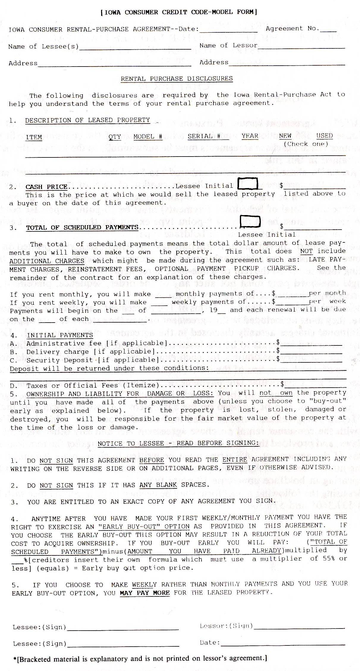

TERMS OF AGREEMENT
1.
ADDITIONAL CHARGES: [Charges referred to below are maximums. Lessors may insert a different amount if it is less than the maximums. Lessors need to print only those charges and terms which apply to their agreement.]
LATE PAYMENT CHARGES: A [up to $5.00] charge for monthly payments not made within five (5) business days of the date payment is due, or [up to $3.00] charge for weekly payments not made within three (3) business days of the date when payment is due. This charge may only be made when no “payment pick-up charge” has been made.
REINSTATEMENT FEES: A [up to $5.00] fee for the right to reinstate the agreement after failing to make a timely rental payment and if the conditions governing reinstatement are met.
DELIVERY FEES: A $10.00 fee for up to five (5) items and $25.00 for delivery of more than five (5) items.
ADMINISTRATIVE FEES: An initial fee of [up to $10.00] to cover administrative costs of the Agreement. [But ONLY if there is no delivery charge.]
OPTIONAL IN HOME PICK UP OF RENTAL PAYMENTS: For a charge of [$7.00 maximum] per payment, we can pick up the payment at your home. In no event will this charge be assessed in excess of three (3) times in any three (3) month period if the agreement is weekly or three (3) times in any six (6) month period if the agreement is monthly.
OPTIONAL PROPERTY INSURANCE: You do not have to carry insurance on the property. If you want property insurance to cover the property you may buy it from us or from someone else.

2. YOUR REINSTATEMENT RIGHT: If you fail to make a renewal rental payment you may have the right to reinstate this agreement by paying all rental payments past due, all applicable late charges, reinstatement fees and redelivery fees provided: 1) You voluntarily returned the property to us, if requested and 2) Not more than sixty (60) days have passed since you have returned the property.

3. YOUR TERMINATION RIGHT: You may terminate this agreement at any time without paying any charges other than those previously due. The property must be returned in its present condition, fair wear and tear excepted.

4. OUR TERMINATION RIGHT: We may terminate this agreement for a default in payment or breach of any other material term of this Agreement. If termination occurs we shall be entitled to all rental payments and other charges due up to the date of termination as well as the reasonable expenses of repossession of the property if you fail to surrender the property to us.

5. WARRANTY: [if applicable]
[Filed 10/16/87, Notice 8/26/87—published 11/4/87, effective 12/9/87]

