CHAPTER 53
PROTECTED WATER SOURCES
[Prior to 12/3/86, Water, Air and Waste Management[900]]
Chapter rescission date pursuant to Iowa Code section 17A.7: 6/18/30
567—53.1(455B) Designation of protected sources.
53.1(1) The department may designate a surface water or groundwater source within a defined geographical area as a protected source. Notwithstanding the requirements in this chapter, the department may impose permit conditions on a case-by-case basis to protect the water resources of the state.
53.1(2) The purpose of designating a water source as a protected source is to ensure long-term availability in terms of quantity and quality to preserve public health and welfare. Purposes include but are not limited to the following:
a. To preserve the availability of the protected source for sustained beneficial use.
b. To prevent or minimize the movement of groundwater contaminants.
c. To maintain the surface water quality within a specific stream segment in order to meet state or federal standards, to preserve protected flows, or to maintain its availability for other beneficial use.
d. To preserve the protected flows in a stream that is hydraulically connected to a protected groundwater source.
This rule is intended to implement Iowa Code sections 455B.262, 455B.264 through 455B.274 and 455B.278.
[ARC 9200C, IAB 5/14/25, effective 6/18/25]
567—53.2(455B) Designation procedure. The procedure for designation of a protected source shall be a rulemaking to amend the list of protected sources in rule 567—53.5(455B). In addition to the requirements of rule 561—5.1(17A), an interested person who petitions the department to designate a protected water source may also be required to provide supporting information, including but not limited to:
53.2(1) Facts and arguments demonstrating that existing rules and the opportunity for public participation in the application review and decision-making procedures of rule 567—50.7(17A,455B) and 567—subrule 50.8(3) are inadequate to ensure the long-term availability of the source and to preserve the public health and welfare.
53.2(2) Predictive geohydrological and chemical analyses of the groundwater source if the petition is to prevent or minimize the movement of known or suspected contaminants.
53.2(3) Facts and arguments demonstrating the effect that additional withdrawals from a stream or stream segment proposed for designation would have on downstream discharges, surrounding alluvial systems, and biological systems, and on potential changes in the frequency at which the protected stream discharge levels are reached.
This rule is intended to implement Iowa Code sections 455B.262, 455B.264 through 455B.274 and 455B.278.
[ARC 9200C, IAB 5/14/25, effective 6/18/25]
567—53.3(455B) Information requirements for applications to withdraw water from protected sources. An applicant proposing to withdraw water from a protected source, as listed in rule 567—53.5(455B), may be required to submit information necessary for the department to determine the effects resulting from such withdrawal.
53.3(1) Withdrawals from protected groundwater sources. Applicants for water use permits may be required to provide the information detailed in rule 567—50.7(17A,455B) and additional predictive geohydrological and chemical analyses of the groundwater source. Where there is potential for a known contaminant to migrate, predictive analyses may also be requested to show potential movement and effects of the withdrawal on the hydraulic head. Monitoring may be required in permits authorizing withdrawals from a protected groundwater source.
53.3(2) Withdrawals from protected surface water sources. Applicants for water use permits may be required to demonstrate the effect of proposed withdrawals on downstream discharges, surrounding alluvial systems, and biological systems, and of potential changes in the frequency at which protected stream discharge levels are reached, for any stream or stream reaches listed in rule 567—53.5(455B).
This rule is intended to implement Iowa Code sections 455B.262, 455B.264 through 455B.274 and 455B.278.
[ARC 9200C, IAB 5/14/25, effective 6/18/25]
567—53.4(455B) Conditions in permits for withdrawals of water from a protected source. The designation of a protected water source in rule 567—53.5(455B) may include a list of special conditions for permits issued for withdrawals of water from the designated source. The designation may also include guidelines for the imposition of special limitations on withdrawals authorized by permits that were in force on the effective date of the protected source designation. However, such guidelines may be enforced only in accordance with the procedures in rule 567—50.14(455B) for modification, termination, and emergency suspension of permits, or after a permittee has had an opportunity to contest the imposition of proposed special limitations in permit renewal proceedings. When a group of permits is potentially affected by the guidelines in rule 567—53.5(455B), hearings under rule 567—50.14(455B) may be consolidated.
53.4(1) Withdrawals from streams or associated alluvium that are protected sources. The department may apply special conditions on all water use permits for withdrawals from streams and associated alluvial systems that are protected water sources listed in rule 567—53.5(455B). Such conditions may include a cessation of withdrawals at a stream discharge rate as determined by the department when withdrawals may be in excess of the level required by 567—subrule 50.15(3). These conditions may apply to both consumptive and nonconsumptive withdrawals.
53.4(2) Withdrawals from groundwater sources that are protected sources. The department may apply special conditions on all water use permits for withdrawals from groundwater systems that are protected water sources listed in rule 567—53.5(455B). Such conditions may include immediate cessation of withdrawals if declines in hydraulic head or movement of known contaminants in the source are detected. These conditions may apply to both consumptive and nonconsumptive withdrawals.
This rule is intended to implement Iowa Code chapter 455B.
[ARC 9200C, IAB 5/14/25, effective 6/18/25]
567—53.5(455B) List of protected water sources. The following list identifies water sources designated as protected sources under this chapter. Each listing includes the name of the designated surface water or groundwater source, the geographical areas affected, the specific purposes for designating the source, and special limitations imposed or recommended to achieve the purpose of the protected source designation. The listing may also include special monitoring requirements or specify a date by which the department must review a protected source designation.
53.5(1) Ralston Site, Linn County.
a. Geographic area. The protected water source area includes an area within the boundaries of the cities of Cedar Rapids and Marion in Linn County. The actual geographical boundaries of the area are defined in 53.5(1)“d.”
b. New or modified water use permits. Any new application for a permit to withdraw groundwater or to increase an existing permitted groundwater withdrawal from within the protected water source area will be restricted or denied, if necessary, to preserve public health and welfare or to minimize movement of groundwater contaminants from the Ralston Site. The Ralston Site is identified as an EPA Comprehensive Environmental Response, Compensation, and Liability Act site under identification number IAD 980632491.
c. Groundwater withdrawal. Groundwater withdrawal from within the protected water source area may also be restricted or denied from what would otherwise be nonregulated wells, if necessary, to preserve public health and welfare or to minimize the movement of groundwater contaminants from the Ralston Site. The Linn County health department will refer any application for a private well construction permit within the protected water source area to the department, which will determine whether to permit the proposed well.
d. Map of protected water source area. The department shall maintain a map of the protected water source area.
(1) The entire following described area within Linn County is defined as a protected water source:
1. All areas of Section 35, Township 84 North, Range 7 West.
2. All areas of the SW ¼ of Section 36, Township 84 North, Range 7 West.
3. All areas of the SW ¼ of the NW ¼ of Section 36, Township 84 North, Range 7 West.
4. All areas of the SE ¼ of Section 34, Township 84 North, Range 7 West.
5. All areas of the SE ¼ of the SE ¼ of Section 34, Township 84 North, Range 7 West.
6. All areas of Section 2, Township 83 North, Range 7 West.
7. All areas of the NW ¼ of the NW ¼ of Section 1, Township 83 North, Range 7 West.
8. All areas of the N ½ of the SW ¼ of Section 1, Township 83 North, Range 7 West.
9. All areas of the SW ¼ of the SW ¼ of Section 1, Township 83 North, Range 7 West.
10. All areas of the NE ¼ of Section 3, Township 83 North, Range 7 West.
11. All areas of the N ½ of the SE ¼ of Section 3, Township 83 North, Range 7 West.
12. All areas of the SE ¼ of the SE ¼ of Section 3, Township 83 North, Range 7 West.
(2) Map of the protected source area.
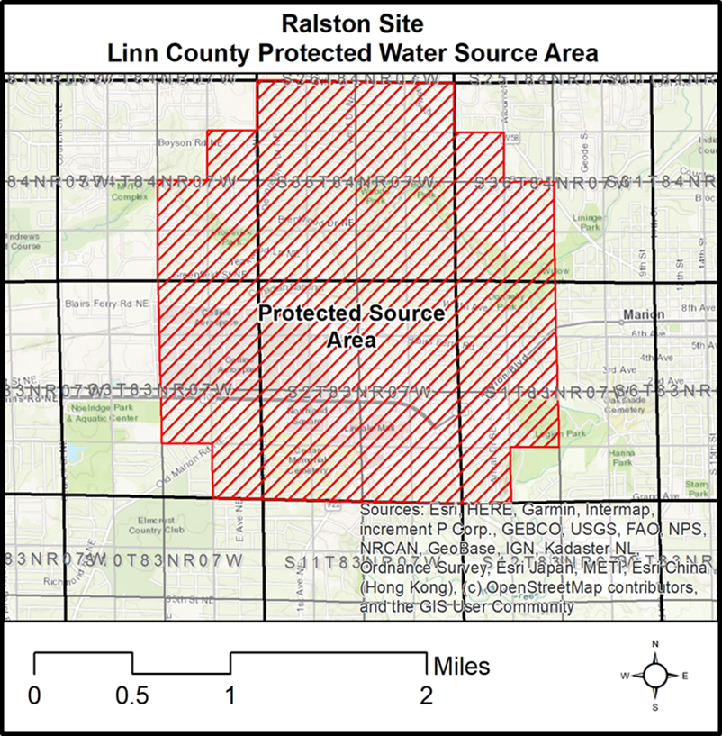
53.5(2) Cambrian-Ordovician (Jordan) aquifer in Johnson and Linn Counties.
a. Geographical area. The protected water source area includes portions of Johnson and Linn Counties. The actual geographical boundaries of the area are defined in 53.5(2)“d.”
b. New or modified water use permits. Any new application for a permit to withdraw groundwater or to increase an existing permitted groundwater withdrawal from the Cambrian-Ordovician (Jordan) aquifer within the protected water source area will be restricted or denied if necessary to preserve public health and welfare.
c. Groundwater withdrawal. Groundwater withdrawal from within the protected water source area may also be restricted or denied from water supply wells constructed in the Cambrian-Ordovician (Jordan) aquifer, public or private, and the construction of all new water supply wells in this aquifer shall be restricted or denied, if necessary, to preserve public health and welfare or to minimize adverse effects to the available head. The Johnson County and Linn County health departments are not authorized to issue a construction permit for a private well drilled into or through the Cambrian-Ordovician (Jordan) aquifer within the protected water source area without department approval. The department will determine whether the proposed well can be constructed and may require that the well meet public water well standards.
d. Map of protected water source area. The department shall maintain a map of the protected water source area.
(1) The entire following described area within Johnson County and within Linn County is defined as a protected water source.
Johnson County
1. All areas of Township 79 North, Range 6 West.
2. All areas of Township 79 North, Range 7 West.
3. All areas of Township 79 North, Range 8 West.
4. All areas of Township 80 North, Range 6 West.
5. All areas of Township 80 North, Range 7 West.
6. All areas of Township 80 North, Range 8 West.
7. All areas of Township 81 North, Range 6 West.
8. All areas of Township 81 North, Range 7 West.
9. All areas of Township 81 North, Range 8 West.
Linn County
1. All areas of Township 82 North, Range 6 West.
2. All areas of Township 82 North, Range 7 West.
3. All areas of Township 82 North, Range 8 West.
4. All areas of Township 83 North, Range 6 West.
5. All areas of Township 83 North, Range 7 West.
6. All areas of Township 83 North, Range 8 West.
7. All areas of Township 84 North, Range 6 West.
8. All areas of Township 84 North, Range 7 West.
9. All areas of Township 84 North, Range 8 West.
(2) Map of the described protected water source area in Linn and Johnson Counties.
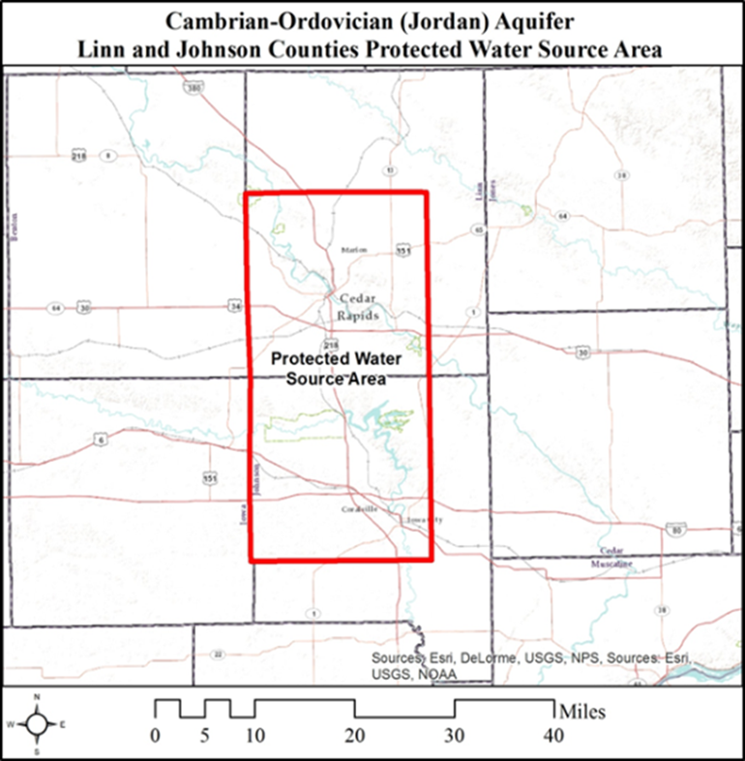
53.5(3) Cambrian-Ordovician (Jordan) aquifer in Webster County.
a. Geographical area. The protected water source area includes portions of Webster County. The actual geographical boundaries of the area are defined in 53.5(3)“d.”
b. New or modified water use permits. Any new application for a permit to withdraw groundwater or to increase an existing permitted groundwater withdrawal from the Cambrian-Ordovician (Jordan) aquifer within the protected water source area will be restricted or denied if necessary to preserve public health and welfare.
c. Groundwater withdrawal. Groundwater withdrawal from within the protected water source area may also be restricted or denied from water supply wells constructed in the Cambrian-Ordovician (Jordan) aquifer, public or private, and the construction of all new water supply wells in this aquifer shall be restricted or denied, if necessary, to preserve public health and welfare or to minimize adverse effects to the available head. The Webster County health department is not authorized to issue a construction permit for a private well drilled into or through the Cambrian-Ordovician (Jordan) aquifer within the protected water source area without department approval. The department will determine whether the proposed well can be constructed and may require that the well meet public water well standards.
d. Map of protected water source. The department shall maintain a map of the protected water source area.
(1) The entire following described area within Webster County is defined as a protected water source.
1. All areas of Township 88 North, Range 28 West.
2. All areas of Township 88 North, Range 29 West.
3. All areas of Township 89 North, Range 28 West.
4. All areas of Township 89 North, Range 29 West.
(2) Map of the described protected water source area in Webster County.
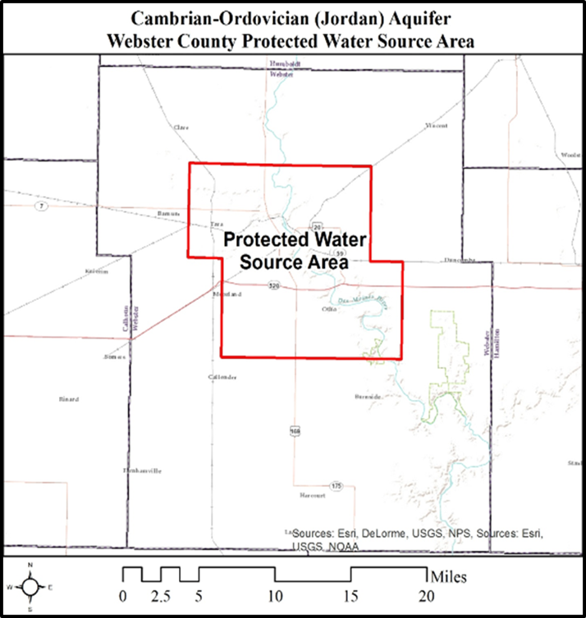
53.5(4) Iowa Army Ammunition Plant (IAAAP) RDX Contaminant Site in Des Moines County and Lee County. The IAAAP hexahydro-1,3,5-trinitro-1,3,5-triazine (CAS Registry Number 121-82-4, also known as RDX, or Royal demolition explosive) protected water source area is known as the IAAAP RDX protected water source area.
a. Geographical area. The IAAAP RDX protected water source area includes portions of Des Moines and Lee Counties. The geographical boundaries of the area are defined in 53.5(4)“e.” The IAAAP site is identified as an EPA Comprehensive Environmental Response, Compensation, and Liability Act site under identification number IA7213820445.
b. New or modified water use permits. Any new application for a permit to withdraw groundwater or to increase an existing permitted groundwater withdrawal from the IAAAP RDX protected water source area will be restricted or denied if necessary to preserve public health and welfare and to minimize the movement of groundwater contaminants from the IAAAP RDX site.
c. Groundwater withdrawal. Groundwater withdrawal from within the protected water source area may also be restricted or denied from regulated or nonregulated water supply wells, and the construction of all new water supply wells shall be restricted or denied, if necessary, to preserve public health and welfare and to minimize movement of groundwater contaminants.
(1) The department is the only authorized well permitting authority within the protected water source area. No well shall be constructed within the protected water source area unless a written permit is obtained from the department.
(2) All well construction permit applications for this protected water source area shall be submitted to the department. The Des Moines County and Lee County health departments or their designated permitting authorities shall refer all private well construction permit applications to the department when the proposed wells are located within the protected water source area.
(3) The department will determine whether the proposed well can be installed and the well construction standards that are required for the well’s installation. All approved well construction shall use department-approved well construction standards and operational standards to ensure the protection of public health and welfare and to minimize the potential movement of contaminants in the groundwater within the protected water source area.
d. Boundaries. When monitoring results, or an investigation conducted by the department, the IAAAP, or an agent designated by either party indicates that the monitored contaminant concentrations or the monitored contaminant boundaries have significantly changed, the department may increase or decrease the boundaries of the protected water source area to maintain the separation distance to the monitored contamination. The department will publish any changes in the contaminant boundaries and send a notice to the IAAAP, the Des Moines County and Lee County health departments, and the affected landowners.
e. Map of protected water source. The department shall maintain a map of the protected water source area.
(1) The following described area within Des Moines County and Lee County is defined as a protected water source.
1. Des Moines County, Union Township
● East one-half of section 34 in Township 69 North, Range 3 West
● All areas of section 35 in Township 69 North, Range 3 West
● West one-half of section 36 in Township 69 North, Range 3 West
2. Des Moines County, Green Bay Township
● Northeast quarter section 3 in Township 68 North, Range 3 West
● All areas of section 2 in Township 68 North, Range 3 West
● West one-half of section 1, Township 68 North, Range 3 West
3. Lee County, Green Bay Township
● All areas of section 2 in Township 68 North, Range 3 West
● All areas of section 1 in Township 68 North, Range 3 West
(2) Map of the described protected water source area in Des Moines and Lee Counties.
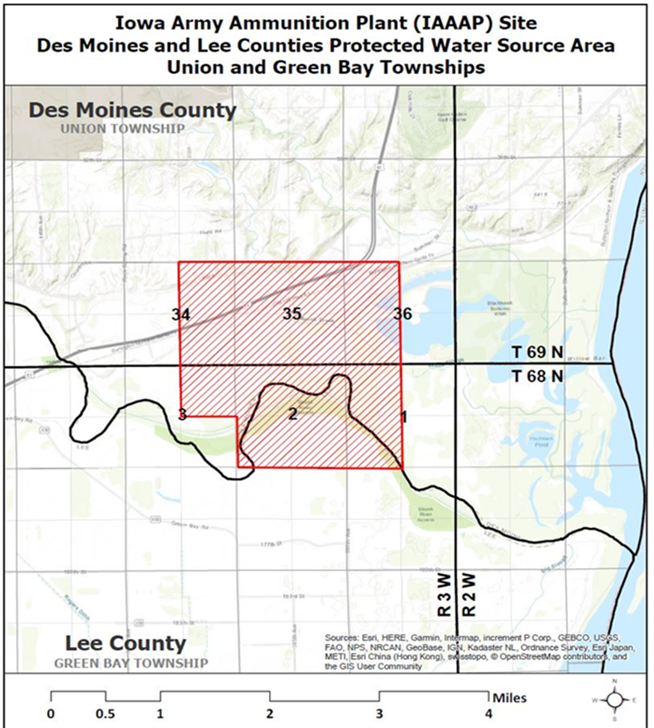
[ARC 9200C, IAB 5/14/25, effective 6/18/25]
NOTE: When protected sources are designated, they will be listed as part of this rule.
This rule is intended to implement Iowa Code sections 455B.262, 455B.264 through 455B.274 and 455B.278.
[Filed 11/1/85, Notice 7/31/85—published 11/20/85, effective 12/25/85]
[Filed emergency 11/14/86—published 12/3/86, effective 12/3/86]
[Filed 9/20/96, Notice 7/17/96—published 10/9/96, effective 11/13/96]
[Filed 5/17/06, Notice 3/15/06—published 6/7/06, effective 7/12/06]
[Filed ARC 2053C (Notice ARC 1914C, IAB 3/18/15), IAB 7/8/15, effective 8/12/15]
[Filed ARC 4426C (Notice ARC 4277C, IAB 2/13/19), IAB 5/8/19, effective 6/12/19]
[Filed ARC 9200C (Notice ARC 8652C, IAB 1/8/25), IAB 5/14/25, effective 6/18/25]

