TITLE I
GENERAL DEPARTMENTAL PROCEDURES
CHAPTER 1
DEPARTMENTAL ORGANIZATION AND PROCEDURES
[Prior to 3/20/91, Corrections Department[291]]
Chapter rescission date pursuant to Iowa Code section 17A.7: 1/1/28
201—1.1(904) Title I definitions.
“Department” means the department of corrections.
“Director” means the director of the department of corrections.
“Plan of compliance” means a schedule of action to be followed in correcting statute or rule deficiencies cited by the department of corrections.
“Public official” means any officer of the federal government, any state or a political subdivision thereof, receiving a salary or per diem, if elected or appointed or whether serving full-time or part-time.
[ARC 3929C, IAB 8/1/18, effective 9/5/18; see Delay note at end of chapter; ARC 4152C, IAB 12/5/18, effective 11/14/18]
201—1.2(904) Mission and function. The department of corrections is mandated by Iowa Code chapter 904 and consists of a policy board, a director and areas of responsibility.
The mission of the department of corrections is creating opportunities for safer communities.
[ARC 3929C, IAB 8/1/18, effective 9/5/18; see Delay note at end of chapter; ARC 4152C, IAB 12/5/18, effective 11/14/18]
201—1.3(904) Offices.
1.3(1) Central office. The central office for the department of corrections is located in the Jessie Parker State Office Building in the Capitol Complex in Des Moines. Its mailing address is the Department of Corrections, Jessie Parker State Office Building, 510 E.
12th Street, Des Moines, Iowa 50319; telephone (515)725-5701. Office hours are 8 a.m.
to 4:30 p.m., Monday through Friday, excluding holidays.
1.3(2) Division offices. The central offices of the divisions of the department are also located in the Jessie Parker State Office Building.
1.3(3) Contact information. Contact information for correctional institutions and judicial district departments of correctional services and other offices located outside the principal headquarters is listed below and may also be found on the department’s website, which is listed in rule 201—1.4(904). The following map provides a general overview of judicial district department of correctional services and correctional institution locations.
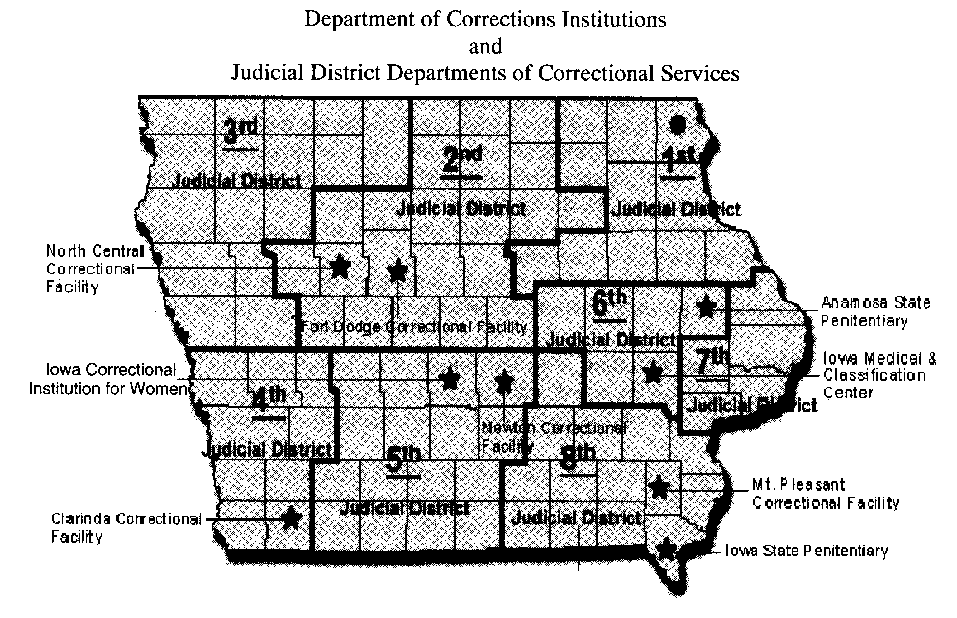
Anamosa State Penitentiary | Iowa Medical and Classification Center
406 North High Street | 2700 Coral Ridge Avenue
Anamosa, IA 52205 | Coralville, IA 52241
(319)462-3504 | (319)626-2391
(319)462-4962 Fax | (319)626-2141 Fax
Mt. Pleasant Correctional Facility | Iowa State Penitentiary
1200 East Washington | 2111 330th Avenue, P.O. Box 316
Mt. Pleasant, IA 52641 | Fort Madison, IA 52627
(319)385-9511 | (319)372-5432
(319)385-8828 Fax | (319)372-6967 Fax
Newton Correctional Facility | Fort Dodge Correctional Facility
307 S. 60th Avenue W, P.O. Box 218 | 1550 L Street
Newton, IA 50208 | Fort Dodge, IA 50501-5767
(641)792-7552 | (515)574-4700
(641)791-1683 Fax | (515)574-4707 Fax
North Central Correctional Facility | Iowa Correctional Institution for Women
313 Lanedale | 420 Mill Street SW
Rockwell City, IA 50579 | Mitchellville, IA 50169
(712)297-7521 | (515)725-5042
(712)297-7875 Fax | (515)725-5015 Fax
Clarinda Correctional Facility | First Judicial District, DCS
2000 N. 16th Street | 314 East Sixth Street, P.O. Box 4030
Clarinda, IA 51362 | Waterloo, IA 50704-4030
(712)695-7140 | (319)236-9626
(712)695-7130 Fax | (319)291-3947 Fax
Second Judicial District, DCS | Third Judicial District, DCS
509 Main Street, Suite 200 | 515 Water Street
Ames, IA 50010 | Sioux City, IA 51103
(515)232-1511 | (712)252-0590
(515)232-9453 Fax | (712)252-0634 Fax
Fourth Judicial District, DCS | Fifth Judicial District, DCS
810 South Tenth Street | 1000 Washington Street
Council Bluffs, IA 51501 | Des Moines, IA 50314
(712)325-4943 | (515)242-6611
(712)325-0312 Fax | (515)242-6656 Fax
Sixth Judicial District, DCS | Seventh Judicial District, DCS
951 29th Ave.  SW | 605 Main Street
Cedar Rapids, IA 52404 | Davenport, IA 52803-5244
(319)398-3675 | (563)322-7986
(319)398-3684 Fax | (563)324-2063 Fax
Eighth Judicial District, DCS
1805 West Jefferson, P.O. Box 1060
Fairfield, IA 52556-1060
(641)472-4242
(641)472-9966 Fax
[ARC 3929C, IAB 8/1/18, effective 9/5/18; see Delay note at end of chapter; ARC 6431C, IAB 7/27/22, effective 8/31/22]
201—1.4(904) Internet website. The department’s Internet home page is located at doc.iowa.gov.
[ARC 3929C, IAB 8/1/18, effective 9/5/18; see Delay note at end of chapter; ARC 6431C, IAB 7/27/22, effective 8/31/22]
201—1.5(904) Method by which and location where the public may obtain information or make submissions or reports.
1.5(1) Persons wishing to obtain information from or report information to the department may contact any of the offices listed in rule 201—1.3(904) or found on the department’s website.
1.5(2) Persons wishing to make submissions to the department may do so by delivering or forwarding information to the principal offices of the affected division or, if the subject matter is relevant to a specific prison or judicial district department of correctional services, the nearest office as listed in rule 201—1.3(904) or found on the department’s website.
201—1.6(904) Board of corrections. The director of the department has, by statute, the advice and counsel of the board of corrections. This seven-member board is appointed by the governor with confirmation by the senate, and its powers and duties are policymaking and advisory with respect to the services and programs operated by the department.
1.6(1) A quorum shall consist of two-thirds of the membership appointed and qualified to vote.
1.6(2) When a quorum is present, a position is carried by a majority of the qualified members of the board.
1.6(3) Copies of administrative rules and other materials considered are made a part of the minutes by reference.
1.6(4) Copies of the minutes are kept on file in the director’s office.
1.6(5) At each meeting the board shall set the date and location of the next meeting.
a. Notice of the meetings shall be given pursuant to Iowa Code chapter 21.
b. When it is determined by the chairperson of the board that an emergency meeting is required, the communications media shall be notified as far in advance of the meeting as time allows. The nature of the emergency shall be stated in the minutes.
c. Persons wishing to appear before the board shall submit their request to the department office not less than ten days prior to the meeting. Presentations may be made at the discretion of the chairperson and only upon matters appearing on the agenda.
d. Persons wishing to submit written material should do so at least ten days in advance of the scheduled meeting to ensure that board members have adequate time to receive and evaluate the material.
1.6(6) In cases not covered by these rules, Robert’s Rules of Order shall govern.
1.6(7) The chairperson may appoint committees of the board as necessary to conduct the business of the board. Committee meetings shall comply with Iowa Code chapter 21.
1.6(8) The board shall:
a. Oversee the work of the department as defined in Iowa Code section 904.105 and, for this purpose, the board shall have access at any time to all books, papers, documents and records of the department.
b. Report to the governor and the general assembly recommendations regarding the activities of the department when necessary.
[ARC 3929C, IAB 8/1/18, effective 9/5/18; see Delay note at end of chapter]
201—1.7(904) Director. The governor appoints the director of the department of corrections. The director is responsible for the daily administration of the department as follows:
1.7(1) The appointment and qualifications of the director are mandated in Iowa Code section 904.107.
1.7(2) Duties of the director are prescribed in Iowa Code section 904.108.
1.7(3) The director shall have the authority to place on notice intended administrative action pursuant to Iowa Code chapter 17A by approval of the board of corrections. A report listing all rules placed under notice during the previous month shall be submitted to the board of corrections at its regular meeting for review. The board of corrections shall review and shall adopt rules following the period of public comment.
[ARC 3929C, IAB 8/1/18, effective 9/5/18; see Delay note at end of chapter; ARC 4152C, IAB 12/5/18, effective 11/14/18]
201—1.8(904) Organization of the department.
1.8(1) The deputy director of institutional operations is responsible for all institutions and facilities. These descriptions are in no way binding on the director’s authority to transfer incarcerated individuals between institutions.
a. The deputy director of institutional operations is responsible for:
(1) The Iowa state penitentiary, Fort Madison.
(2) The Anamosa state penitentiary, Anamosa.
(3) The Iowa medical and classification center, Coralville.
(4) Mount Pleasant correctional facility, Mount Pleasant.
(5) The Iowa correctional institution for women, Mitchellville.
(6) The Clarinda correctional facility, Clarinda.
(7) The north central correctional facility, Rockwell City.
(8) The Newton correctional facility and the Newton correctional release center, Newton.
(9) The Fort Dodge correctional facility, Fort Dodge.
b. The deputy director of institutional operations is also responsible for the following:
(1) Classification.
(2) Education.
(3) Safety officers.
(4) Records.
(5) Transfers.
(6) Security operations.
1. Investigations.
2. Reserved.
1.8(2) The deputy director of community-based corrections:
a. Is responsible for the coordinating of Code of Iowa requirements as they apply to the judicial district department of correctional services for all eight judicial districts to include:
(1) The first judicial district department of correctional services.
(2) The second judicial district department of correctional services.
(3) The third judicial district department of correctional services.
(4) The fourth judicial district department of correctional services.
(5) The fifth judicial district department of correctional services.
(6) The sixth judicial district department of correctional services.
(7) The seventh judicial district department of correctional services.
(8) The eighth judicial district department of correctional services.
b. Is to act as liaison with and assist community-based corrections through the purchase of service agreement and periodic review and accreditation of these programs:
(1) Pretrial interviews.
(2) Pretrial supervision.
(3) Presentence investigation.
(4) Probation.
(5) Residential services.
(6) Community service sentencing.
(7) OWI facilities.
(8) Parole supervision.
(9) Interstate compact.
(10) Substance abuse treatment services.
(11) Cognitive learning.
(12) Iowa domestic abuse program.
(13) Sex offender treatment.
(14) Preemployment programs.
(15) Special sentences.
1.8(3) The fiscal manager for the division of administration shall be responsible for the following:
a. Budget development and control.
b. Personnel.
c. Accountable government oversight.
d. Planning and development.
e. General administrative support.
f. Fiscal policy and procedures.
g. Engineering.
h. Data processing.
1.8(4) The deputy director for prison industries shall be responsible for the following:
a. The manufacturing/service/purchasing operations.
b. The activities and programs of the sales manager and territorial sales staff of Iowa prison industries.
c. The budget, income and expense forecasts and financial record keeping/reporting required to operate Iowa prison industries as a self-supporting activity.
d. Private sector employment.
e. Farms.
f. Centralized canteen.
g. State and federal surplus.
1.8(5) The director of research/recidivism reduction shall be responsible for the following:
a. Learning center.
b. Research department.
1.8(6) The general counsel shall be responsible for the following:
a. Legal services.
b. Coordination of court orders.
c. Public records.
d. Civil rights.
e. Administrative law judges.
f. Jail inspections.
g. Administrative rules.
1.8(7) The director of media and public relations shall be responsible for the following:
a. Providing public information to constituency groups and the media.
b. Facilitating internal communications in the department.
c. Legislative program.
1.8(8) The medical services director shall be responsible for the following:
a. Institutional medical services.
b. Central pharmacy.
[ARC 3929C, IAB 8/1/18, effective 9/5/18; see Delay note at end of chapter; ARC 4152C, IAB 12/5/18, effective 11/14/18; ARC 6431C, IAB 7/27/22, effective 8/31/22]
These rules are intended to implement Iowa Code sections 904.101 to 904.108.
[Filed emergency 9/9/83—published 9/28/83, effective 10/1/83]
[Filed 11/18/83, Notice 9/28/83—published 12/7/83, effective 1/11/84]
[Filed emergency 1/27/84—published 2/15/84, effective 1/27/84]
[Filed 5/4/84, Notice 2/15/84—published 5/23/84, effective 6/27/84 and 7/1/84]
[Filed 7/24/84, Notice 5/23/84—published 8/15/84, effective 9/19/84]
[Filed 4/4/85, Notice 10/24/84—published 4/24/85, effective 5/29/85]
[Filed 9/20/85, Notice 7/31/85—published 10/9/85, effective 11/13/85]
[Filed emergency 2/20/91—published 3/20/91, effective 2/20/91]
[Filed emergency 5/10/91—published 5/29/91, effective 5/10/91]
[Filed 4/17/07, Notice 2/14/07—published 5/9/07, effective 6/13/07]
[Filed ARC 3929C (Notice ARC 3806C, IAB 5/23/18), IAB 8/1/18, effective 9/5/18]1
[Filed Emergency ARC 4152C, IAB 12/5/18, effective 11/14/18]
[Filed ARC 6431C (Notice ARC 6324C, IAB 5/18/22), IAB 7/27/22, effective 8/31/22]
September 5, 2018, effective date of ARC 3929C [amendments to chs 1, 5, 10, 11, 20, 38, 40, 41, 42, 43, 44, 45, 47, 50, 51] delayed 70 days by the Administrative Rules Review Committee at its meeting held August 14, 2018.

