CHAPTER 450
MOTOR VEHICLE EQUIPMENT
[Appeared as Ch 1, Department of Public Safety, 1973 IDR; amended January 1975 IDR Supplement]
[Prior to 6/3/87, Transportation Department[820]—(07,E)Ch 1]
Chapter rescission date pursuant to Iowa Code section 17A.7: 1/1/28
761—450.1(321) Addresses, information and forms. Assistance under this chapter is available as follows:
450.1(1) Information and forms for vehicle registration and certificate of title may be obtained from the county treasurer or by mail from the Motor Vehicle Division, Iowa Department of Transportation, P.O. Box 9278, Des Moines, Iowa 50306-9278; in person at Iowa Department of Transportation, 6310 SE Convenience Blvd., Ankeny, Iowa; by telephone at (515)237-3264; or on the department’s website at www.iowadot.gov.
450.1(2) Information for inspections may be obtained from the Bureau of Investigation and Identity Protection, Iowa Department of Transportation, 6310 SE Convenience Boulevard, Ankeny, Iowa; by telephone at (515)237-3050; or on the department’s website at www.iowadot.gov.
This rule is intended to implement Iowa Code section 17A.3.
[ARC 5203C, IAB 10/7/20, effective 11/11/20; ARC 6219C, IAB 3/9/22, effective 4/13/22]
761—450.2(321) Equipment requirements for specially constructed, reconstructed, street rod, and replica motor vehicles, other than autocycles, motorcycles and motorized bicycles. The following standards are minimum requirements for constructing and equipping specially constructed, reconstructed, street rod, and replica motor vehicles other than autocycles, motorcycles and motorized bicycles.
450.2(1) Definitions. The definitions in Iowa Code section 321.1 and rule 761—400.16(321) are hereby made part of this chapter.
450.2(2) Application. As outlined in rule 761—400.16(321), the applicant shall submit the required application forms and exhibits to the county treasurer. The vehicle and ownership documents shall be examined by the department. If the department determines that the motor vehicle complies with this rule, that the integral parts and components have been identified as to ownership, and that the application forms have been completed properly, the department shall assign an identification number to the vehicle and certify that the motor vehicle is eligible for titling and registration. If the frame or unibody specified on an application for a specially constructed, reconstructed, street rod, or replica motor vehicle is designated “not for highway use,” the application shall not be approved. The exchange of compatible body parts does not constitute a specially constructed, reconstructed, street rod, or replica motor vehicle. The removal, addition, or substitution of reconstructed motor vehicle parts that modifies the vehicle’s external appearance so that it does not reflect the original make or manufacturer model for that model does constitute a specially constructed, reconstructed, street rod, or replica motor vehicle.
450.2(3) Defroster and defogging device. Every closed motor vehicle shall be equipped with a device capable of defogging or defrosting the windshield area.
450.2(4) Door latches. Every motor vehicle that is equipped with doors leading directly into a compartment that contains one or more seating accommodations shall be equipped with mechanically actuated door latches which firmly and automatically secure the door when pushed closed and which allow each door to be opened from the inside by the actuation of a convenient lever, handle or other nonelectric device. Interior handles must be visible.
450.2(5) Floor pan. Every motor vehicle shall be equipped with a floor pan under the entire passenger-carrying compartment. The floor pan shall support the weight of the number of occupants that the vehicle is designed to carry. The floor pan shall be so constructed that it prevents the entry of exhaust fumes.
450.2(6) Glazing.
a. Windshields. Every motor vehicle shall be equipped with a laminated safety glass windshield that complies with and bears the approval marking of the American National Standards Institute (ANSI) Z 26.1 Standard. The windshield shall be in such a position that it affords continuous horizontal frontal protection to the driver and front seat occupants. The minimum vertical height of the unobstructed windshield glass shall be 6 inches. This paragraph does not preclude the use of a windshield that can be folded down to a horizontal position, provided that the windshield can be firmly fastened in both the vertical and horizontal positions.
b. Side and rear glass. Side and rear glass is not required in motor vehicles. If present, however, this glass must be either laminated or tempered safety glass bearing the approval of the ANSI Z 26.1 Standard.
450.2(7) Driver visibility. Each motor vehicle shall provide the driver with a minimum outward horizontal vision capability of 90 degrees each side of a vertical plane passing through the fore and aft centerline of the vehicle. This plane of vision may be interrupted by window framing and windshield door support posts not exceeding 4 inches in width at each side location.
450.2(8) Hood latches. If a motor vehicle is equipped with a front-opening hood, that hood shall be equipped with a primary and secondary latching system to hold the hood in a closed position.
450.2(9) Instruments and controls. Each motor vehicle shall be equipped with:
a. An operating speedometer calibrated to indicate “miles per hour.”
b. An operating odometer calibrated to indicate “total miles driven.”
c. A steering wheel circular or nearly circular in shape, having an outside diameter of not less than 13 inches.
d. An accelerator control system that returns the engine throttle to an idle position automatically when the driver removes the actuating force from the accelerator control.
450.2(10) Brakes.
a. Every motor vehicle shall be equipped with brakes acting upon all wheels. The service brakes must be capable of meeting or exceeding the stopping requirements of Iowa Code section 321.431. If necessary, the braking system may be tested by a road test on a public roadway by an officer of the motor vehicle division of the department.
b. Every motor vehicle shall be equipped with a parking brake operating on at least two wheels applied with required effectiveness despite exhaustion of any source of energy or leakage of any kind in the service brake system. The parking brake shall meet the requirements of Iowa Code sections 321.430 and 321.431.
450.2(11) Rearview mirror. Every motor vehicle shall be equipped with two rearview mirrors, each having substantial unit magnification. One shall be mounted on the inside of the vehicle in such a position that it affords the driver a clear view to the rear. The other shall be mounted on the outside of the vehicle on the driver’s side in such a position that it affords the driver a clear view to the rear. When an inside mirror does not give a clear view to the rear, a right-hand outside mirror shall be required in lieu thereof. The mirror mounting shall provide a stable support for the mirror, and shall provide for mirror adjustment by tilting in both horizontal and vertical directions. Each mirror shall have a minimum of 10 square inches of reflective surface.
450.2(12) Seat belts. Every motor vehicle shall be equipped with at least a Type I (lap belt) seat belt for the driver and each passenger seating position. The belts at each location shall comply with DOT Motor Vehicle Safety Standard No.
209, and shall be firmly anchored to the vehicle body.
450.2(13) Seating. All bench-type and individual seats in motor vehicles shall be firmly anchored to structural components or body parts.

450.2(14) and 450.2(15) Rescinded IAB 9/8/10, effective 10/13/10.
450.2(16) Exhaust system. Every motor vehicle shall have an exhaust system meeting the following requirements:
a. The system shall be free of leaks, including the exhaust manifold (or headers), piping forward of the muffler, the muffler(s), and tail piping.
b. Exhaust fumes shall be emitted to the extremity of the vehicle, behind the rear wheels, or to the extremity of the vehicle within 6 inches in front of the rear wheels. Exhaust fumes from trucks, other than enclosed vans, may be emitted to the rear of that part of the vehicle designed for and normally used for carrying the driver and passengers.
c. Each exhaust system must be equipped with a muffler that prevents excessive noise.
d. No part of the exhaust system shall pass through any area of the vehicle that is used as a passenger-carrying compartment, and shall be so constructed that persons entering the vehicle cannot make contact with the exhaust system.
e. All exterior side exhaust pipes must be fully shielded and any vertical truck exhaust stacks shall be shielded to the top of the cab.
450.2(17) Frame. Every vehicle shall be equipped with a frame consisting of wall box tubing, round tubing, wall channel or unitized construction capable of supporting the vehicle, its load and the torque produced by the power source.
450.2(18) Fuel system. Every motor vehicle shall have a fuel system in which all components are securely fastened with fasteners designed for this purpose, including the tank, tubing, hoses, clamps, etc.
The filler from the system shall be located in a position not within the passenger-carrying compartment, and shall be capped. The system shall be leakproof, and fuel lines shall be positioned so as not to come in contact with high temperature surfaces or moving parts.
450.2(19) Steering and suspension.
a. Every motor vehicle shall have no parts extending below the wheel rims in their lowest position, except for tires and electrical grounding devices designed for this purpose.
b. The steering system shall remain unobstructed when turned from lock to lock.
c. The steering wheel shall have no less than two turns and no more than six turns when turning the road wheels from lock to lock.
d. While in a sharp turn at a speed between 5 and 15 MPH, release of the steering wheel shall result in a distinct tendency for the vehicle to increase its turning radius.
e. No motor vehicle shall be constructed so that the weight on any axle is less than 20 percent of the gross weight of the vehicle and load.
f. Motor vehicles shall be equipped with a damping device at each wheel location providing a minimum relative motion between the unsprung axle and the chassis of plus or minus 2 inches.
g. When each corner of the vehicle is depressed and released the damping device shall stop vertical body motion within two cycles.
h. There shall be no heating or welding on coil springs, leaf springs, or torsion bars.
450.2(20) Tires. Tires shall comply with Iowa Code section 321.440. Each tire shall have a load-bearing capacity in keeping with the size and weight of the vehicle.
450.2(21) Lighting and electrical system. Each motor vehicle shall be equipped with approved lighting devices in sufficient number, type, and locations to meet the requirements of Iowa Code sections 321.384 to 321.423, including headlamps, rear lamps, license plate lamp, rear reflectors, parking lamps, stop lamps, turn signals, and high-low beam indicator. In addition, every motor vehicle shall be equipped with:
a. A driver-controlled switch capable of selecting high and low beams (dimmer switch).
b. A motor vehicle more than 40 inches in width shall be equipped with turn signal lamps and have a manually operated switch controlled by the driver that shall cause the turn signal lamps to function. This switch shall be self-canceling.
c. A horn that shall be electrically actuated, and shall emit a sound clearly audible from a distance of 200 feet. The horn shall be actuated with a switch easily accessible to the driver when operating the vehicle.
d. All wiring shall be done in an orderly and workmanlike fashion, with no wiring in contact with high temperature surfaces or moving parts.
e. Headlamps shall be in a plane that is perpendicular to a vertical plane through the longitudinal centerline of the vehicle. The headlamps shall be mounted not less than 24 inches, nor more than 54 inches, above the road surface when measured to the headlamp center.
f. A tail lamp or lamps shall be mounted on the rear of the motor vehicle or vehicle, exhibiting a red light plainly visible from a distance of 500 feet to the rear. The tail lamp or lamps shall be mounted not less than 15 inches, nor more than 72 inches, above the roadway.
g. All original lamps and lighting equipment provided on the motor vehicle by the manufacturer shall be maintained in working condition or shall be replaced with equivalent equipment.
This rule is intended to implement Iowa Code section 321.23.
[ARC 9048B, IAB 9/8/10, effective 10/13/10; ARC 5203C, IAB 10/7/20, effective 11/11/20]
761—450.3(321) Mud and snow tire. A mud and snow tire is a tire that is designed to provide additional starting, stopping and driving traction in mud and snow. The tread design shall have ribs, lugs, blocks or knobs which are discontinuous and have a minimum separation of one-eighth of an inch between the ribs, lugs, blocks or knobs. A substantial portion of the rib, lug, block or knob edge in the design of the tread shall be at an angle greater than 30 degrees to the periphery centerline. A mud and snow tire must comply with the tire restrictions expressed in Iowa Code section 321.440.
A tire labeled “Mud and Snow” or any contraction using the letters “M” and “S,” such as “MS,” “M/S,” “M-S” or “M & S” shall be considered a mud and snow tire.

A representation of the distinguishing features of a mud and snow tire is pictured below.

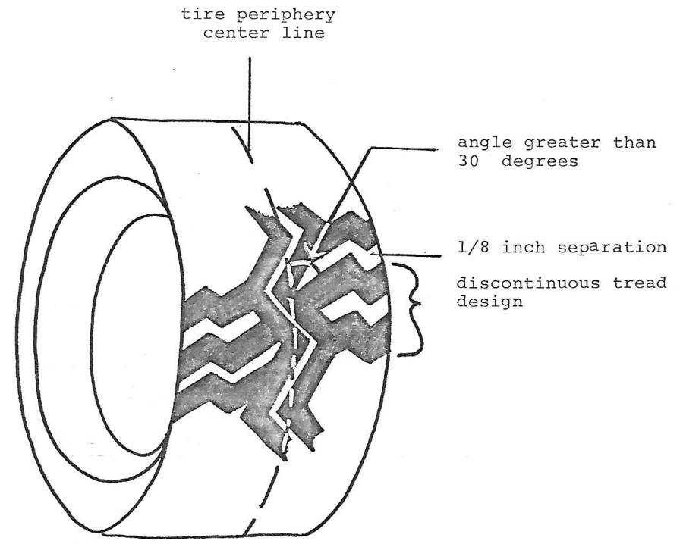
This rule is intended to implement Iowa Code subsection 321.236(12).
761—450.4(321) Minimum requirements for constructing and equipping specially constructed or reconstructed motorcycles or motorized bicycles. Minimum requirements for constructing and equipping specially constructed or reconstructed motorcycles or motorized bicycles as defined in Iowa Code section 321.1 are as follows:
450.4(1) Application. As outlined in rule 761—400.16(321), the applicant shall submit the required application forms and exhibits to the county treasurer. The vehicle and ownership documents shall be examined by the department. If the department determines that the motor vehicle complies with this rule, that the integral parts and components have been identified as to ownership, and that the application forms have been completed properly, the department shall assign an identification number to the vehicle and certify that the motor vehicle is eligible for titling and registration. If the frame specified on an application for a specially constructed or reconstructed motorcycle or motorized bicycle is designated “not for highway use,” the application shall not be approved. The exchange of compatible body parts does not constitute a specially constructed or reconstructed motorcycle or motorized bicycle. The removal, addition, or substitution of a reconstructed motorcycle or motorized bicycle part that modifies the vehicle’s external appearance so that it does not reflect the original make or manufacturer model does constitute a specially constructed, reconstructed, street rod, or replica motorcycle or motorized bicycle. EXEMPTION: The conversion of a manufactured motorcycle from two wheels to three-wheel operation by the addition or substitution of a bolt-on conversion kit shall not constitute a reconstructed motorcycle.
450.4(2) Upgrade pulls—minimum speed. No motor vehicle or combination of vehicles which cannot proceed up a 3 percent grade, on dry concrete pavement, at a minimum speed of 20 miles per hour, shall be operated upon the highways of this state.
450.4(3) Engine. Rescinded IAB 9/8/10, effective 10/13/10.
450.4(4) Frame/chassis. A motorcycle or motorized bicycle frame/chassis, including the suspension components and engine mountings, shall be of sufficient strength, capable of supporting the combined weight of all vehicle components and riders for which the vehicle was designed.
450.4(5) Front end assembly.
a. Trail (extended fork measured in inches). No reconstructed or specially constructed motorcycle or motorized bicycle shall have the front fork so extended as to place the center of the front wheel axle farther than 36 inches from a vertical plane through the steering axis.
b. Rake (extended fork measured in degrees). No reconstructed or specially constructed motorcycle or motorized bicycle shall have the front fork so extended as to exceed a 45-degree angle between the fork assembly and a vertical plane through the steering axis.
c. Extensions. No reconstructed or specially constructed motorcycle or motorized bicycle shall be equipped with extension slugs. However, one-piece extension tubes and springer units, if approved, are acceptable.
d. Wheelbase. No reconstructed or specially constructed motorcycle or motorized bicycle shall have an overall wheelbase, measured from the center of the front axle to the center of the rear axle, of less than 40 inches.
e. Motorcycle front end geometry. A representation of the front end geometry of a motorcycle is depicted in the Appendix to this rule.
450.4(6) Brakes. Every motorcycle and motorized bicycle shall be equipped with at least a rear brake. If the vehicle is also equipped with a front brake, all control cables, lines and hoses shall be located and secured so as not to become pinched between the fork and frame members when the wheel is turned completely to the left or right. Brake-actuating devices shall be in a readily accessible location, unencumbered by vehicle components. A suitable mechanism shall be provided for the purpose of automatically returning the actuating devices to a normal position upon release.
450.4(7) Tires, wheels, rims. Motorcycle tires shall be of pneumatic design with a minimum width of two and twenty-five hundredths inches and designed for highway use. Wheel rim diameters shall not be less than 10 inches and rims shall otherwise comply with applicable federal standards.
450.4(8) Steering and suspension.
a. Stability. Motorcycle or motorized bicycle steering and suspension shall provide the operator with the means of safely controlling vehicle direction.
b. Wheel alignment. The rear wheel of a two-wheel motorcycle or motorized bicycle shall track behind the front wheel within 1 inch with both wheels in a vertical plane when the vehicle is operating on a straight course. On a three-wheel motorcycle or motorized bicycle, the two wheels mounted on the rear axle shall have a wheel track distance not less than 30 inches and the midpoint of the rear wheel track distance shall be within 1 inch of the front wheel track when the vehicle is proceeding on a straight course.
c. Steering.
(1) The steering head shall be provided with a bearing or similar device that will allow the steering shaft to turn freely in rotational motion only. All handlebar-mounted control cables, wires, lines and hoses shall be located and secured so as not to become pinched between the fork and frame members when the wheel is turned completely to the right or the left.
(2) A steering wheel may be used on a three-wheel reconstructed or specially constructed motorcycle or motorized bicycle provided:
1. The steering wheel is circular or nearly circular in shape, having an outside diameter of not less than 13 inches.
2. The steering wheel shall have no less than two turns and no more than six turns when the road wheels are turned from lock to lock.
d. Handlebars. Handlebars shall be of sturdy construction, adequate in size (length) to provide proper leverage for steering, and capable of withstanding a minimum force of 100 pounds applied to each hand grip in any direction. The handlebars shall provide a minimum distance of 18 inches between grips after final assembly.
e. Hand grips. Motorcycles or motorized bicycles shall have handlebars equipped with hand grips of nonslip design or material.
f. Suspension. Motorcycles or motorized bicycles shall be equipped with a suspension system, and the suspension system shall be applicable to at least the front wheel. The suspension system(s) shall be designed for the purpose of maximum vehicle stability.
450.4(9) Fuel system. All fuel system components, including the tank, pump, tubing, hoses, clamps, etc., shall be securely fastened to the motorcycle or motorized bicycle so as not to interfere with vehicle operation and be leakproof when the vehicle is in its normal operating attitude. Fuel lines and tank shall be positioned in a manner so as to prevent their contact with the engine head, manifold, exhaust system, or other high temperature surfaces or moving components. The fuel system shall be adequately vented and provided with a fuel shutoff valve located between the fuel supply and the engine.
450.4(10) Exhaust system. Motorcycles or motorized bicycles with an internal combustion engine shall be equipped with an exhaust system incorporating a muffler or other mechanical device for the purpose of reducing engine noise. Cutouts and bypasses in the exhaust system are prohibited. The system shall be leakproof and all components shall be securely attached to the vehicle and located so as not to interfere with the operation of the motorcycle or motorized bicycle. Shielding shall be provided to prevent inadvertent contact with the exhaust system by the operator and/or passenger during normal operations.
450.4(11) Mirrors. Every motorcycle and motorized bicycle shall be equipped with at least one mirror of unit magnification, securely affixed to the handlebar and capable of adjustment within a range that will reflect an image that includes at least the horizon and the road surface to the rear of the motorcycle or motorized bicycle. The mirror shall consist of a minimum reflective surface of 10 square inches. All mirrors shall be regular in shape (circular, oval, rectangular, or square) and shall not contain sharp edges or projections capable of producing injury.
450.4(12) Fenders. Rescinded IAB 9/8/10, effective 10/13/10.
450.4(13) Seat or saddle. A seat or saddle securely attached to the vehicle shall be provided for the use of the operator. The seat or saddle shall not be less than 20 inches above a level road surface when measured to the lowest point on top of the seat or saddle cushion with the driver seated in a driving position. The seat or saddle adjustment locking device shall prevent relative movement of the seat from its selected and secured position under all normal vehicle operating conditions.
450.4(14) Horn. Every motorcycle and motorized bicycle shall be equipped with at least one horn. The horn shall be electrically operated and shall operate from a control device located on the handlebar. When operated the horn shall be audible for at least 200 feet.
450.4(15) Speedometer and odometer. Every motorcycle and motorized bicycle shall be equipped with a properly operating speedometer and odometer calibrated in miles per hour and miles respectively and shall be fully illuminated when the headlamp(s) is activated.
450.4(16) Lighting equipment. Every motorcycle and motorized bicycle shall be equipped with at least one headlamp but not more than two, mounted securely. Headlamp(s) shall be mounted not less than 24 inches, nor more than 54 inches, above the level road surface. A headlight beam indicator light shall be located within the operator’s field of vision and illuminated automatically when the high beam of the headlamp is actuated. Every motorcycle and motorized bicycle shall be equipped with a tail and brake light assembly and a license plate light. All original lamps and lighting equipment provided on the motor vehicle by the manufacturer shall be maintained in working condition or shall be replaced with equivalent equipment.
450.4(17) Footrest. Every motorcycle shall be equipped with two footrests, one on each side of the vehicle and shall be provided for each designated seating position. Footrests shall be located so as to provide reasonable accessibility. Footrests shall be able to fold upward if they protrude beyond the side of the motorcycle’s fixed items. Every motorized bicycle shall be equipped with either two footrests or two pedals, one on each side of the vehicle, to provide reasonable accessibility.
450.4(18) Highway bars. If a motorcycle or motorized bicycle is so equipped, highway bars (alternate footrests) shall be located at a maximum distance of 26 inches from the foot controls and shall not interfere with the operation of the foot controls.
This rule is intended to implement Iowa Code section 321.23.
[ARC 9048B, IAB 9/8/10, effective 10/13/10; ARC 3108C, IAB 6/7/17, effective 7/12/17; ARC 5203C, IAB 10/7/20, effective 11/11/20]
761—450.5(321) Minimum requirements for constructing and equipping specially constructed or reconstructed autocycles. Minimum requirements for constructing and equipping specially constructed or reconstructed autocycles as defined in Iowa Code section 321.1 are as follows:
450.5(1) Application. As outlined in rule 761—400.16(321), the applicant shall submit the required application forms and exhibits to the county treasurer. The vehicle and ownership documents shall be examined by the department. If the department determines that the autocycle complies with rule 761—450.5(321), that the integral parts and components have been identified as to ownership, and that the application forms have been completed properly, the department shall assign an identification number to the autocycle and certify that the autocycle is eligible for titling and registration. If the frame or unibody specified on an application for a specially constructed, reconstructed, street rod, or replica autocycle is designated “not for highway use,” the application shall not be approved. The exchange of compatible body parts does not constitute a specially constructed, reconstructed, street rod, or replica autocycle. The removal, addition, or substitution of reconstructed autocycle parts that modifies the autocycle’s external appearance so that it does not reflect the original make or manufacturer model for that model does constitute a specially constructed, reconstructed, street rod, or replica autocycle.
450.5(2) Seat belt. A seat belt for each seat shall be installed in the autocycle in accordance with Federal Motor Vehicle Safety Standard No. 209.
450.5(3) Seat. A seat that is firmly attached to the autocycle and does not require the operator to straddle or sit astride shall be provided for the use of the operator.
450.5(4) Lighting equipment. Every autocycle shall be equipped with at least one headlamp, at least one taillight, and either a taillight or a separate white light that illuminates the license plate if a taillight does not. All original lamps and lighting equipment provided on the autocycle by the manufacturer shall be maintained in working condition or shall be replaced with equivalent equipment.
450.5(5) Warning devices. Every autocycle shall be equipped with at least one red reflector, either separate or as part of the taillight or taillights.
450.5(6) Brakes. Every autocycle shall be equipped with a braking system, other than a parking brake, in accordance with Iowa Code section 321.431.
450.5(7) Horn. Every autocycle shall be equipped with a horn that shall be electrically actuated and shall emit a sound clearly audible from a distance of 200 feet.
450.5(8) Exhaust system. Each autocycle with an internal combustion engine shall be equipped with a muffler and emission control system in accordance with federal regulation 49 CFR 393.83. When a muffler and emission control system is factory equipped, neither may be removed.
450.5(9) Mirrors. Every autocycle shall be equipped with a mirror that shall consist of a minimum reflective surface of 10 square inches. All mirrors shall be regular in shape (circular, oval, rectangular, or square) and shall not contain sharp edges or projections capable of producing injury.
450.5(10) Tires. Every autocycle shall be equipped with tires that comply with the requirements of Iowa Code section 321.440.
450.5(11) Floor pan. Every autocycle shall be equipped with a floor pan under the entire passenger-carrying compartment. The floor pan shall support the weight of the number of occupants that the autocycle is designed to carry. The floor pan shall be so constructed that it prevents the entry of exhaust fumes.
This rule is intended to implement Iowa Code section 321.23.
[ARC 5203C, IAB 10/7/20, effective 11/11/20]
761—450.6(321) Safety requirements for the movement of implements of husbandry on a roadway. Transferred to 661—24.1(321), IAC Supplement 8/7/24.
761—450.7(321) Front windshields, windows or sidewings.
450.7(1) Prohibition. Except as provided in Iowa Code section 321.438(2), a person shall not operate on the highway a motor vehicle equipped with a front windshield, a side window to the immediate right or left of the driver (front side window) or a sidewing forward of and to the left or right of the driver (front sidewing) which is excessively dark or reflective.
450.7(2) Standard of transparency. “Excessively dark or reflective” means that the windshield, front side window or front sidewing does not meet a minimum standard of transparency of 70 percent light transmittance.
450.7(3) Dark window exemption.
a. Effective July 4, 2012, no exemption shall be granted from the minimum standard of transparency set forth in subrule 450.7(2).
b. A motor vehicle fitted with a front windshield, a front side window or a front sidewing with less than 70 percent but not less than 35 percent light transmittance before July 4, 2012, may continue to be maintained and operated with a front windshield, a front side window or a front sidewing with less than 70 percent but not less than 35 percent light transmittance on or after July 4, 2012, so long as the vehicle continues to be used for the transport of a passenger or operator who obtained Form 432020, which documented a medical need for such reduced transparency, and was signed by the person’s physician before July 4, 2012. Form 432020 must be carried at all times in the vehicle to which the exemption applies. At such time as the vehicle is no longer used for the transport of the passenger or operator who is the subject of Form 432020, the exemption expires and may not be renewed. The owner of the vehicle to which the exemption applied must return the vehicle to conformance with the minimum standard of transparency set forth in subrule 450.7(2) within 60 days of expiration of the exemption.
c. “Physician” as used in this rule means a person licensed under Iowa Code chapter 148, 151 or 154.
This rule is intended to implement Iowa Code section 321.438.
[ARC 0136C, IAB 5/30/12, effective 7/4/12]
[ARC 6219C, IAB 3/9/22, effective 4/13/22]
APPENDIX TO RULE
761—450.2(321)
Rescinded IAB 9/8/10, effective 10/13/10

APPENDIX TO RULE
761—450.4(321)
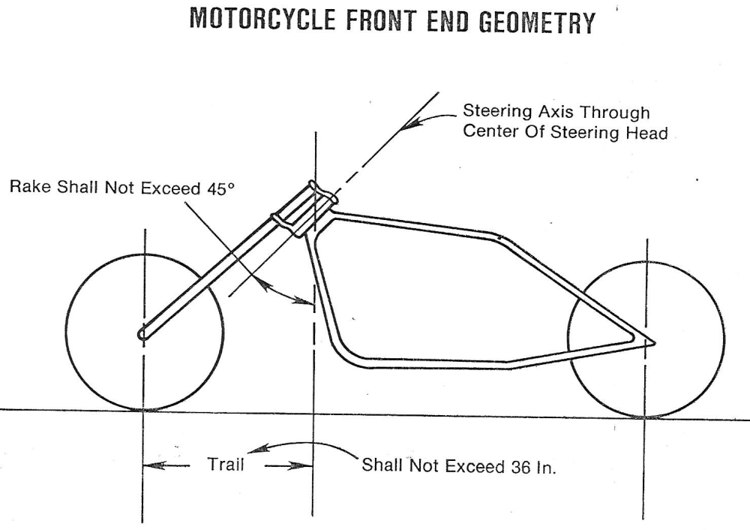

[Filed 6/30/61; amended 6/14/72, 12/9/74;
Transferred to Department of Transportation 7/1/75]
[Emergency amendment filed 10/10/75—published 10/20/75, effective 11/1/75]
[Filed 3/17/76, Notice 1/26/76—published 4/5/76, effective 5/10/76]
[Filed 10/26/79, Notice 9/5/79—published 11/14/79, effective 12/19/79]
[Filed 1/28/82, Notice 12/9/81—published 2/17/82, effective 3/24/82]
[Filed 9/8/83, Notice 7/20/83—published 9/28/83, effective 11/2/83]
[Filed 12/23/83, Notice 11/9/83—published 1/18/84, effective 2/22/84]
[Filed 1/9/85, Notice 11/21/84—published 1/30/85, effective 3/6/85]
[Filed 2/7/86, Notice 12/18/85—published 2/26/86, effective 4/2/86]
[Filed emergency 6/20/86—published 7/16/86, effective 7/1/86]
[Filed 8/29/86, Notice 7/16/86—published 9/24/86, effective 10/29/86]
[Filed 5/11/87, Notice 3/11/87—published 6/3/87, effective 7/8/87]
[Filed emergency 3/30/88—published 4/20/88, effective 4/1/88]
[Filed 6/22/88, Notice 4/20/88—published 7/13/88, effective 8/17/88]
[Filed 11/3/88, Notice 9/21/88—published 11/30/88, effective 1/4/89]
[Filed emergency 11/30/89—published 12/27/89, effective 12/1/89]
[Filed emergency 8/8/90—published 9/5/90, effective 8/10/90]
[Filed 11/7/90, Notice 9/5/90—published 11/28/90, effective 1/2/91]
[Filed 12/18/92, Notice 10/28/92—published 1/6/93, effective 2/10/93]
[Filed 12/16/93, Notice 11/10/93—published 1/5/94, effective 2/9/94]
[Filed 11/29/95, Notice 10/25/95—published 12/20/95, effective 1/24/96]
[Filed 3/5/97, Notice 1/29/97—published 3/26/97, effective 4/30/97]
[Filed 10/28/98, Notice 8/26/98—published 11/18/98, effective 12/23/98]
[Filed 6/19/02, Notice 4/17/02—published 7/10/02, effective 8/14/02]
[Filed ARC 9048B (Notice ARC 8869B, IAB 6/30/10), IAB 9/8/10, effective 10/13/10]
[Filed ARC 0136C (Notice ARC 0068C, IAB 4/4/12), IAB 5/30/12, effective 7/4/12]
[Filed ARC 3108C (Notice ARC 2989C, IAB 3/29/17), IAB 6/7/17, effective 7/12/17]
[Filed ARC 5203C (Notice ARC 5101C, IAB 7/29/20), IAB 10/7/20, effective 11/11/20]
[Filed ARC 6219C (Notice ARC 6118C, IAB 12/29/21), IAB 3/9/22, effective 4/13/22]
[Editorial change: IAC Supplement 8/7/24]

