CHAPTER 53
PROTECTED WATER SOURCES — PURPOSES — DESIGNATION PROCEDURES —
INFORMATION IN WITHDRAWAL APPLICATIONS — LIMITATIONS —
LIST OF PROTECTED SOURCES
[Prior to 12/3/86, Water, Air and Waste Management[900]]
Chapter rescission date pursuant to Iowa Code section 17A.7: 1/1/28
567—53.1(455B) Scope of chapter. This chapter describes the purpose and procedures for designating specific surface water and groundwater sources as protected sources. This includes the special information that may be required of applicants for permits to withdraw water from such sources and conditions that may be applied to approved permits. Those protected sources so designated by rule are also listed.
This rule is intended to implement Iowa Code sections 455B.262, 455B.264 through 455B.274 and 455B.278.
567—53.2(455B) Designation of protected sources. The department, after consultation with the Iowa geological survey (IGS) and other authorities, may designate a surface water or groundwater source within a defined geographical area as a protected source.
Notwithstanding rules 567—53.3(455B) to 567—53.7(455B), the department may impose permit conditions on a case-by-case basis as it determines necessary to protect water resources of the state.
This rule is intended to implement Iowa Code sections 455B.262, 455B.264 through 455B.274 and 455B.278.
[ARC 4426C, IAB 5/8/19, effective 6/12/19]
567—53.3(455B) Purposes of designating a protected source. The general purpose of designating a specific water source as a protected source is to ensure long-term availability in terms of quantity and quality to preserve public health and welfare. Specific purposes include but are not limited to the following:
53.3(1) To preserve the availability of the protected source for sustained beneficial use.
53.3(2) To prevent or minimize the movement of groundwater contaminants.
53.3(3) To maintain the surface water quality within a specific stream segment in order to meet state or federal standards, to preserve protected flows, or to maintain its availability for other beneficial use.
53.3(4) To preserve the protected flows in a stream which is hydraulically connected to a protected aquifier.
This rule is intended to implement Iowa Code section 455B.262.
567—53.4(455B) Designation procedure. The procedure for designation of a protected source shall be a rule-making proceeding to amend the list of protected sources in rule 567—53.7(455B). In addition to the requirements of rule 561—5.1(17A), as adopted by reference in 567—Chapter 5, an interested person who petitions the department to designate a protected water source may also be required to provide further supporting information including, but not limited to:
53.4(1) Facts and arguments demonstrating that existing rules and the opportunity for public participation in the application review and decision-making procedures of rules 567—50.7(17A,455B) to 567—50.9(17A,455B) are inadequate to ensure the long-term availability of the source and to preserve the public health and welfare.
53.4(2) Predictive geohydrological and chemical analyses of the groundwater source if the basis of the petition is to prevent or minimize the movement of known or suspected contaminants.
53.4(3) Facts and arguments demonstrating the effect that additional withdrawals from a stream or stream segment proposed for designation would have on downstream discharges, surrounding alluvial systems, natural biological systems, and potential changes in the frequency at which the protected stream discharge levels are reached.
This rule is intended to implement Iowa Code sections 455B.262, 455B.264 through 455B.274 and 455B.278.
567—53.5(455B) Information requirements for applications to withdraw water from protected sources. An applicant proposing to withdraw water from a protected source, as listed in rule 567—53.7(455B), may be required to submit information necessary for the department to determine the effects resulting from such withdrawal.
53.5(1) Withdrawals from protected groundwater sources. Applicants for permits may be required to provide that information detailed in rule 567—50.7(17A,455B) and additional predictive geohydrological and chemical analyses of the groundwater source. Where there is potential for a known contaminant to migrate, predictive analyses may also be requested to show potential movement and effects of the withdrawal on the piezometric head. Monitoring may be required in a permit authorizing withdrawals from a protected groundwater source.
53.5(2) Withdrawals from protected surface water sources. Applicants for permits may be required to demonstrate the effect of proposed withdrawals on downstream discharges, surrounding alluvial systems, natural biological systems, and potential changes in the frequency at which protected stream discharge levels are reached for any stream or stream reaches listed in rule 567—53.7(455B).
This rule is intended to implement Iowa Code sections 455B.262, 455B.264 through 455B.274 and 455B.278.
567—53.6(455B) Conditions in permits for withdrawals of water from a protected source. The designation of a protected water source in rule 567—53.7(455B) may include listing of special conditions on issuance of permits for withdrawals of water from the designated source. The designation may also include guidelines for imposition of special limitations on withdrawals authorized by permits which were in force on the effective date of the protected source designation. However, such guidelines may be enforced only in accordance with the procedures in rule 567—52.7(455B) for modification, cancellation and emergency suspension of permits, or after a permittee has had an opportunity to contest the imposition of proposed special limitations in permit renewal proceedings. When a group of permits is potentially affected by guidelines in rule 567—53.7(455B), hearings under rule 567—52.7(455B) may be consolidated.
53.6(1) Withdrawals from streams or associated alluvium that are protected sources. The department may apply special conditions on all permits for withdrawals from streams and associated alluvial systems that are protected water sources as listed in rule 567—53.7(455B). Such conditions may include cessation of withdrawals at a stream discharge rate to be determined by the department which may be in excess of the level required by 567—subrule 52.8(3). These restrictions may apply to both consumptive and nonconsumptive withdrawals.
53.6(2) Withdrawals from groundwater sources that are protected sources. The department may apply special conditions on all permits for withdrawals from groundwater systems that are protected water sources as listed in rule 567—53.7(455B). Such conditions may include immediate cessation of withdrawals if declines in piezometric levels or movement of known contaminants in the source are detected. These restrictions may apply to both consumptive and nonconsumptive withdrawals.
567—53.7(455B) List of protected water sources. The following list identifies water sources designated as protected sources under this chapter. Each listing includes the name of the surface water or groundwater source designated, the geographical areas affected, the specific purposes for designating the source, and special limitations imposed or recommended to achieve the purpose of the protected source designation. The listing may also include any special monitoring requirements and may specify a date by which the department must review the designation of the protected source.
53.7(1) Ralston Site, Linn County. The area within a one-mile radius of a point which is 600 feet south of the midpoint of the northern edge of Section 2, Township 83 North, Range 7 West in Linn County is a protected water source. Any new application for a permit to withdraw groundwater or to increase an existing permitted withdrawal of groundwater from within the protected water source area will be restricted or denied, if necessary to preserve public health and welfare or to minimize movement of groundwater contaminants from the Ralston Site. The Ralston Site is identified in the Registry of Hazardous Waste or Hazardous Substance Disposal Sites pursuant to Iowa Code section 455B.426.
Withdrawal of groundwater from within the protected water source area may also be restricted or denied from what would otherwise be nonregulated wells, if necessary to preserve public health and welfare or to minimize movement of groundwater contaminants from the Ralston Site. The Linn County health department will refer any application for a construction permit for a private well within the protected water source area to the department’s water supply section that will determine whether the proposed well will be allowed.
53.7(2) Cambrian-Ordovician (Jordan) aquifer in Johnson and Linn Counties.
a. Geographical area. The protected water source area includes portions of Johnson and Linn Counties. The actual geographical boundaries of the area are defined in subparagraph 53.7(2)“a”(3).
(1) New or modified water use permits. Any new application for a permit to withdraw groundwater or to increase an existing permitted withdrawal of groundwater from the Cambrian-Ordovician (Jordan) aquifer within the protected water source area will be restricted or denied if necessary to preserve public health and welfare.
(2) Withdrawal of groundwater. Withdrawal of groundwater from within the protected water source area may also be restricted or denied from water supply wells constructed in the Cambrian-Ordovician (Jordan) aquifer, public or private, and the construction of all new water supply wells in the Cambrian-Ordovician (Jordan) aquifer shall be restricted or denied, if necessary, to preserve public health and welfare or to minimize adverse effects to the “available” head (i.e., the original pressure head above the top of the aquifer). The Johnson County and Linn County health departments are not authorized to issue a construction permit for a private well drilled into or through the Cambrian-Ordovician (Jordan) aquifer within the protected water source area without the approval of the department. The department’s water supply engineering section will determine whether the proposed well can be constructed and may require that the well meet public water well standards.
(3) Map of protected water source area. The department shall maintain a map of the protected water source area.
1. The entire following described area within Johnson County and within Linn County is defined as a protected water source.
Johnson County
● All areas of Township 79 North, Range 6 West.
● All areas of Township 79 North, Range 7 West.
● All areas of Township 79 North, Range 8 West.
● All areas of Township 80 North, Range 6 West.
● All areas of Township 80 North, Range 7 West.
● All areas of Township 80 North, Range 8 West.
● All areas of Township 81 North, Range 6 West.
● All areas of Township 81 North, Range 7 West.
● All areas of Township 81 North, Range 8 West.
Linn County
● All areas of Township 82 North, Range 6 West.
● All areas of Township 82 North, Range 7 West.
● All areas of Township 82 North, Range 8 West.
● All areas of Township 83 North, Range 6 West.
● All areas of Township 83 North, Range 7 West.
● All areas of Township 83 North, Range 8 West.
● All areas of Township 84 North, Range 6 West.
● All areas of Township 84 North, Range 7 West.
● All areas of Township 84 North, Range 8 West.
2. Map of the described protected water source area in Linn and Johnson Counties.
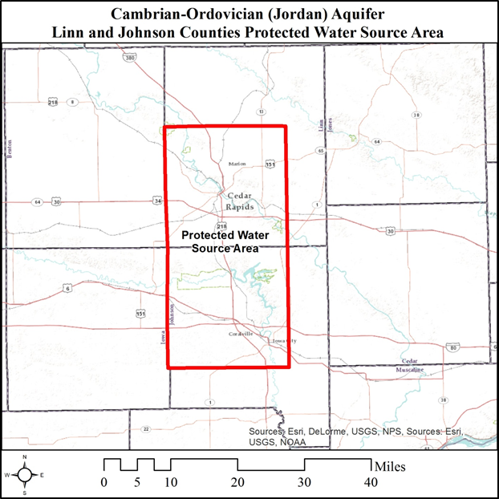
b. Reserved.
53.7(3) Cambrian-Ordovician (Jordan) aquifer in Webster County.
a. Geographical area. The protected water source area includes portions of Webster County. The actual geographical boundaries of the area are defined in subparagraph 53.7(3)“a”(3).
(1) New or modified water use permits. Any new application for a permit to withdraw groundwater or to increase an existing permitted withdrawal of groundwater from the Cambrian-Ordovician (Jordan) aquifer within the protected water source area will be restricted or denied if necessary to preserve public health and welfare.
(2) Withdrawal of groundwater. Withdrawal of groundwater from within the protected water source area may also be restricted or denied from water supply wells constructed in the Cambrian-Ordovician (Jordan) aquifer, public or private, and the construction of all new water supply wells in the Cambrian-Ordovician (Jordan) aquifer shall be restricted or denied, if necessary, to preserve public health and welfare or to minimize adverse effects to the “available” head (i.e., the original pressure head above the top of the aquifer). The Webster County health department is not authorized to issue a construction permit for a private well drilled into or through the Cambrian-Ordovician (Jordan) aquifer within the protected water source area without the approval of the department. The department’s water supply engineering section will determine whether the proposed well can be constructed and may require that the well meet public water well standards.
(3) Map of protected water source. The department shall maintain a map of the protected water source area.
1. The entire following described area within Webster County is defined as a protected water source.
● All areas of Township 88 North, Range 28 West.
● All areas of Township 88 North, Range 29 West.
● All areas of Township 89 North, Range 28 West.
● All areas of Township 89 North, Range 29 West.
2. Map of the described protected water source area in Webster County.
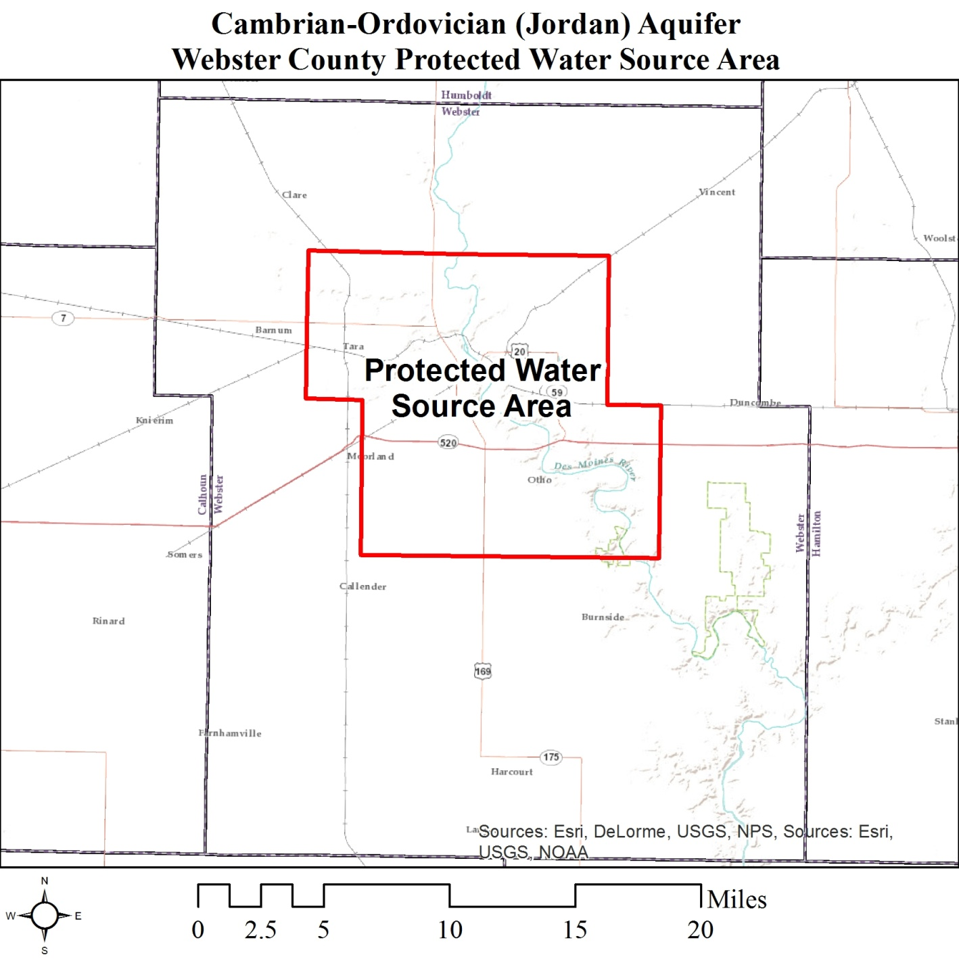
b. Reserved.
NOTE: When protected sources are designated they will be listed as part of this rule.
This rule is intended to implement Iowa Code sections 455B.262, 455B.264 through 455B.274 and 455B.278.
[ARC 2053C, IAB 7/8/15, effective 8/12/15; ARC 4426C, IAB 5/8/19, effective 6/12/19]
[Filed 11/1/85, Notice 7/31/85—published 11/20/85, effective 12/25/85]
[Filed emergency 11/14/86—published 12/3/86, effective 12/3/86]
[Filed 9/20/96, Notice 7/17/96—published 10/9/96, effective 11/13/96]
[Filed 5/17/06, Notice 3/15/06—published 6/7/06, effective 7/12/06]
[Filed ARC 2053C (Notice ARC 1914C, IAB 3/18/15), IAB 7/8/15, effective 8/12/15]
[Filed ARC 4426C (Notice ARC 4277C, IAB 2/13/19), IAB 5/8/19, effective 6/12/19]

