ARC 0658D
CORRECTIONS DEPARTMENT[201]
Notice of Intended Action
Proposing rulemaking related to departmental organization and procedures
and providing an opportunity for public comment
The Department of Corrections hereby proposes to rescind Chapter 1, “Departmental Organization and Procedures,” Iowa Administrative Code, and to adopt a new Chapter 1 with the same title.
Legal Authority for Rulemaking
This rulemaking is proposed under the authority provided in Iowa Code section 904.103.
State or Federal Law Implemented
This rulemaking implements, in whole or in part, Iowa Code chapter 904.
Purpose and Summary
This proposed rulemaking rescinds and replaces Chapter 1 with revised administrative rules to satisfy the requirements of Executive Order 10. The purpose of Chapter 1 is to provide the public with a clear, accessible overview of the Department’s organizational structure, mission, and central contact protocols.
Pursuant to Executive Order 10, the Department conducted a comprehensive review of this chapter to eliminate restrictive terms, obsolete rules, and language that duplicates State statutes. Specifically, this rulemaking does the following:

● Updates the description of the Board of Corrections to align its function with the statutory changes mandated by 2024 Iowa Acts, Senate File 2385.
● Consolidates and streamlines public contact paths.
● Deletes granular internal staff responsibilities and specific facility contact metrics that are more accurately maintained on the Department’s active website, thereby preventing the rules from becoming instantly obsolete.
● Eliminates redundant text regarding topics that are already comprehensively governed by Iowa Code chapters 21 and 904.
The result is a streamlined chapter that maintains essential public transparency while ensuring alignment with provisions of the Iowa Code.
Regulatory Analysis
A Regulatory Analysis for this rulemaking was published in the Iowa Administrative Bulletin on August 19, 2026. A public hearing was held on the following date(s):
● September 8, 2026
No comments were received, and no changes from the Regulatory Analysis have been made.
Fiscal Impact
This rulemaking has no fiscal impact to the State of Iowa.
Jobs Impact
After analysis and review of this rulemaking, no impact on jobs has been found.
Waivers
Any person who believes that the application of the discretionary provisions of this rulemaking would result in hardship or injustice to that person may petition the Department for a waiver of the discretionary provisions, if any, pursuant to 201—Chapter 2504.
Public Comment
Any interested person may submit written or oral comments concerning this proposed rulemaking, which must be received by the Department no later than 4:30 p.m. on November 3, 2026. Comments should be directed to:
Jen Rathje
Iowa Department of Corrections
Jessie Parker Building
510 East 12th Street
Des Moines, Iowa 50319
Phone: 515.802.0898
Email: jen.rathje1@iowa.gov
Public Hearing
Public hearings at which persons may present their views orally or in writing will be held as follows:
November 3, 2026  9:30 to 10:30 a.m. | Via Google Meet Video at  meet.google.com/hjx-panj-ukw  Or dial: ‪(US) +1 318.814.8332‬  PIN: ‪569 488 452‬#
November 3, 2026  1:30 to 2:30 p.m. | Via Google Meet Video at  meet.google.com/rzq-sqzh-aae  Or dial: ‪(US) +1 401.315.8618‬  PIN: ‪517 967 012‬#
Persons who wish to make oral comments at a public hearing may be asked to state their names for the record and to confine their remarks to the subject of this proposed rulemaking.
Any persons who intend to attend a public hearing and have special requirements, such as those related to hearing or mobility impairments, should contact the Department and advise of specific needs.
Review by Administrative Rules Review Committee
The Administrative Rules Review Committee, a bipartisan legislative committee which oversees rulemaking by executive branch agencies, may, on its own motion or on written request by any individual or group, review this rulemaking at its regular monthly meeting or at a special meeting. The Committee’s meetings are open to the public, and interested persons may be heard as provided in Iowa Code section 17A.8(6).
The following rulemaking action is proposed:
ITEM 1. Rescind 201—Chapter 1 and adopt the following new chapter in lieu thereof:

TITLE I
GENERAL DEPARTMENTAL PROCEDURES
CHAPTER 1
DEPARTMENTAL ORGANIZATION AND PROCEDURES
201—1.1(904) Title I definitions.
“Department” means the department of corrections.
“Director” means the director of the department of corrections.
“District department” means the same as defined in Iowa Code section 904.101(7).
201—1.2(904) Mission and function.
1.2(1) The department is established by Iowa Code chapter 904 and consists of an advisory board, a director and areas of responsibility.
1.2(2) The mission of the department is creating opportunities for safer communities.
201—1.3(904) Offices.
1.3(1) Central office. The central office for the department is located in the Jessie Parker State Office Building in the Capitol Complex in Des Moines. Its mailing address is the Department of Corrections, Jessie Parker State Office Building, 510 East 12th Street, Des Moines, Iowa 50319.
1.3(2) Contact information. Contact information for correctional institutions, district departments and other offices located outside the principal headquarters may be found on the department’s website at doc.iowa.gov. The following map provides a general overview of district department and correctional institution locations.
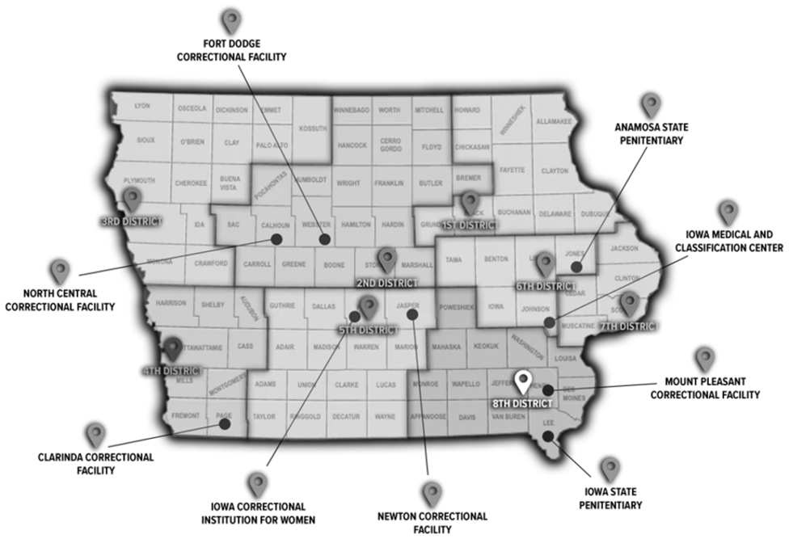
201—1.4(904) Public contact information.
1.4(1) Information regarding department offices and methods for contacting the department are available on the department’s website.
1.4(2) Public records requests shall be submitted in accordance with 201—Chapter 2505.
201—1.5(904) Board of corrections.
1.5(1) The director of the department has, by statute, the advice and counsel of the board of corrections. This seven-member board is appointed by the governor with confirmation by the senate, and its powers and duties are advisory with respect to the services and programs operated by the department.
1.5(2) The board will oversee the work of the department as defined in Iowa Code section 904.105 and, for this purpose, will have access at any time to all books, papers, documents, and records of the department.
1.5(3) Meetings of the board and any committees appointed by the chairperson will be conducted in accordance with Iowa Code chapter 21. The chairperson may appoint committees as necessary to conduct the business of the board.
1.5(4) A quorum shall consist of two-thirds of the membership appointed and qualified to vote.
1.5(5) When a quorum is present, a position is carried by a majority of the qualified members of the board.
1.5(6) Persons wishing to appear before the board shall submit their request to the department office not less than ten days prior to the meeting. Presentations may be made at the discretion of the chairperson and only upon matters appearing on the agenda.
1.5(7) Persons wishing to submit written material should do so at least ten days in advance of the scheduled meeting to ensure that board members have adequate time to receive and evaluate the material.
201—1.6(904) Director.
1.6(1) The governor appoints the director of the department. The director is responsible for the daily administration of the department.
1.6(2) The appointment, qualifications, and duties of the director are mandated in Iowa Code sections 904.107 and 904.108 and other applicable provisions of the Iowa Code.
201—1.7(904) Organization of the department. The department is established by Iowa Code section 904.102 to perform the functions and duties set forth in that section, in Iowa Code section 904.103, in other applicable provisions of the Iowa Code, and in the Iowa Administrative Code.
These rules are intended to implement Iowa Code sections 904.101 through 904.108.

