City receives $100K to assist with rehab of future home of Pillar Technology
April 6, 2018Greene County News Online
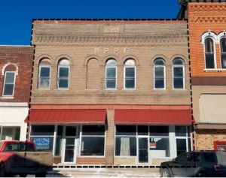
Location of Pillar Technology’s ‘forge’
The city of Jefferson has been awarded a $100,000 Community Catalyst building remediation grant through the Iowa Economic Development Authority for work at the former Odd Fellows hall, west of the Sierra Theatre.
A total of $1.8 million in Community Catalyst grant awards was announced April 5. The program is intended to help communities remediate or redevelop underutilized buildings to stimulate economic growth. Eighteen cities received the maximum $100,000 allowed in the program.
The Community Catalyst grant program is funded through an appropriation from the Iowa legislature. This is the first year these grants are available through the Iowa Economic Development Authority and continued funding is based on annual availability.
The building is planned to house Pillar Technology, a software development company based in Columbus, OH. The company announced its intention to open an office in Jefferson in March, in advance of the April 3 school bond referendum. The company intends to begin a software development workforce training program in collaboration with the Greene County schools, other neighboring K-12 districts, and Iowa Central Community College. The training will be a strand of education at the regional academy that is part of the packaged voters approved earlier this week.
Pillar Technology’s letter of intent was contingent on approval of the bond issue. Although the $21.48 million voters approved does not include funds specifically for the regional academy, the academy would not be built without approval of the larger project. (The county supervisors agreed to pay $5 million for construction of the regional academy, with Iowa Central Community College equipping and staffing it.)
Total cost of the E. State St project is $1.7 million. Chris Deal is developer of the building. He said before the bond election he would forego any profit during Pillar’s long-term lease on the building.

