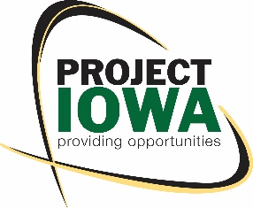
Project IOWA
1111 9th St. Suite 290
Des Moines, IA 50314
515-280-1502
www.projectiowa.org

The future looks bright for Project IOWA and we need the states support to continue the work.
The proposed 50% cut in funding for the upcoming fiscal year from $100,000 to $50,000 would impact our work in the following ways:

- Outcomes and Services: 85% of our budget is for training and program development. A $50,000 cut would mean that we would not be able to provide training to at least 20 individuals.
- Staff: It could be the cost of one staff member who provides training, wrap around support and follow up services.
- Project IOWA would be less likely to leverage funding from other funders and businesses as the state of Iowa’s investment is very influential in obtaining other funds.

Our current completed 990 indicated our revenue at $469,243.00 with $100,000 from the state. $50,000 is a significant amount to cut and will impact the ability for us to function and produce great outcomes.

Project IOWA has had great impact for the State of Iowa and it citizens!!
Since January 2014 - Project IOWA has had 556 individuals complete our Vision, Initiative, and Perseverance 101 (V.I.P.) Course!

Project IOWA has trained 325 individuals in our technical training courses,
with 292 individuals completing which means our completion rate is 90%!
Project IOWA has an 85% Career Placement Rate, with the average wage for Project IOWA Graduates being $13.37 an hour!

For more information contact:
Julie Fugenschuh, LMSW
Executive Director | Project IOWA
Julie.fugenschuh@projectiowa.org
515-280-1502

