March 3, 2017

State of Iowa Legislators
1007 E Grand Ave
Des Moines, IA 50319

RE: House File 484

Dear Representatives,

Thank you for the opportunity to comment on House File 484; which is formerly House File 316.

The City of Windsor Heights held a Special Council Meeting on March 3, 2017, to specifically discuss this proposed legislation. After major consideration Council has requested that I send you this letter indicating that the City of Windsor Heights is opposed to HF 484 and to request more time. The City wishes to continue the conversation on regionalization so we can assure our community that we will continue to provide affordable and quality water for our residents.

The reasons for our opposition include:

- Windsor Heights has not had any issues or concerns with the services provided by Des Moines Water Works. We believe the utility has delivered safe and affordable drinking water, and have long histories of financial diligence that have resulted in healthy water systems at relatively affordable rates. We do not believe there is a problem to fix.

- Delivery of safe drinking water is a public health and safety necessity. We do not believe this legislation addresses these issues.

- The City of Windsor Heights declares our desire to regionalize; however, we believe this can be accomplished without the assistance of the state.

- The City of Windsor Heights understands the Central Iowa Regional Drinking Water Commission has completed a long-term plan and is currently progressing on regionalization and we would like the state to allow them time to do so.

- The City Council has sent correspondence with a list of questions to legislators in order to answer concerns from our residents on affordability concerns. Those have not received a response. The City of Windsor Heights feels this legislation dismantles existing governance structures and replaces them without our local input. Additionally, the legislation provides a vaguely defined governance structure that does not provide a clear impact it would have in our community. This is another reason to provide more time for our City Leaders and residents to understand the impact regionalization will have on our community.

The City of Windsor Heights respectfully requests your consideration to vote in opposition of HF 484; thus, stop the legislation from advancing.
Sincerely,
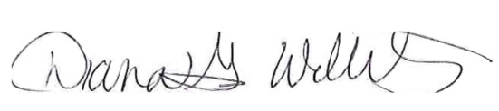
Diana G. Willits
Mayor, City of Windsor Heights, Iowa

