SF496 – significant issues as of 3-28-23
Section 19 - Definition of age appropriate – this needs to be rewritten because it could be interpreted that books which contain the obscene material as defined in 702.17 could be allowed
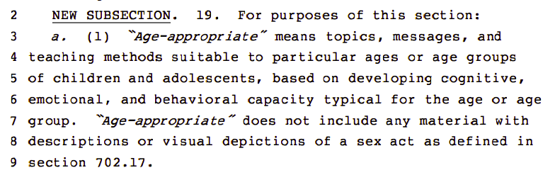
Section 14 -279.78 Transparency— publication of school district information
- Original language: A list of all materials that will be used to teach students in each class [to anyone] posted to the website
- New language: A policy must be made & posted to the website as to how [only] parents can review instructional materials in the classroom but only those approved by the district or state agency
  - This change not only removes the public posting requirement, but will prevent any taxpayer from requesting this information due to the language restricting this right to only parents/guardians, which violates Open Records law. It also limits disclosure of only those materials required by the state or state educational agency, and thus gives the schools the ability to hide all other classroom materials from parents, again violating Open Records law. Please return to the original language.

- Original language: a comprehensive list of all books in the classroom and libraries must be made publicly available on the website
- New language: a comprehensive list of all books in the libraries must be made available to parent or guardian via a link
  - This change reduces transparency by limiting public oversight to only library materials, rather than both classroom & library materials. It also potentially violates Open Records law by limiting access to this link only to parents/guardians. Please return to the original language.

Regular updates to online posting of classroom materials – has been stricken, please put back.
Library materials review committee – has been stricken, along with the requirement that no minor shall serve on it if materials being reviewed contain potentially obscene material. Please put back.
Addition of new library materials are to be reviewed by board – has been stricken; board will no longer provide oversight to ensure obscene materials are not in the library. Please put back.
Regular review of library materials – has been stricken, please put back
Posting of materials removed by the school – has been stricken, please put back

Respectfully submitted,
Heather Stancil
Earlham, IA

