Another year of low SSA Increase, especially when recovering from the effects of a global pandemic, will not serve students well. UEN is opposed to SSB 1985.
Schools spend 80% of general fund budget on staff. Only two ways schools get more efficient:
1) Fewer teachers per pupil increases class sizes and/or fewer non-instructional staff reduces services (counselors, nurses, paras, secretaries)
2) Paying school employees less or cutting benefits.
Schools are part of a market economy and compete with the private sector for all staff. Schools don’t have the captive audience of great talent of two generations ago, when women had few career choices.
Schools are struggling to compete with Walmart in pay scale and benefits packages for custodians, paras, and secretaries. Iowa’s strong economy and low unemployment rate create competition for jobs that are attractive to people who would otherwise be teachers and bus drivers. Schools must have competitive wages and benefits, or we don’t have the human capital to serve students. Over the last decade, the number of applicants for most positions has diminished. Rural schools are lucky to get two applicants for jobs that used to generate 100. Urban school potential employee pools are also smaller. Striving to hire a diversified staff to more closely mirror our diverse students requires resources.
The job is getting harder. School staff have never worked harder than during this last year. This is a time to reward that collective effort and not punish the students in some districts or one district for making the decisions they thought were best for their community and students.
Higher SSA helps property taxes two ways. Iowa’s formula is a mix of state/local taxes with these impacts:
- Higher SSA lower Budget Guarantee property taxes: districts are guaranteed a 1% increase in their regular program budget for one year following an enrollment decline. The state pays part of the formula based on the prior year’s student count. Local property tax payers make up the difference. With almost 6,000 fewer students enrolled in school last fall (over 1/3 of the loss was in Kindergarten), the state’s share of the formula is lower this year. That makes a higher SSA rate affordable for the state. Scenarios:
SSB 1059 at a 2.2% increase leaves 48 districts with less money than the current year state and local funds combined, places 145 school districts under the budget guarantee with less state money and more local property taxes ($31.2 million property taxes for budget guarantee)

HSB 183 and Governor’s Recommendation at 2.5% increase leaves 46 districts with less money than the current year state and local funds combined, places 137 school districts under the budget guarantee with less state money and more local property taxes ($25.9 million property taxes for budget guarantee)

The state can afford between 3-4% increase with average state investment in schools: 3.75% is the sweet spot: leaves 33 districts with less money than the current year state and local funds combined, places 85 school districts under the budget guarantee with less state money and more local property taxes ($9.5 million property taxes for budget guarantee). That budget guarantee amount is more in line with normal enrollment declines, similar to the current year’s $8.3 million property tax.

2. Higher SSA lowers special education deficit property taxes. Sped deficits have risen steadily over the last decade. The formula weightings are multiplied by the SSA. Higher SSA means greater state contribution to services for students with disabilities. Lower SSA means property tax payers are on the hook.

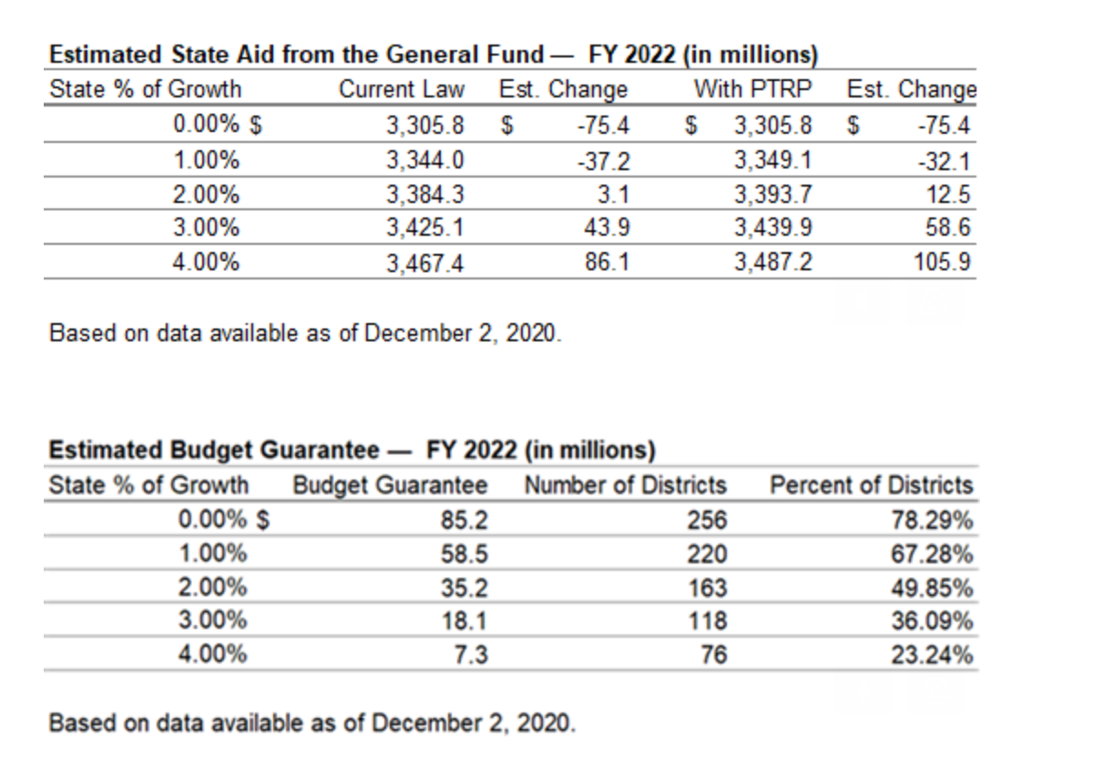
LSA Estimates of the cost of SSA provided before the Session, current law (which includes restoration of $15 million to AEAs which have been cut in the standings appropriations bill every year for over the last decade plus) shows the relative state investment for various levels of SSA. Over the last 12 years, from FY 2009 to FY 2021, the average state investment in public education through the formula has been $95 million.

Where can the state find the money to pay for more SSA?
Don’t penalize any schools, all of whom will be compliant with minimum instructional time requirements by the end of this school year, for instructional models they implemented to the best of their ability during the pandemic. Repurpose that funding for all students through the formula. Why?
- If in person instruction is valued, funding in the formula will provide the resources to staff up to provide in person instruction in all districts safely – with enough substitutes, custodial staff, counselors and social workers to move students and families beyond the pandemic to a level of learning necessary for future success. Penalties for not providing in person learning retroactively applicable to last Fall don’t take care of our neediest students who may have been most impacted by COVID.
- The principles in Iowa’s school funding formula guide this legislature to the best solution:
  - provide an adequate education for all Iowa students
  - promote equity for all Iowa students
  - relieve the burden of Iowa’s property taxpayers
If funding must be one-time, it should further these principles in the formula and be distributed equitably based on enrollment.

Economic Comparisons:
Comparing this cost per pupil to CPI, we are barely keeping up, some years higher and some years lower in the last decade. However, since the consumer’s market basket of goods isn’t the same as school costs, which are mostly people, we suggest looking at other measures to see Iowa’s relative investment in schools.
A true apples-to-apples comparison shows what percent of total state resources are spent on education. The NASBO (National Association of State Budget Officers) annual State Expenditure Report analyzes all state expenditures:
- In FY 2020, Iowa’s education expenditures were 16.9% of total state expenditures.
- Plains states averaged 19.9%.
- All states averaged 19.0%.

Comparing the cost per pupil to the Iowa Economy (State Gross Domestic Product), Iowa is spending dramatically less of its wealth on the per pupil cost. Whether coincidental or causal, Iowa was in the top 5 in the nation in student performance indicators in NAEP in 1993, at a time when our state’s investment in the formula relative to our economy was at its peak. Iowa is now in the middle of the pack, as other states have invested more, modernizing their funding formulas to better meet the needs of all students (the nationwide average of weighting for at-risk/low-income students is .29, or 29% of the state cost per pupil).
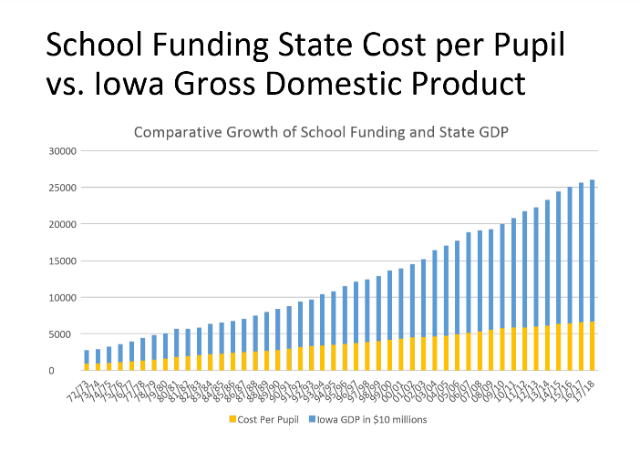
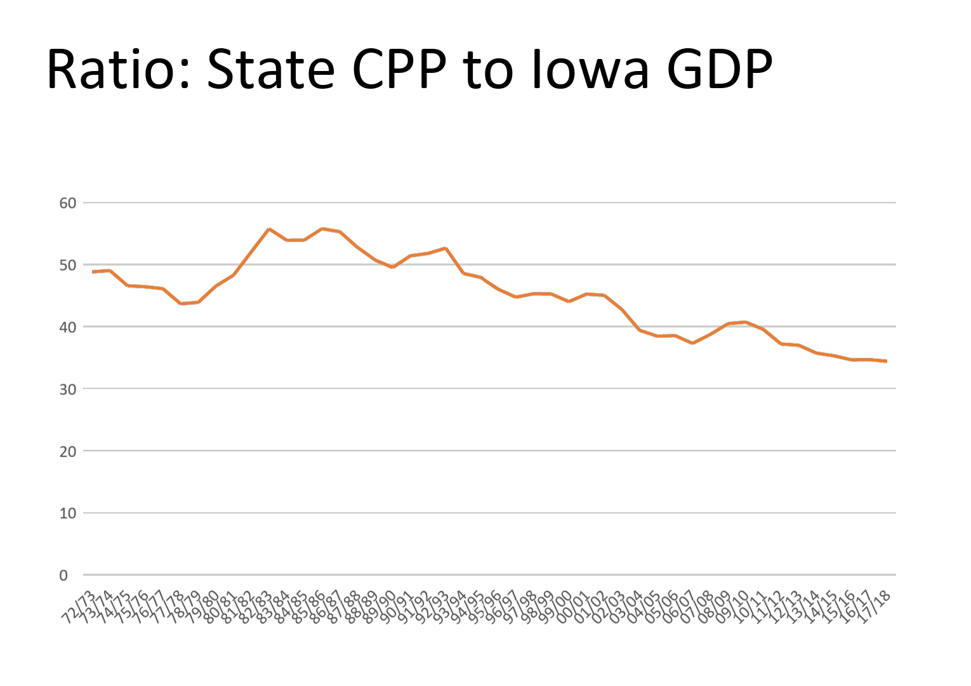
Margaret Buckton, UEN Executive Director, margaret@iowaschoolfinance.com (515) 201-3755 cell

US Census Bureau, May 2020 https://www.census.gov/library/visualizations/2020/comm/school-system-spending.html
Iowa’s education spending: ranks 8th out of 12 in the Midwest Region. Spends $1,041 less than Midwest region state average. Ranks 28th in the nation and spends $880 below the national average.
This data is all education spending except for capitals, includes formula funding (state cost per pupil) plus categoricals (like TLC, transportation equity etc.) in includes state and local funds.
