Urban Education Network: Survey of Instructional Models as of Jan. 21, 2021
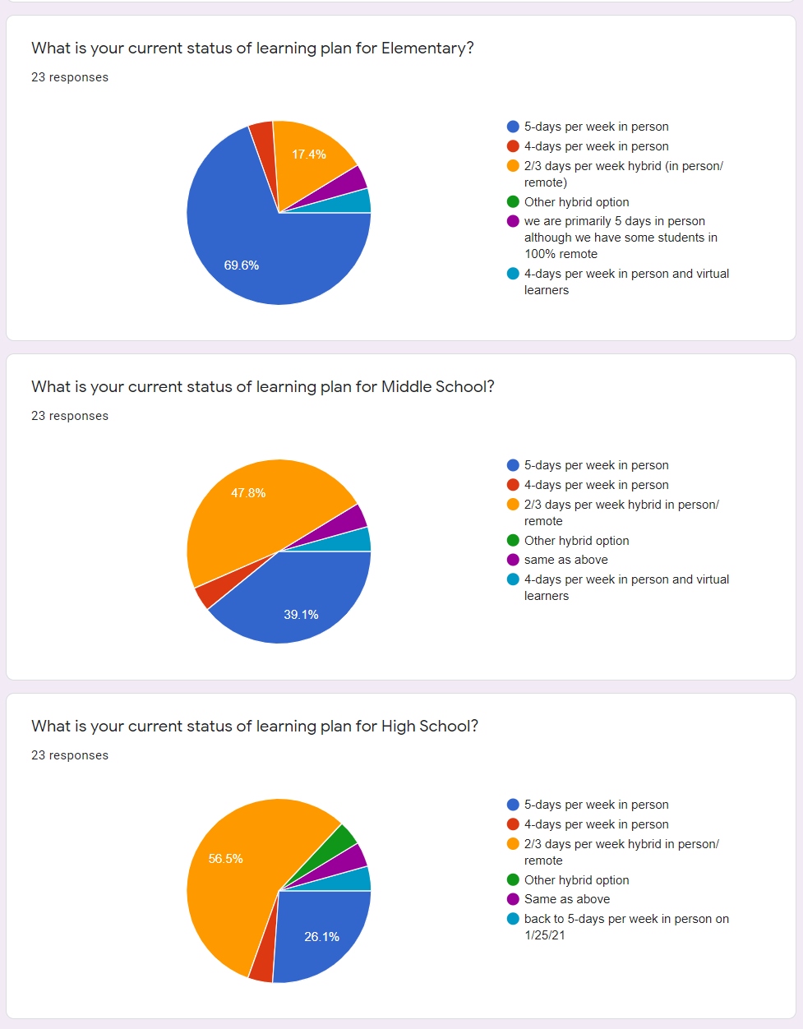
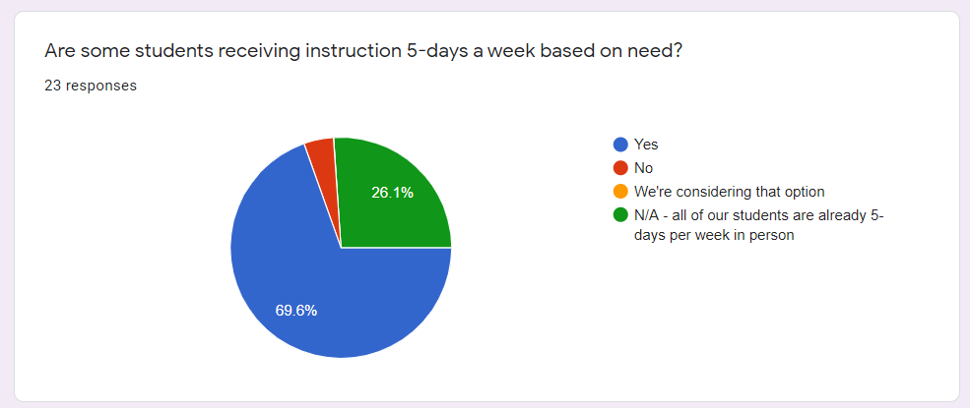

Comments regarding hybrid or virtual learning options:
Staff are concerned about health risks without a vaccine
Classes sizes will be too large to allow for CDC recommended social distancing, Contact tracing & quarantine requirements with more students in person at the same time, Time for secondary staff to adjust instruction/planning for daily instruction. Schedule changes are complicated at the secondary level.
Insufficient teaching staff to cover both previously selected virtual & 5-days in person, Staff are concerned about health risks without a vaccine, Staff will resign if required to be in school with full classes 5-days a week, Classes sizes will be too large to allow for CDC recommended social distancing, Contact tracing & quarantine requirements with more students in person at the same time, Not enough substitutes to cover classes 5-days per week in person
Insufficient teaching staff to cover both previously selected virtual & 5-days in person, Staff are concerned about health risks without a vaccine, Classes sizes will be too large to allow for CDC recommended social distancing
Staff are concerned about health risks without a vaccine, Classes sizes will be too large to allow for CDC recommended social distancing
Staff are concerned about health risks without a vaccine, Most of our teachers are responsible for both in-person and continuous learning. We provide 1 day a week to do both.
Staff are concerned about health risks without a vaccine, Bus driver shortages to run full routes 5-days a week, Classes sizes will be too large to allow for CDC recommended social distancing, Contact tracing & quarantine requirements with more students in person at the same time, Not enough substitutes to cover classes 5-days per week in person
Staff are concerned about health risks without a vaccine, Classes sizes will be too large to allow for CDC recommended social distancing
Classes sizes will be too large to allow for CDC recommended social distancing
Staff are concerned about health risks without a vaccine, Classes sizes will be too large to allow for CDC recommended social distancing
We have had more positive cases with high school students and they are involved in more outside of school activities.

Margaret@iowaschoolfinance.com
515.201.3755 cell

