Rural School Advocates of Iowa: Survey of Instructional Models as of Jan. 21, 2021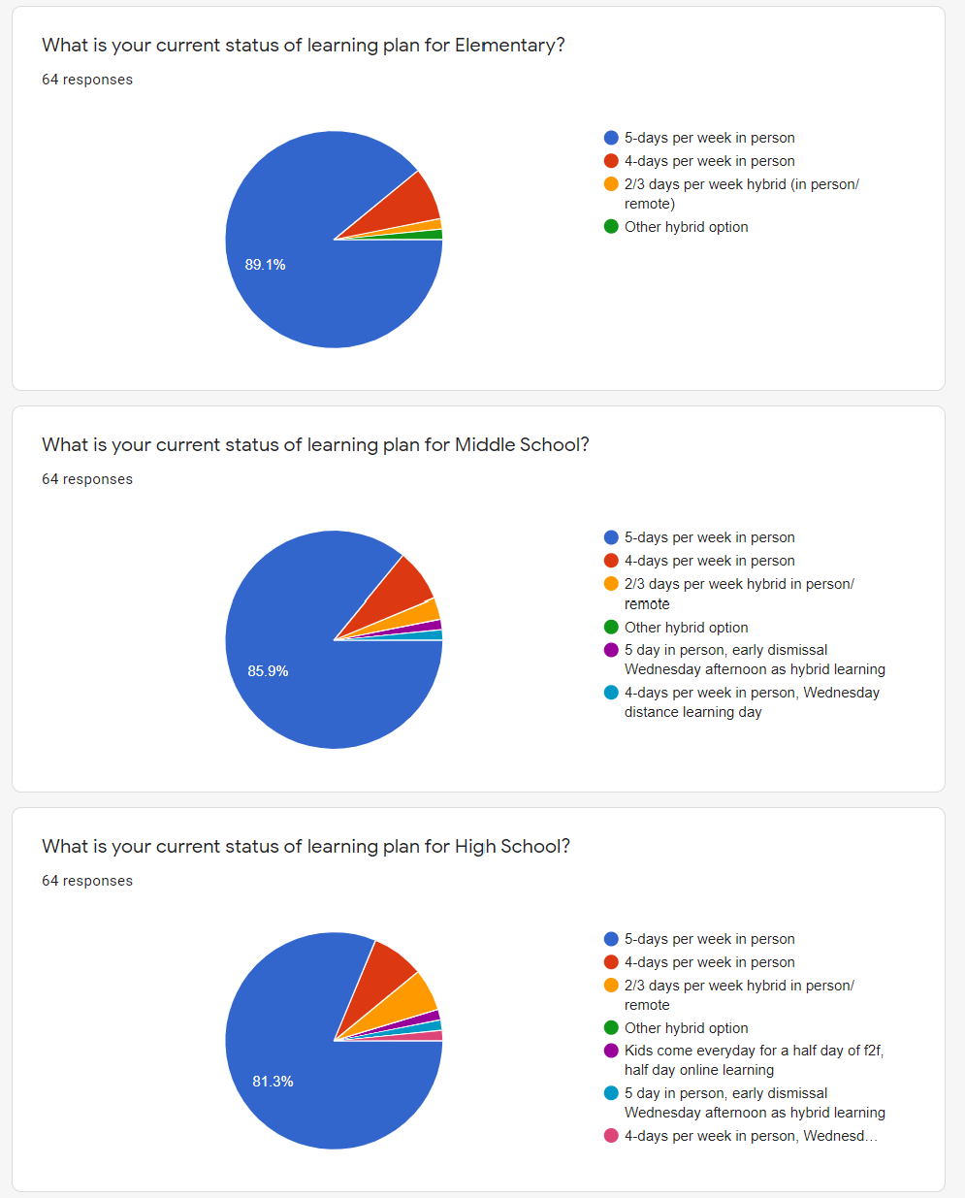

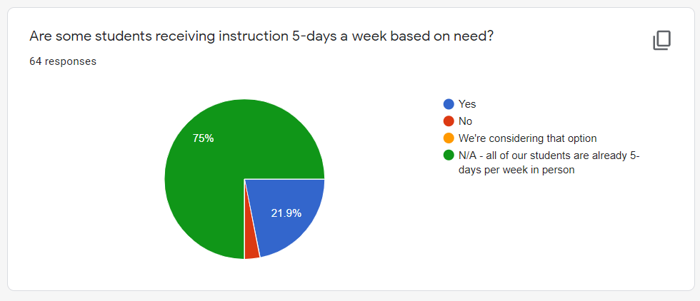

Comments regarding hybrid or virtual learning options:
We just moved to this model (5 days a week) this week. Prior to this, we were in a Hybrid model for the first semester.
Albia has been pretty adamant in trying to provide full in-person learning this school year. Because of Covid numbers, we did have to go hybrid at the 7-12 level for approximately 6 weeks this year. However, PK-6 has gone full in-person every day this school year. We are working hard to continue full in-person as we believe that is the best learning option for our students.
We plan to go 5 days per week for all students by the end of February. We are coordinating this with the vaccinations.
We did have 1:10 dismissal every other week for pd. We know have 1:10 early dismissal every week. Every other week is PD and the other weeks are for PD work and mitigation completion for our staff.
Plan to go to 5 days for all students by mid-February at end of 2nd trimester, and in conjunction with vaccine administration.
We offer an on-line option for families. We currently have about 5% of our students on-line.
We have roughly 150 students who are online virtually all the time, however more parents are having their students return as we have excellent strategies in place to reduce the spread of the virus. Basically K-8 are cohort groups with plexi glass and mandatory masks. We have hired extra long-term subs to cover as needed daily. 9-12 on a A/B schedule. Hoping to bring them back by March 13 unless a vaccine comes sooner.
Our staff are providing instruction to in person, remote quarantined and online students at the same time.
Our 4 day a week model, with virtual learning on Wednesdays is working! We need to keep this consistency for our families!
We have spread out our K-8 students through all of our buildings including our HS to allow for social distancing. That meant we had to find spaces in the community to allow for social distancing for HS. We do not have the space to spread kids out and teach HS all day long. Once our staff are vaccinated, we plan to bring back HS students and offer more space but right now, that hasn't been a safe option. About 70% of our families working at a packing plant in town, we have a lot of positive COVID activity - we created this plan to get kids IN school and keep them in school. We made a plan that would work until vaccines could get here and it’s frustrating to think that our teachers may be forced to be in spaces not distanced when we worked so hard to create safe spaces to teach kids. We turned our district upside down to offer safe options.
We attend 5 days a week, however we had a late start every Wednesday, and this year we extended that late start by 2 hours to allow for teachers to plan/prepare for online learning for families that opted for that.
I hope that any bill would not open a window for parents in our district to choose to go face to face or online. We have passed our deadlines for parents to select these options.
Prek-5th has been 5 days the entire year. 6-12 has moved into Hybrid twice based on our numbers. We used a 4-day week schedule with 2 cohorts. We just moved back F2F January 18th grades 6-12 and are hoping to finish the year F2F PK-12 unless numbers change. We use a 2 hour early release every Wednesday for PD. We are moving our TQ day to the end of the year in order to use those hours for instruction.
COVID Update as of 7:30 AM today: Community positivity is 12.0% for Cherokee County. CCSD has 1 student positive and in quarantine and 77 recovered positive and out of quarantine. CCSD has 1 staff member positive and in quarantine and 38 recovered positive and out of quarantine.
If we were mandated to offer 100% option, we would like to have some transition time to prepare for lesson planning and to literally move furniture.
We started the year with five weeks of hybrid model learning. We provide full remote learning the week after Thanksgiving, and December 21 and 22. Neither week required approval from the DE because we remained within the 50% in-person requirement. We will continue to monitor conditions and will adjust our model if necessary and if it remains legal.
Our high school was in a hybrid model the majority of the first semester. We have no plan to use that model again at any level of our school district.

Margaret@iowaschoolfinance.com
515.201.3755 cell

