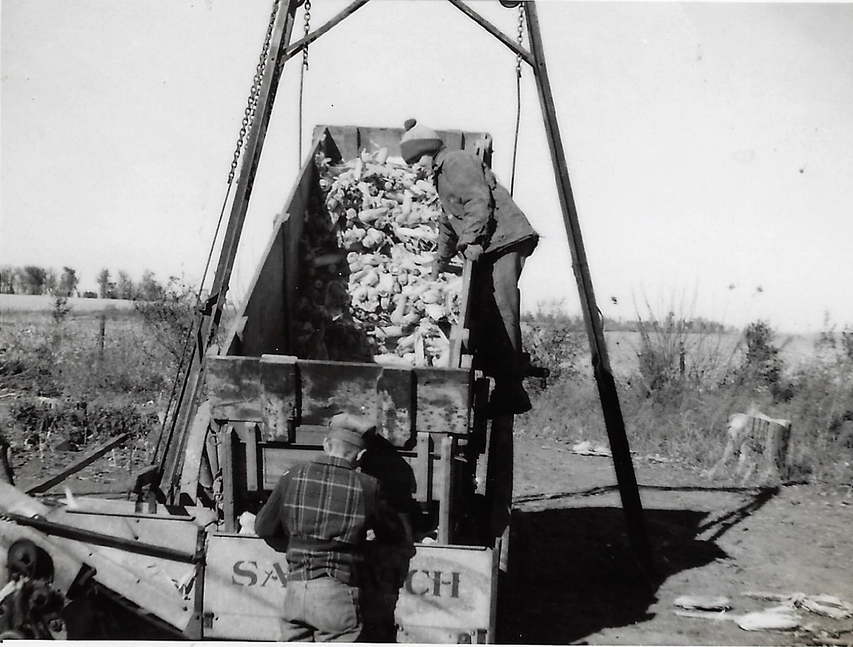
Our Grandma and Dad – Harvest, 1942.

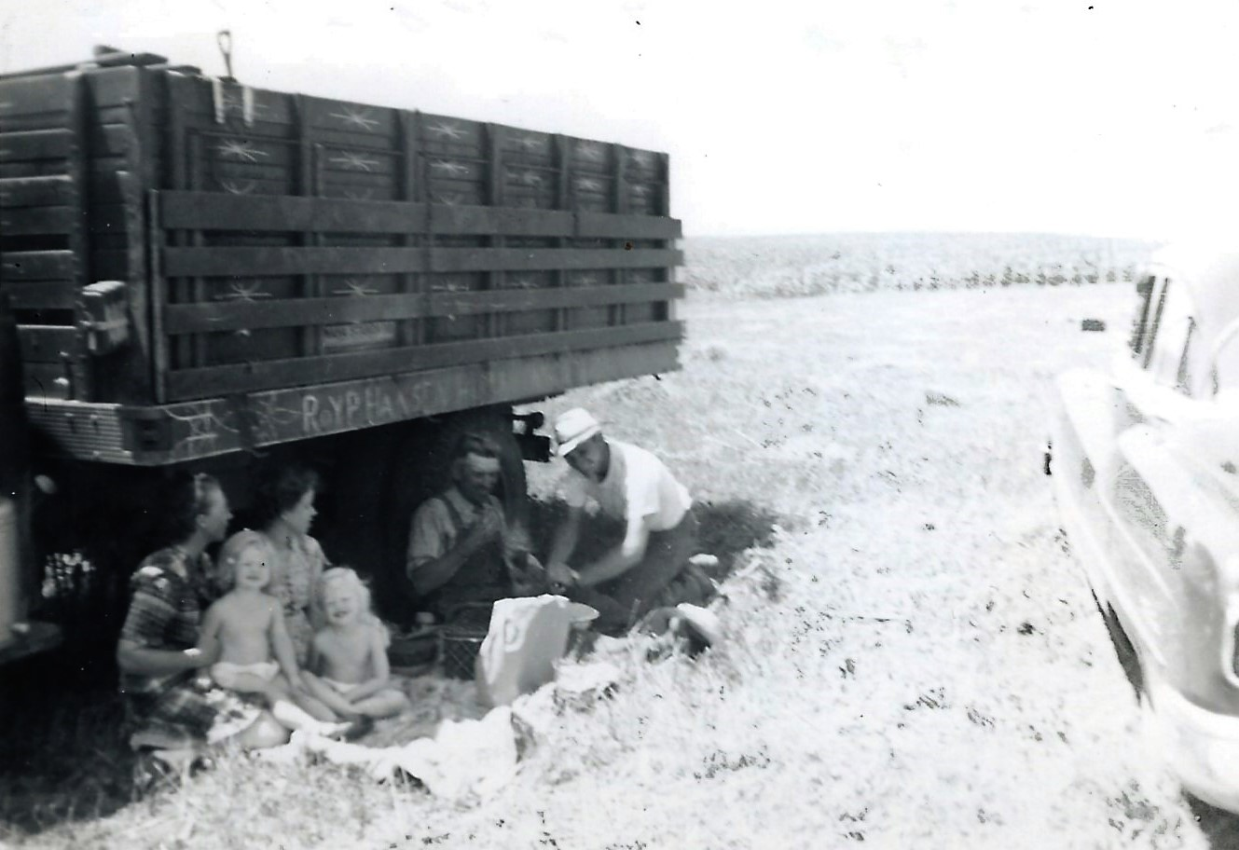
Our Grandma and Grandpa, Dad and Mom, my sister and myself – harvest, 1953

