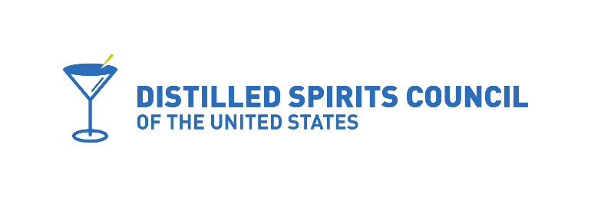

March 9, 2022

Iowa House Ways and Means Subcommittee Members
HF 2525

On behalf of Distilled Spirits Council of the United States, we regretfully write in opposition to HF2525. The spirits industry supported Representative Jones’ original bill (HF2108) because it recognized that Iowa spirits consumers deserve the same convenience that has been afforded to wine consumers for decades.

However, HF2525, the amended bill, would prohibit Iowa consumers from purchasing spirits and having those products directly shipped from a distillery, in or out-of-state, which produces more than 100,000 gallons annually. Our association supports legislation that ensures consumers can access products from all distilleries equally. Such a limitation not only provides less choice for Iowa consumers, but also places a glass ceiling over small distillers and discriminates against those who have already achieved broader success. The number of distilleries in the U.S. has skyrocketed from just 70 to more than 2,300 over the past 15 years. There are now more than 15,000 distilled spirits products in the marketplace; that number is growing each year. Wholesalers and retailers simply cannot accommodate the sheer number of brands and products that exist in the modern competitive marketplace.

Why should Iowa consumers be prevented access to certain spirits products that are not available on their local retail shelves solely because of the size or success of a distillery that produced them? The highest court in the land has already affirmed equal direct-to-consumer (DTC) access for the wine industry, which has responsibly shipped wine direct-to-adult consumers for decades. In fact, adult consumers in 46 out of the 47 wine DTC states have access to wines from wineries across the United States, regardless of winery size. Why shouldn’t distillers of ALL SIZES have the same treatment?

The U.S. distilling industry is innovative and dynamic and is inextricably linked to our nation's history. In our view, limiting DTC access for Iowa consumers to small producers only creates a barrier to future growth. We should provide all distillers who are working hard to grow their businesses the same opportunities to compete in the marketplace, and then let consumers decide.

For these reasons, we ask you to oppose HF2525, as amended.

The Distilled Spirits Council of the United States remains committed to continuing to work with legislators, ABD and distilleries of all sizes to develop legislation that provides Iowa consumers convenient and responsible access to the distilled spirits products they want.

Sincerely,

Kristi Brown
Senior Director

